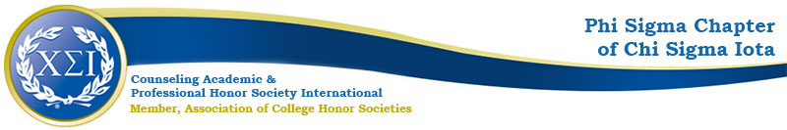

Phi Sigma Chapter Meeting Minutes
March 14, 2023
4:30pm
https://uncp.webex.com/meet/nicole.stargell

Welcome!
President: Eliza Burgess
Vice President: Whitney Scott
Secretary/Treasurer: Darcentia Turner
co-CFA: Dr. Ashley Smith
co-CFA: Dr. Nicole Stargell

Check-in
2 CFAs
1 Officer
5 New Members

Announcements
  - Tshirts are in!
  - Order one here: https://uncp.co1.qualtrics.com/jfe/form/SV_e3b1JmoaRfR3fTg
Spring Projects
- PDA Workshops: Professional Preparation
  - 16th Annual GHW Counseling Workshop—Wednesday 03/15/23 8:45-3:00pm
  - Youth Mental Health First Aid—Matthew Miles, LCSW, Tuesday 03/28/23 8a-5pm, SOE 223
- UNCP Graduate Research Symposium
  - https://www.uncp.edu/academics/colleges-schools/graduate-school/professional-development/graduate-research-symposium
  - Proposals due today
  - Tuesday April 4, 2023 5:30-7:00pm
- Induction Thursday 03/30/23 at 5:30pm via Webex
  - Officer Speaking Parts
  - 2023-2024 Officer Nominations
- Ideas for Next Year:
  - Increase member participation
  - Increase communication to all students
  - Professional Development

Next Meeting:
Tuesday 04/11/23 at 4:30 via Webex

