Guide to running and reading a Degree Audit
- Log in to your Braveweb account.
- Click Banner Self Service link.
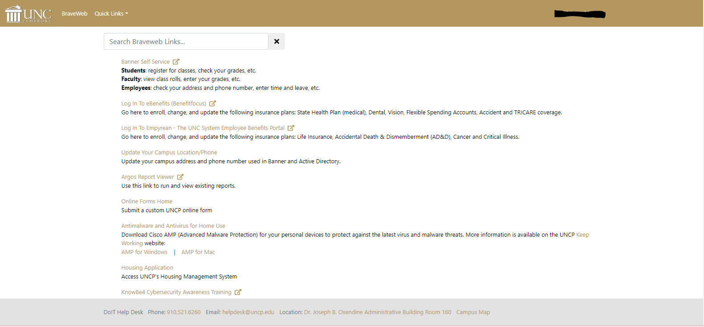

- Click Faculty and Advisors or Faculty Services link on the Main Menu Page. 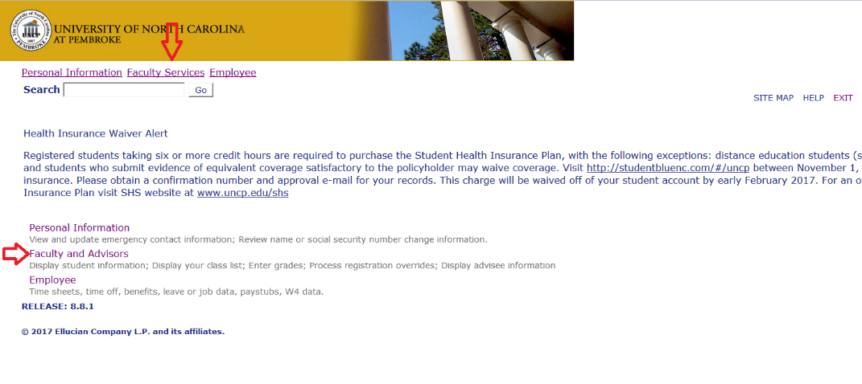

- Click Degree Audit. 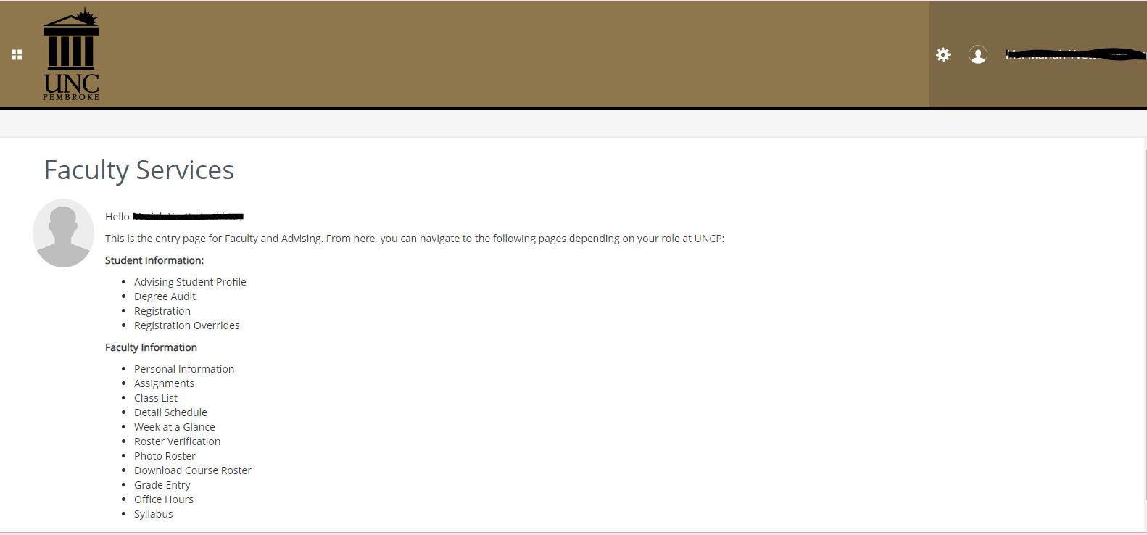

- U Achieve will open in a new window. Click Students
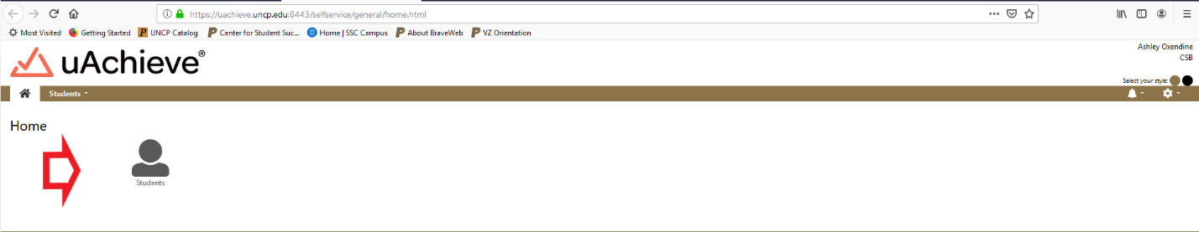
- Enter the Student’s Banner ID or First and Last Name and click Submit or Search. 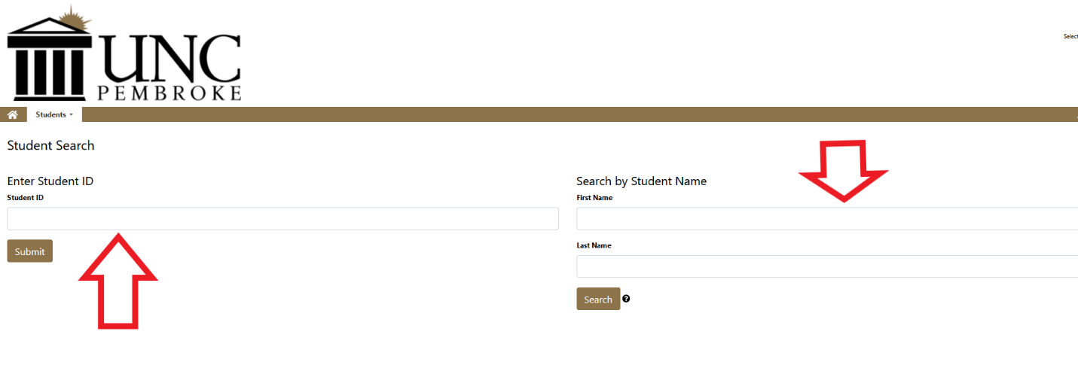

- Once you have entered the student’s information. Click Request Audit.
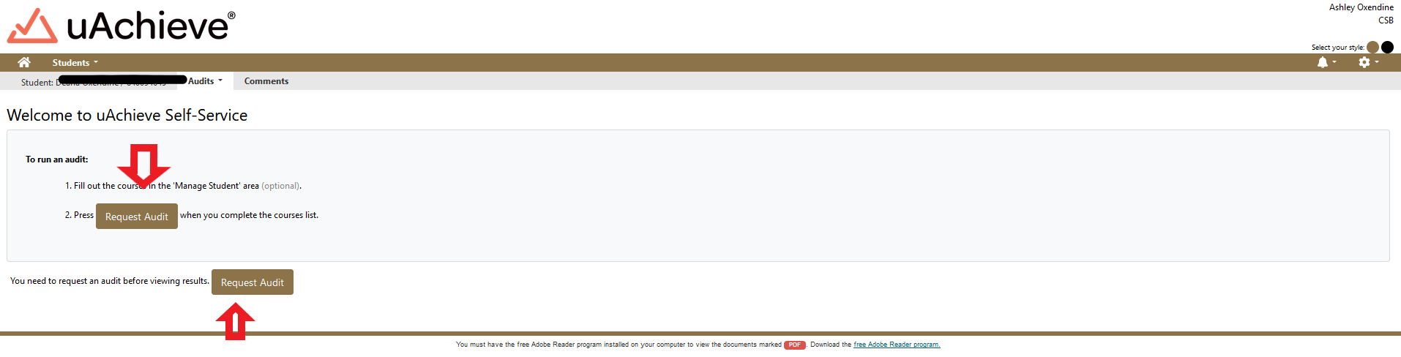

- If you are running an audit on the student’s current degree click Run Declared Program. If you want to change the degree click Select a Different Program (If running a current degree audit skip to step 11.)
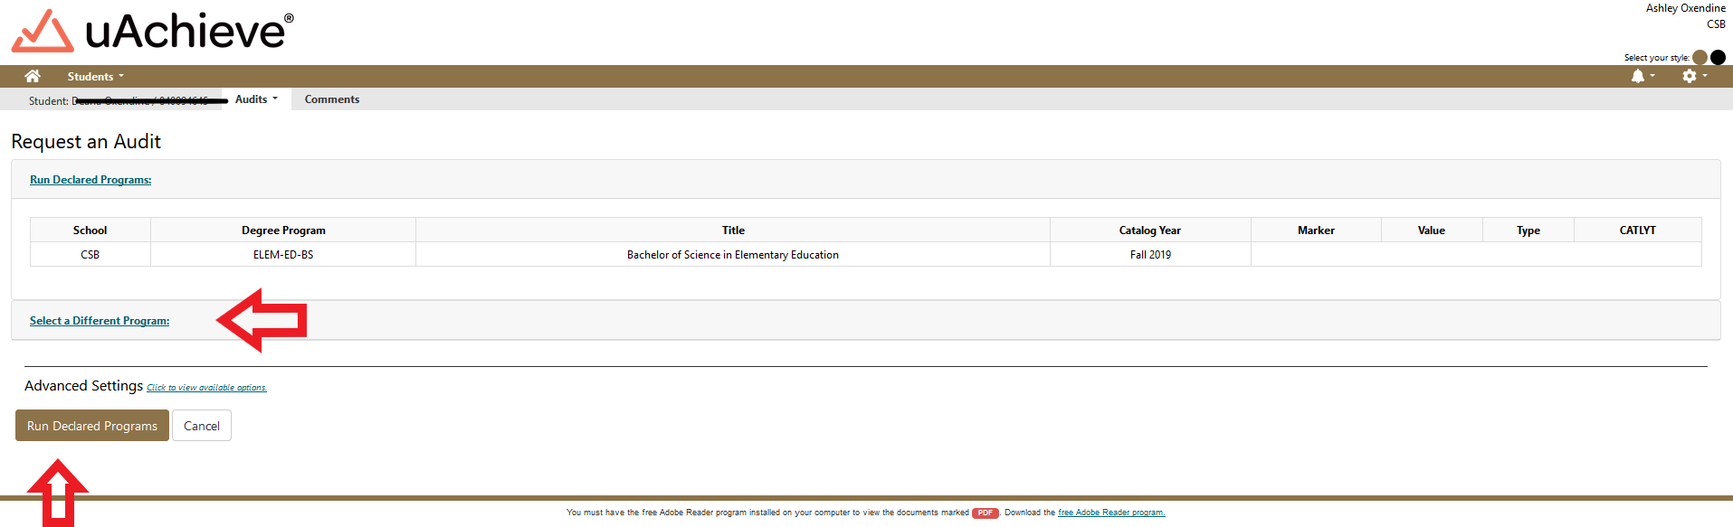

- Select New Program (Major) and Catalog Year from Drop downs.
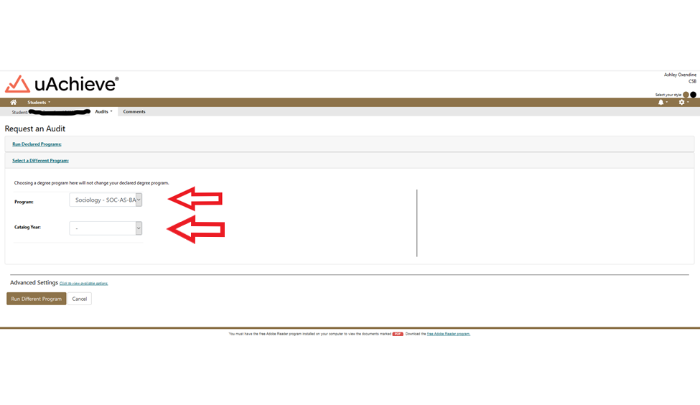

- Click Run Different Program.
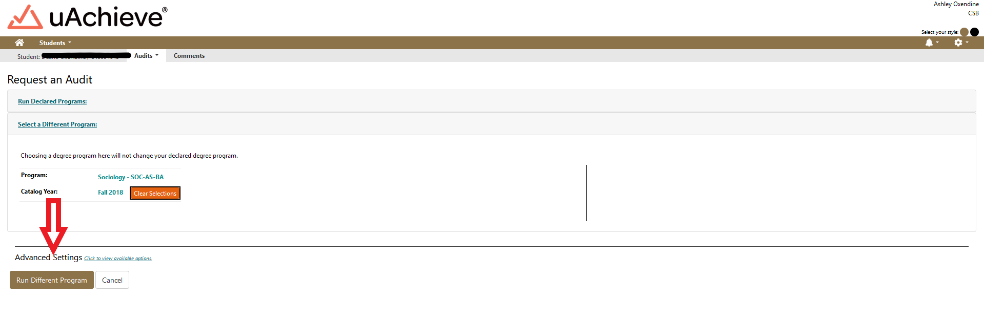

- The Audit will then propagate with the student information at the top that includes their name and Degree at the top Banner ID, Program Code, and Catalog year. 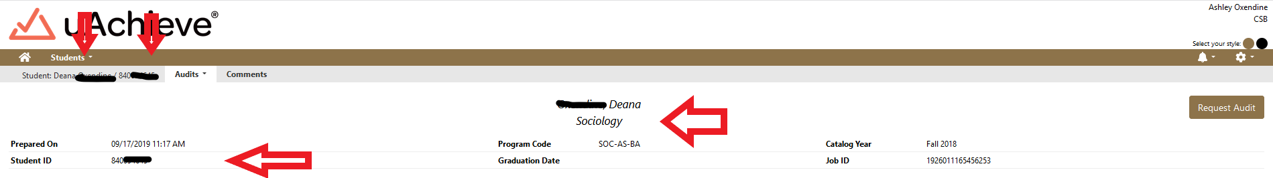

- Below the student information at the top is charts and graphs that represent the student’s progress towards degree completion. There is a legend that is color coded to represent each of the following: complete (green), in progress (blue) and unfulfilled (red). Planned (purple) is located here as well but we do not use this feature.
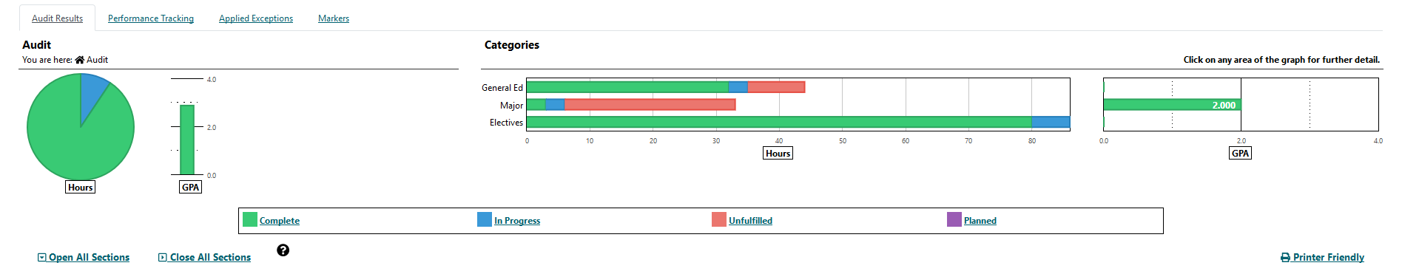

- You can hover over the colored sections of the charts and grafts to see the number of hours related to that section either completed, in progress or unfulfilled.
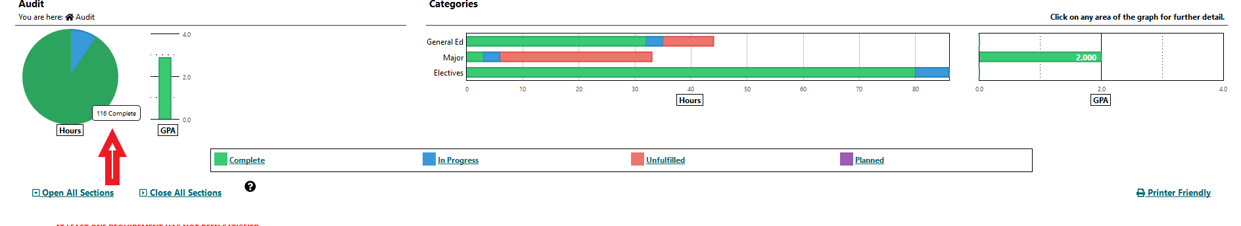

- You can click on bar in the categories table below to go directly to that related section on the Degree Audit.
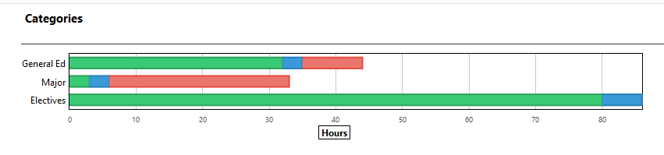

- In the category section we selected Major. Below you will see a screen shot of the major requirements which include completed, in progress and unfulfilled requirements. 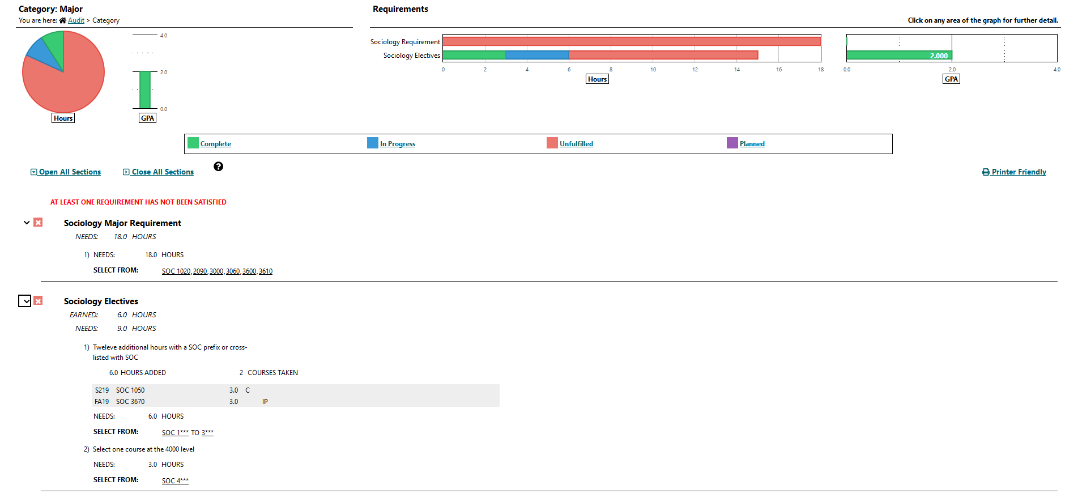

- When the Audit is initially opened, All sections are closed. Click open all sections to see all requirements in each section. 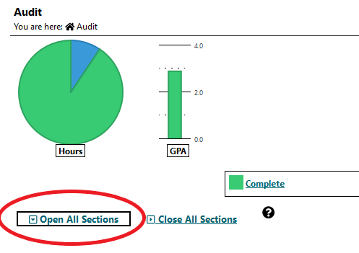

- When reviewing the Degree Audit. = completed requirement, = In progress requirement, = unfulfilled requirements.
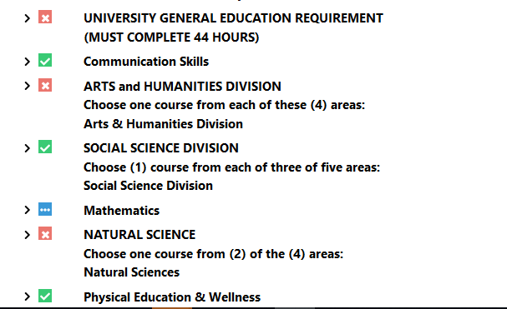

- You can then scroll through each section of the DARS if you want to review more information. There are sections on In-Progress Courses, Total Hours/GPA, Residence, Major GPA, General Education, Major, Minor and Track Requirements. 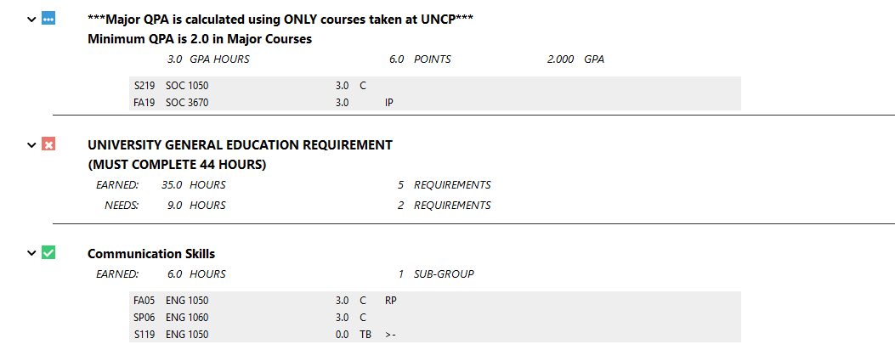

- If courses cross list or the course names change they will show up MATCHED AS: ABC 1XXX in the system.
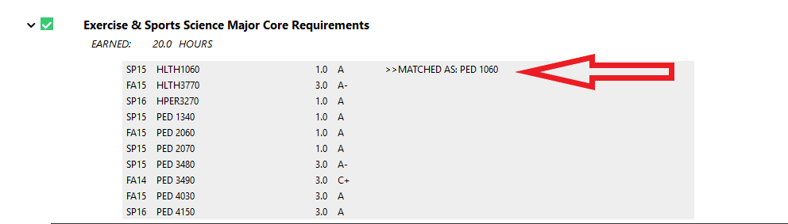

- If a student has not met a requirement for a section it will be indicated beside NEEDS: X.X Hours indicating the number of hours and the courses needed will be located under the courses taken Indicated the by the SELECT FROM: ABC 1XXX 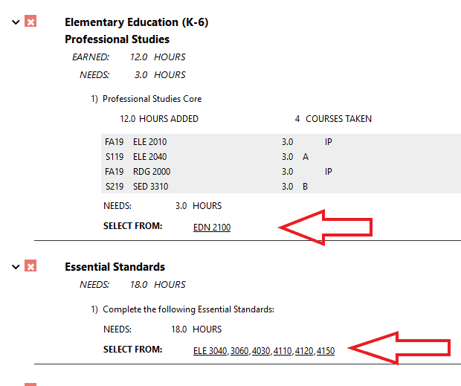

- University Electives are located towards the bottom of the Degree Audit. Make sure to review this area especially if a student is required to have a certain number of elective hours. ***Please review this section carefully. Elective hours may not always be accurate. Anything not counting as a requirement for the major will fall here.***

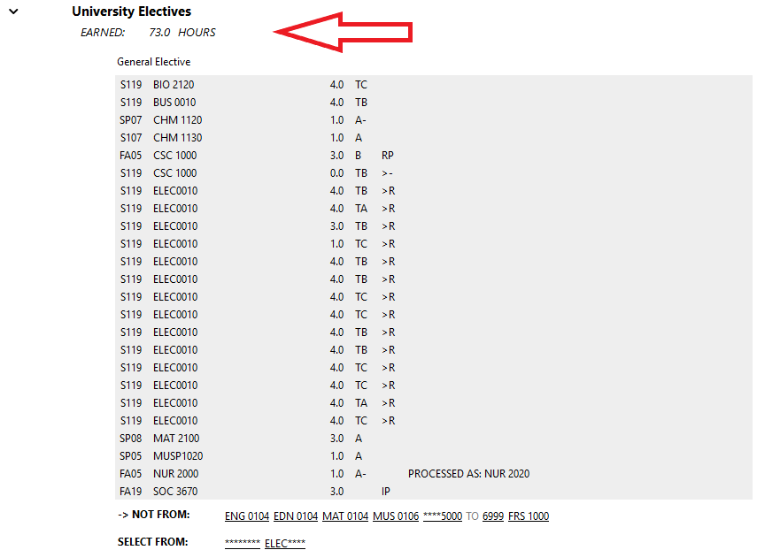
- Work not Applicable appears at the bottom of the Audit. This includes ENG 104, MAT 104, any course withdrawals or any course removed from overall GPA due to special readmission policy.
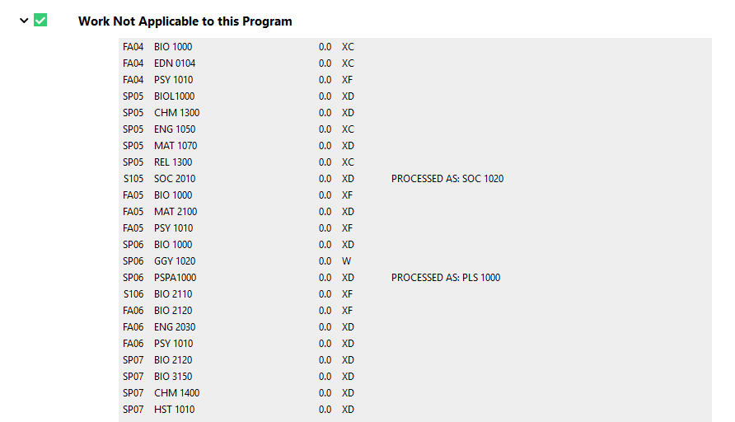

- DARS also includes a legend at the bottom for your reference. >X is a grade replacement. 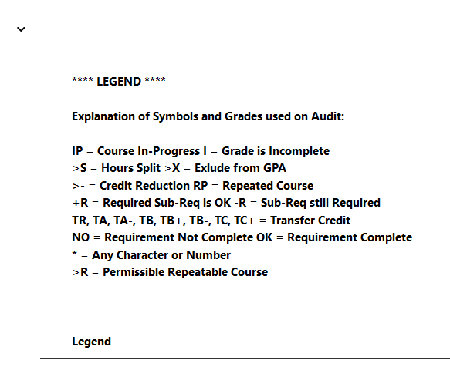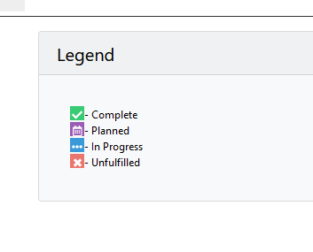
- Once you complete an Audit on a student it will show all Audits ran on that student on the individual students audit request page. 