UNC Pembroke

EAB Student Success Collaborative

Calendar Sync

Center for Student Success

From Staff Home, select the Calendar icon…

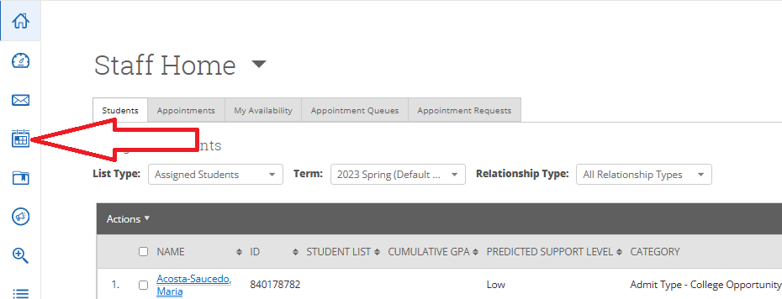

…at the right of your screen select ‘Settings and Sync’…

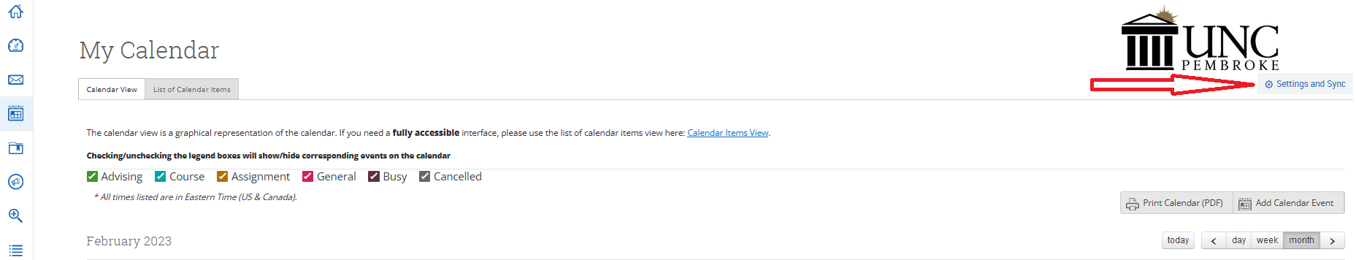

…click ‘Setup Sync’

…Pick your version……(this step may take 30 minutes or more)…

If you still experience issues with your Calendar Sync…please contact mark.hunt@uncp.edu or call 910.521.6625 for assistance.

