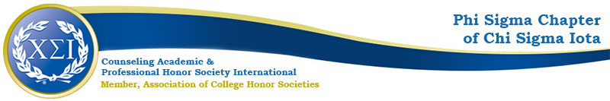

Phi Sigma Chapter Meeting Minutes
September 14, 2021

https://uncp.webex.com/meet/nicole.stargell

Phi Sigma Coffee Break

Welcome! (Introductions of Officers and Welcome for the New Faces)
*All guests and members were welcomed to the Coffee Break meeting of the Chapter. It was noted that the turnout for this meeting was excellent.

In addition to the Officers and Advisor introduction, the doctoral intern for this department through October was introduced, Ms. Sitonja Valenzuela.

President: Scottie Miller
Deputy President: Brianna DeDeaux
Vice President: Alexis Nappier
Secretary: Laura McAliley
Treasurer: Rocio Serna
Wilmington Liaison: Eliza Burgess

Phi Sigma is the UNCP Chapter of the International Counseling Honor Society and is the only honor society for counselors. There is support for all of the activities shown below.

The requirement for qualification for membership in Chi Sigma Iota is primarily:

        - semester hours (3 classes) with a GPA of 3.5

Induction in April, Fee of $55 (This is a Lifetime Membership Fee, but dues are owed to headquarters annually to remain active)

This Includes All of the Following:
- Certificate of Membership
- Access to National Chi Sigma Iota
- Monthly Meetings
- Social Events
- Service Projects
- Professional Development
  - Leadership
  - Continued Education
  - Excellence
- Finals Support Program-wellness resource email (s) & social media/Instagram polls/live
- UNCP Social Media Handles on website- send any celebrations to nicole.stargell@uncp.edu
- Holiday Social- BD – Online Bingo, scavenger hunt, ugly sweater contest, door prizes, http://playspent.org/ - other ideas, please let Dr. Stargell or Scottie know.

Fall Projects
- CPCE Study Groups:
a. SV & BD to work on this with Kahoots
- PDA Workshops: Wellness
a. October- Sitonja Valenzuela
b. November- Whitney Akers (Trans Awareness Week)
d. February- Sam Simon (Making Wellness Accessible: Social justice and wellness)
e. March- GHW Counseling Workshop

- Fundraiser: We will look at posting opportunities for PDA/CEUs online for inexpensive ways to get needed professional development that will bring in funds for our chapter
- Advocacy Project- Trans Awareness Week
- Fall Meetings: October 12th, November 9th

