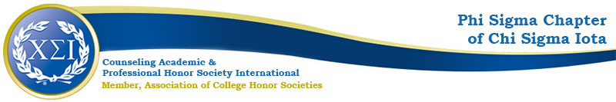

Phi Sigma Chapter Meeting Agenda
October 12th, 2021
4:30-5:30pm

https://uncp.webex.com/meet/nicole.stargell

Present!
Nicole Stargell
LM-Secretary
EL-W Liaison
4 Members

President: Scottie Miller
Deputy President: Brianna DeDeaux
Vice President: Alexis Nappier
Secretary: Laura McAliley
Treasurer: Rocio Serna
Wilmington Liaison: Eliza Burgess

Welcome!
- Checkin
- CPCE Study Groups
  - APA style
  - Reflections
  - Transition from undergrad to grad
  - Balance between support and effectiveness
  - Field Placement
- PDA Workshops: Wellness and Social Justice
  - October—Sitonja Valenzuela
  - November—Whitney Akers (2)
  - February—Sam Simon
  - March—15th Annual Glen H. Walter Counseling Workshop
- Fundraisers
- Advocacy Project
  - Trans Awareness Week
  - OSID- LGBTQ+ Panel (LM)
  - UNCP Professors & CARE Referral
  - SOE Student Advisory Board
    - LS CMHC Rep (and co-chair)
    - PSC Rep Needed
    - Email lcs012@bravemail.uncp.edu with anything that needs to be voiced
    - Email nicole.stargell@uncp.edu if you would like to represent PSC or CMHC
- Finals Support Project—smores- beautifully toasted, but not burnt out
- Holiday Party
  - Stargell will bring possible dates/times next time
  - Meet and Greet
    - 3-minute intro
    - Personal and Professional
- Spring Induction

Next Meeting: November 9th @4:30

