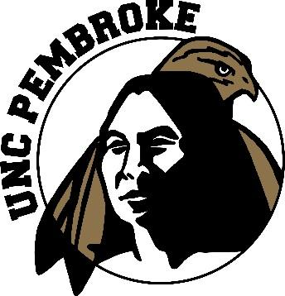

UNCP Summer Camps 2022 Registration Form

Junior Braves / June 20 – 24 Missions to Mars / July 18 – 22

(Grades 1-5) (Grades 5– 8)
Registration fee: $150 Free: Limited to 50 students

All Sports Camp / June 27 – July 1 G-Camp: “Wizard of Oz” July 25-29

(Grades 1 -5) (Grades 1-8)
Registration fee: $150 Registration fee: $150

3D Printing Camp / June 13 – 17
(Grades 9-12)
Fee: $150

Agriculture Leaders Institute for American Indian Youth / June 27 - July 1

(Grades 9-11 )
FREE: Limited to 20 students

Please complete this application and return to the UNCP Office for Regional Initiatives, 115 Livermore Drive at COMTech in Pembroke. Or you may fax to (910) 775-4005. For questions, call (910) 775-4000.

Child’s Name: ______________________________ Parent/Guardian Name:________________________________

Address: ____________________________________________________________

Home Phone: ________________________________________________________

Email (if available): ___________________________________________________

Age: _______ Date of Birth: ___________ Gender: ________ T-Shirt Size: __________

Grade you are presently in: ________ How did you hear about the Camp? ___________________________

* Make checks payable to:
Office for Regional Initiatives

(There will be a service fee of $25.00 for returned checks)
Method of payment:

Cash *Check

Student’s signature:______________________________________________________ Date: _________________
PARENT/GUARDIAN:______________________________________________________Date:________________
*For the 2022 Summer Camp refund policy visit: www.uncp.edu/rc - Summer Camps

