ENG3460: Aspects of the English language

Hybrid Format: MW (f2f): 9-9:50am, F (Online: Asynchronous)

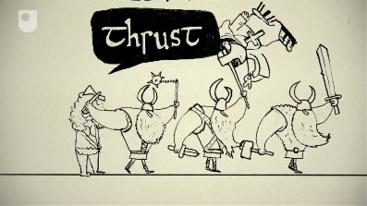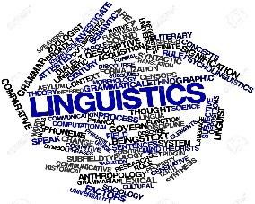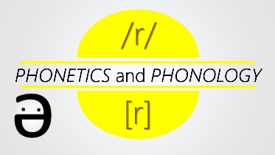

- Interested in how sounds, words,
and sentences are put together in the English language?
- Interested in how speakers organize a conversation so that they sound appropriate for different social contexts?
- Interested in the historical development of the English language?
- Interested in becoming an English or ESL teacher and would like to score high on Praxis in ELA or ESL (or both!)?
- Interested in pursuing a Minor in TESOL or obtaining an ESL add-on licensure?
Then, you should consider taking Aspects! Core assignments include, but are not limited to, small and large-scale linguistic analyses examining word parts, describing rules that govern sentence and discourse organization, and observing and reflecting on your own day-to-day language use. For questions, please contact Dr. Eun Hee Jeon (eunhee.jeon@uncp.edu)

