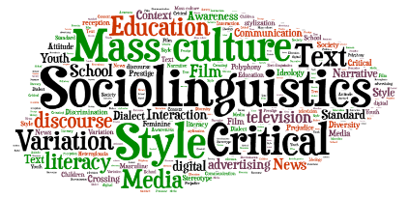
ENG3250: Language and Society

(F2f: TR: 11-12:15)
- Want to find out how social variables such as socio-economic status, ethnicity, gender, sexuality, or regional background of the speaker affects language use?
- Want to find out how linguists bring long-lost Native American languages back to life?
- Want to learn about the linguistic aspects of the Civil Rights movement by reviewing historical court rulings?
- Want to find out how linguistic evidence is used for criminal investigation?
- Interested in becoming an English or ESL teacher and would like to score high on Praxis in ELA or ESL (or both!)?
- Interested in pursuing a Minor in TESOL?
Then, you should consider taking Language and Society! Core assignments include, but are not limited to quizzes, discussion, and a research paper which investigates a topic of your interest within the realm of sociolinguistics. For questions related to this course please email Dr. Danielle Chilcote (Danielle.Chilcote@uncp.edu).

