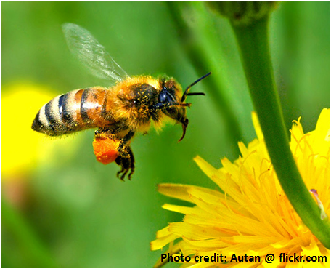
KIDS IN THE GARDEN

SUMMER BEE CAMP 2022
STEM program for
Middle/ High School Students
at the University of North Carolina of Pembroke

The Kids in the Garden program, funded by Burroughs-Wellcome, is a STEM program for rising 6th – 12th grade students from Bladen, Cumberland, Richmond and Robeson Counties as well as the surrounding area to investigate the mysteries of bees and the importance of pollen and pollinators in the environment. Students who participate in the program experience STEM related content to its fullest extent! Students conduct experiments in a science laboratory, take field trips to research facilities such as the Bahr lab, visit a commercial bee operation and an organic farm, go to Sampson’s Landing and the Lumber River Conservancy and visit the UNCP Campus Garden & Apiary. Snacks, supplies, transportation, activity fees, and equipment used during the program are provided. Parents are responsible for transportation to and from UNCP. Applications will be accepted January – May 2022.
The two-week summer camp experience called the “bee camp” will occur from June 20th to July 1st, 2022, Monday through Friday, 9:00 AM – 4:00 PM (lunch and snacks provided). For additional information please contact Dr. Rita Hagevik at rita.hagevik@uncp.edu
APPLY ONLINE AT https://www.uncp.edu/departments/biology/kids-garden-program.

