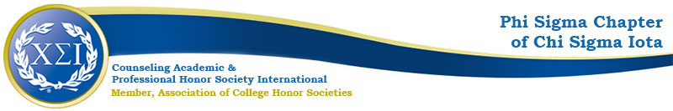

Phi Sigma Chapter Minutes
Tuesday February 2nd 2021
4:30pm

https://uncp.webex.com/meet/Nicole.Stargell
Present:
Nicole Stargell
President
Vice President
Wilmington Liaison

- Welcome!
- Spring Projects
  - Black Lives Matter Workgroup
    - Peace Corps Pres 02/04 & 02/17
    - Waiting for the OSIL results
  - CPCE Study Groups
    - Will work to organize some for this semester
    - Will work to find hosts to take over next year
  - PDAs: The Professional Counselor
    - March— 14th Annual Log-In Conference
      - 03/25/2021
      - Online
      - Keynote: Dr. Ricks
  - Welcome Back Coffee Break
    - March Meeting
    - Wait Until Invitations Are Sent
  - Fundraiser
    - Home Study CEUs
  - ACA / CSI Posters
    - https://www.csi-net.org/page/CSI_Day
    - Due Monday 02/08/21
  - 5th Annual Advocacy Summit
    - Typically combined with the annual NCCA Conference
    - Haven’t seen advertising yet
  - NCCA 02/24-02/27/21 Online
    - https://nccounselingassociation.org/2021-annual-conference/
  - Induction
    - April 27th 2021 6-7:30pm
    - Online
    - Speaker: Dr. Victoria Kress
    - Speak in classes to invite new members

Action Items:
- Dr. Stargell will send a doodle poll over the listserv for the best meeting day and time
- We will talk to students in classes this month
- Dr. Stargell will advertise the Coffee Break, the Drive-in, and the Induction
- President will contact people who were involved last semester and with the practicum students this semester to see times and dates that work best

