The Faculty Evaluation Review Subcommittee shall review the Faculty Evaluation Model regularly and strive to clarify the existing document. The subcommittee shall make recommendations to the Faculty and Institutional Affairs Committee regarding any changes in the written document and shall respond to all requests for alteration of the document or its underlying philosophy.

The subcommittee shall consist of seven members. Each division will be represented on the subcommittee, and there will be one at-large member. At least two of the faculty appointed each year must be tenured. The At-Large member must come from a department not already represented. The subcommittee meets on the First Monday of the Month.

Minutes
Faculty Evaluation Review Subcommittee
February 2, 2021 3:30PM
https://uncp.webex.com/meet/rachel.smith
Join by phone
+1-415-655-0001 US Toll
Access code: 739 591 491
Members:
Anthony Johnson (Letters to 2022), Camille Goins (Education to 2021), Tracy Vargas (SBS to 2022), Jessica Dupuis (ARTS to 2021), Rachel Smith (Chair, NSM to 2021), Larry Arnold (At large to 2022), Jonathan Ricks (CHS to 2021)

Members not in attendance: Tracy Vargas (SBS to 2022)
Guests: Dr. Liz Normandy, Professor and Associate Vice Chancellor of Planning and Accreditation
Dr. Aaron Vandermeer, Chair and Associate Professor, Department of Music, Dr. Alice Locklear, Associate Professor, Department of Social Work and Dr. Polina Chemishanova, Associate Professor and Director of Composition

- Call to Order
The meeting was called to order at 3:31pm.
- Adoption of the Agenda
The agenda was adopted.
- Approval of Minutes from November 3, 2020
The minutes of the November 3, 2020 meeting were approved as circulated.
- Chair’s Report
The Chair welcomed two new committee members, Larry Arnold and Camille Goins.

There was no progress from the Provost on delaying probationary review. This item will be revisited at the next meeting.

The PTR changes approved at our last meeting have not advanced because the FIAC meeting was cancelled and the Chair resigned. Rachel will be forwarding this item to the new Chair of FIAC, Maria Pereira. Hopefully, it will be voted on at the February FIAC meeting.
- Old Business
The subcommittee reviewed the responses that were submitted from the Survey of Chairs re: Spring SEI’s in annual evaluation (Appendix A). Based on the results, if the Chairs annual evaluations were delayed, we would need to find some of kind of compensation for them and it led the subcommittee to discuss completing SEI’s every semester.

The Chair shared and reviewed the proposal for revision of the annual evaluation calendar. The Chair will make concrete changes to the language on the revised calendar for us to consider at the next meeting. The Chair noted, it would be beneficial to have some understanding of when and how the University administration will move written evaluations to online evaluations, so we can change the language in the faculty handbook.

Dr. Vandermeer had recommended making an online student evaluation of instruction implementation committee at our previous meeting. The Chair presented language for the recommendation to the subcommittee. After reviewing the language, the Chair called for a vote. The recommendation passed unanimously via a voice vote. The Chair will forward the recommendation to FIAC.
Based on the recommendation of the Academic & Information Technology, which was accepted by the Faculty Senate in Spring of 2019, the Faculty Evaluation Review subcommittee recommends that the Faculty Senate create a Special Committee tasked with implementing the conversion of all student evaluations of instruction (SEI) to the online format.

- New Business
Dr. Vandermeer proposed revising the PEC Nomination form (Appendix B). The changes proposed would ensure that there is communication between the Chair of the Department and the faculty member who is being evaluated and that faculty on the PEC are eligible and willing to serve. The Chair called for a vote to approve the changes in Appendix B. There was a unanimous voice vote to revise the PEC Nomination form. The Chair will present it to FIAC.

Expectations for P&T due to COVID, non-tenure stream evaluations expectations, and evaluation procedures for Assistant/Associate Deans will be addressed at the next meeting. Prior to the next meeting, the Chair will follow up with Scott Billingsley about expectations for P&T due to COVID.

- Announcements
Next meeting: March 2nd, 2021 at 3:30pm via Webex
- Adjournment
The meeting was adjourned at 4:58pm.

Appendix A: Responses to Survey of Chairs re: Spring SEI inclusion in annual evaluations
FERS Survey of Department Chairs
January 26th 2021, 7:45 am EST
Q1 - It is important that faculty in my department can view the results of their student evaluations of instruction (SEI's) prior to submitting their annual evaluation.
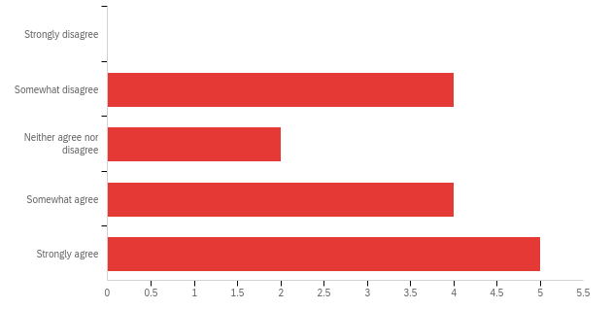

Q4 - Delaying the deadline for Chair's annual evaluation reports until after the end of the Spring semester would allow me to give them the time and attention necessary.
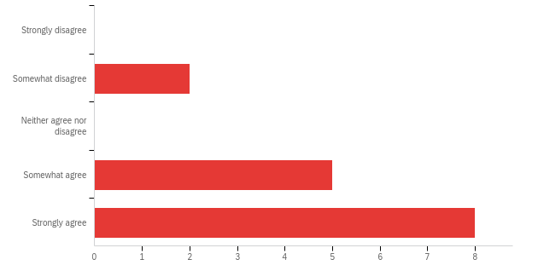
Q5 - Delaying the deadline for Chair's annual evaluation reports to June 1 would require me to work during a time I am not compensated or under contract.
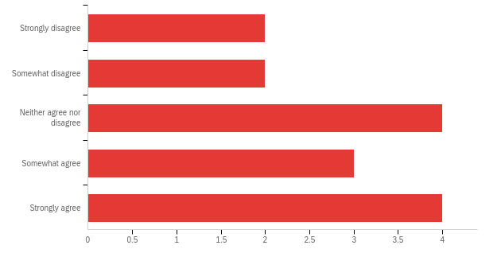

Q6 - It is important that my faculty's annual evaluations include at least one semester of SEI's each year.

Q7 - It is important that the SEI results which are included and discussed in my annual evaluation report are evaluating instruction during the current academic year (and not the preceding academic year).
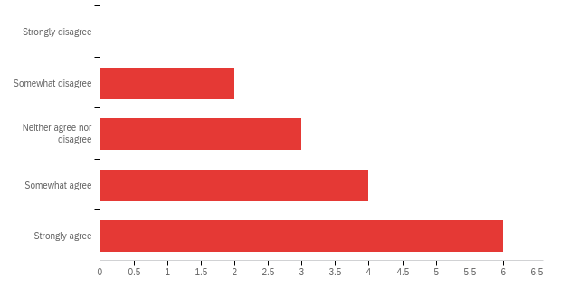

Q8 - All faculty should be evaluated in each course every Fall and Spring semester?
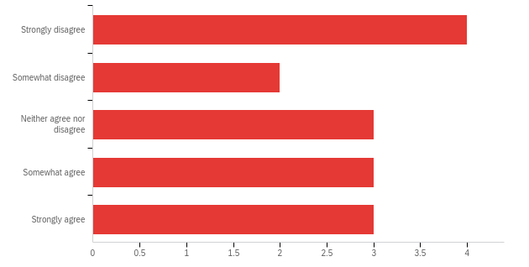
Q9 - Faculty members should have 10 days from the day their SEI results are available to them to submit a rebuttal to their annual Chair's evaluation report.
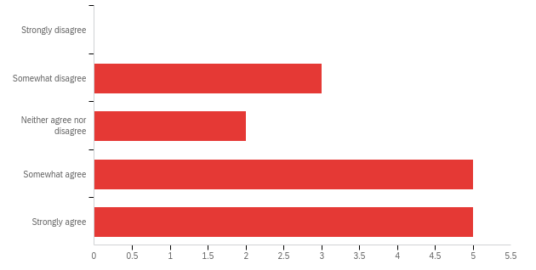
Q11 - Currently in my department:
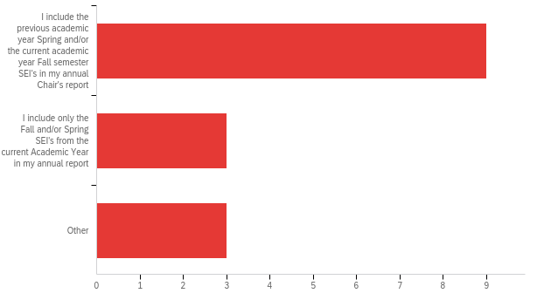
Other:
- I used to do the first, but then was told I couldn't do that when Jeff took over as Dean. My evaluations were returned and I was told to rework them so they conformed to the second choice.
- first year as chair so I don't know yet
- My first year; don't know
Q10 - Please give us any other information or feedback you believe would be helpful to us in our effort to make SEI inclusion in annual evaluations of your faculty more equitable.
Please give us any other information or feedback you believe would be helpful to us in our effort to make SEI inclusion in annual evaluations of your faculty more equitable.

- Having SEIs for every semester means that there is a better basis of evaluation if we have some unusual circumstance (which seems to be more and more of the norm), i.e., massive disrupting hurricanes or pandemics that disrupt the semester.
- SEIs are most useful in the aggregate, to follow trends. So holding them every semester makes them more useful, particularly since the much lower rate of response for online SEIs means we will need to work harder to gather sufficient data.
- Getting the paper reports to faculty before they left for the summer was one of the challenges we had with including the SEI data from Spring with a current report. That problem is somewhat ameliorated by the online portfolio system, thought I wouldn't underestimate some faculty members resistance to being asked to read and respond to their report when they are "off contract."
- I have never understood why all the evaluation material due dates are stuffed into the end of the Spring semester, a very busy time. No administrator could ever give a real reason (the faculty handbook says so is not a real reason). There is always other department business that spills after the end of the semester (e.g., budgets) too.
- It's not a problem. I make sure to observe teaching in the semester they are not being evaluated. Some faculty pull quotes from student emails that came during that academic year. Some pull quotes from course-evaluative assignments. I see every syllabus in my department before the secretary photocopies them for the classes. I see work-product from the classes in a highly visible program. I suppose if I had low-performing faculty I would feel differently. I take the couple of disgruntled students that someone might have, with a grain of salt; a teacher can't please everyone.
- Thanks for asking. I didn't quite know how to answer the first question. It is important to me that faculty members evaluated in the fall receive their SEIs as soon as possible after final grades are submitted. It is not important to me that faculty who are evaluated in the spring see their SEIs before they write their self evaluations. SEIs are only one small part of self evaluation for the academic year.

Appendix B: Review PEC Nomination form

Peer Evaluation Committee Nomination and Appointment Form

Current Academic Year _______________ Department __________________________
Faculty Member's Name ___________________________________________________

Nominate three faculty members. Please consult the appropriate section of the Faculty Handbook for eligibility criteria

a) _____________________________________________

b) _____________________________________________

c) _____________________________________________

Assured nomination. From the names appearing above, enter the name of the one individual whom you wish to be nominated automatically to the Peer Evaluation Committee.

________________________________________________________

____________________________ __________________________________________
Date Signature of Candidate

To be completed by Department Chair:

I appoint the following faculty members to the PEC. I have confirmed that they are eligible and willing to serve.
:

a) _____________________________________________

b) _____________________________________________

c) _____________________________________________

____________________________ __________________________________________
Date Signature of Department Chair

