Quick Start Guide

www.chromeriver.com

Table of Contents
Chrome River EXPENSE: Quick-Start Guide 2
Launching and Logging in to the Chrome River Application 2
Creating a New Expense Report 3
Attaching Receipt Images 6
Upload PDF or JPEG Receipts 6
Submitting a Report 7
Policy Compliance Warnings & Violations 8
Report Tracking 9
Inquiry Reports 9
Expense Approval 10
Approve Online 10
Approve or Return by Email 11
Creating a shortcut on your phone for quick access 12

Chrome River EXPENSE: Quick-Start Guide
This guide will give you the basics needed to hit the ground running with Chrome River EXPENSE. Detailed user guides are available in the Chrome River Help Center, accessible via the “Help” link in the upper right-hand corner of the application.

Launching and Logging in to the Chrome River Application – Now on single sign on through the UNCP website Quick Links:

Launch the Chrome River application from any web browser www.uncp.edu and selecting Quick Links and Chrome River. You will supply the single sign on portal your network user name and password just as you do when you log into your pc in the morning.
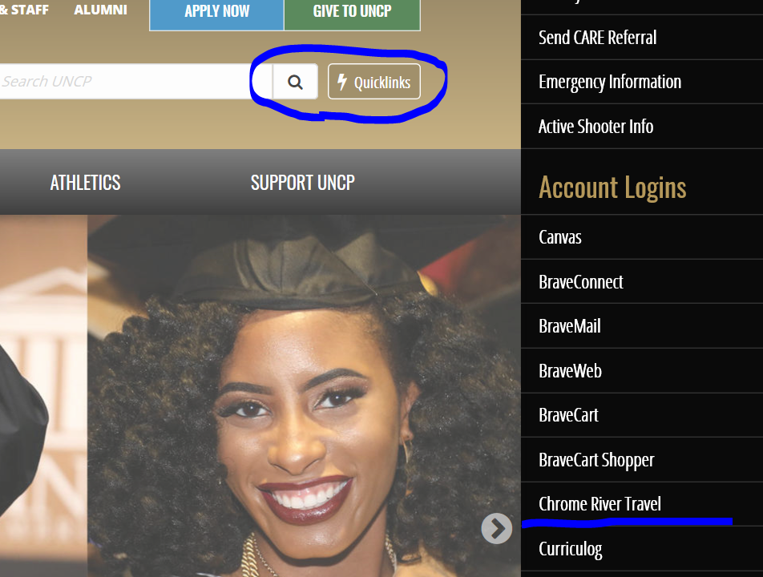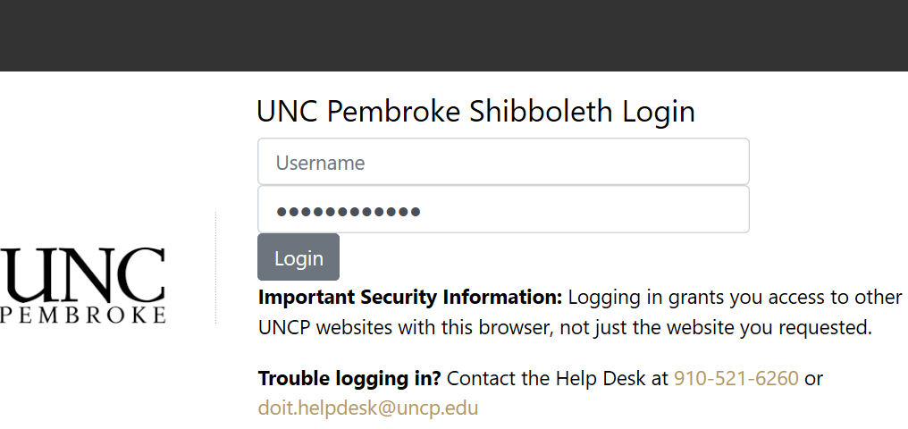

Creating a New Travel Authorization (Pre-Approval Report)
A new travel authorization is called a Pre-Approval in Chrome River and can be created for each new event.
- From the Home Dashboard click on the + sign in the top right hand side of the screen. Choose New Pre-Approval Report
- Enter the travel information and allocation coding and then click on Save at the top right hand of the screen.
- From the pre-approved travel type icons select your necessary items and add their details
- When all expense types for the Pre-Authorization Report have been added, click on SUBMIT at the bottom of the form.

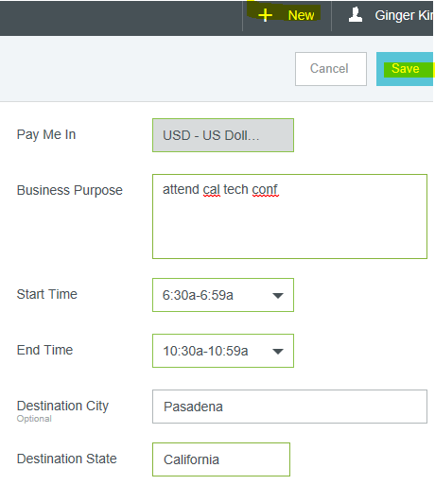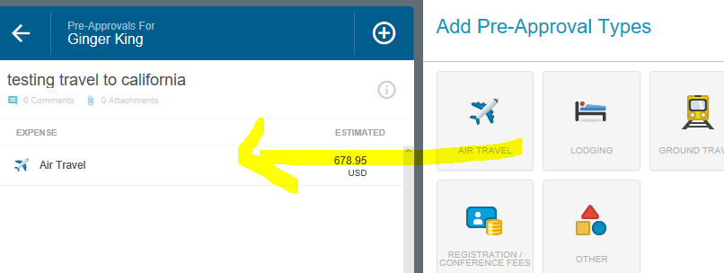

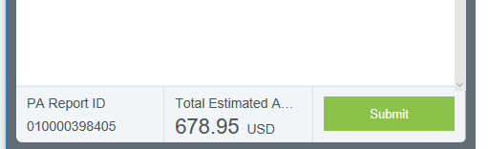

Creating a New Expense Report
A new expense report can be created for each event, or events can be combined into a single report. From the Home Dashboard or the Expense Dashboard, click the NEW EXPENSE REPORT button. The Expense Entry Screen will appear
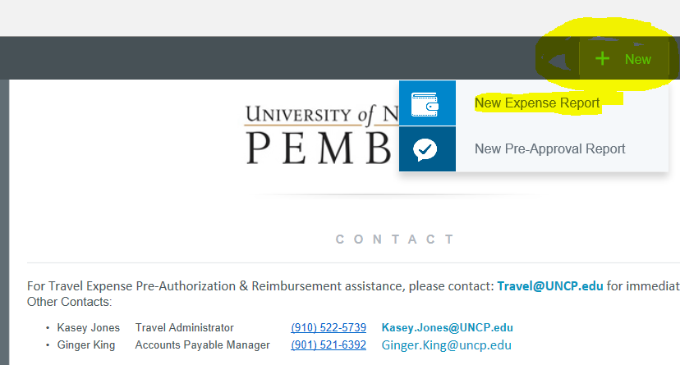
  - The Expense Header section stores all the basic information that applies to every expense listed on the report. Once you have filled out the form click save at the top right of this form.
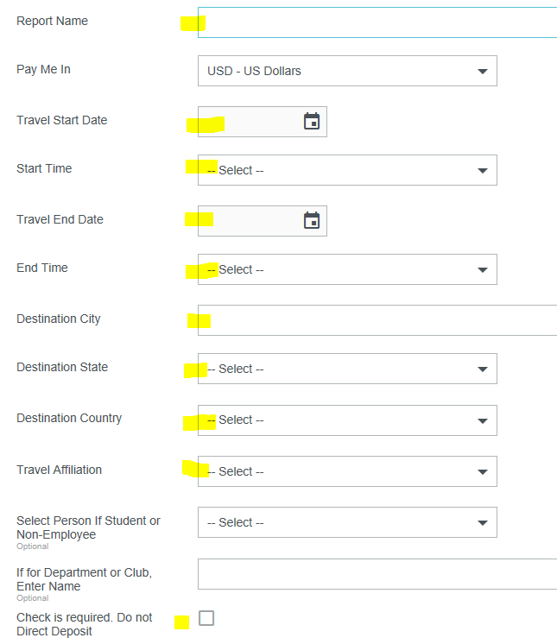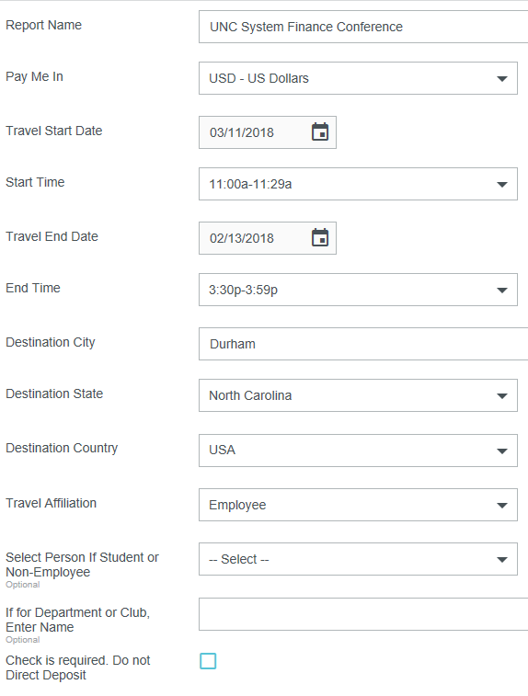
- For your first expense line item, click on the icon button to the right that shows the options for adding expenses. There are two main ways expenses are added:
  - Manually Created – Click on the icon to the right for the expense type you wish to add
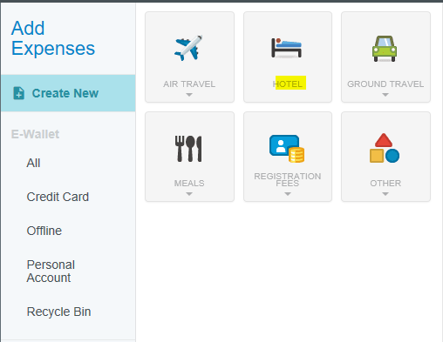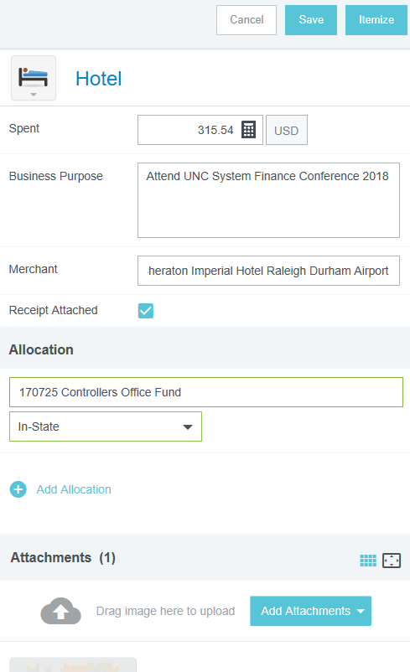
*Itemize expenses as the system prompts you.
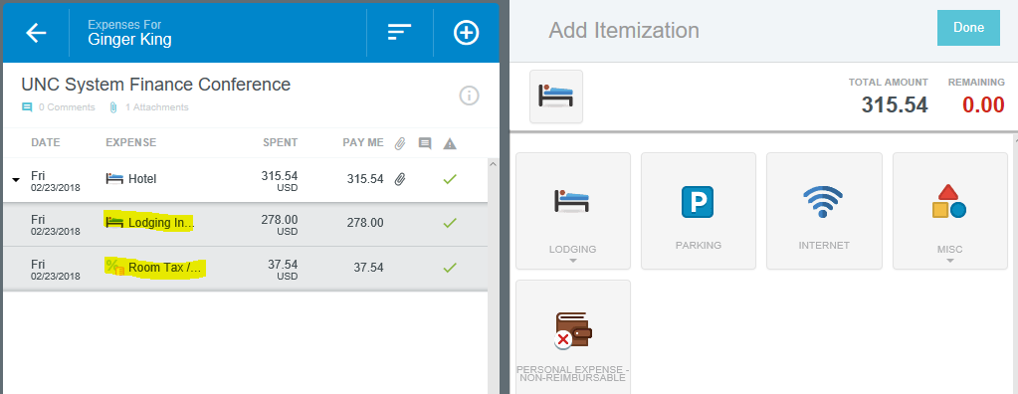

  - Credit Card – Transactions are loaded daily and are available to apply to your expense report from your E-Wallet. Simply choose any pre-loaded transaction and check the box to the right of it (or multiples) to add them to your expense report. Check the amounts and expense allocations then save. 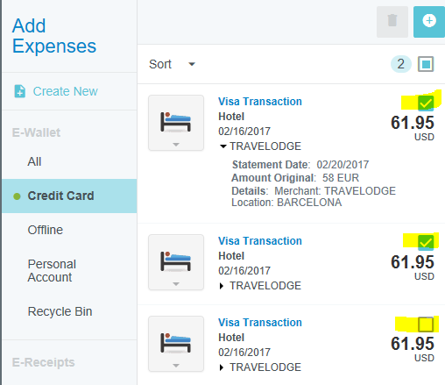

- In the preview pane on the left side of the screen, you can see a summary of the expenses you have added and add notes, receipts and items to your expense report.

Attaching Receipt Images
Receipt images may be uploaded as a PDF, JPG, or GIF, to be immediately attached to your expense report.

Upload PDF or JPEG Receipts
If you choose to upload PDF receipts, the maximum size for a single upload is 5 MB, and the combined size of all the PDF, JPG, or GIF uploaded must be 100 MB or less.
- From Within the Expense Report: On the Expense Entry Screen, click on the RECEIPTS. Click on Browse File to Attach to attach your images file(s).
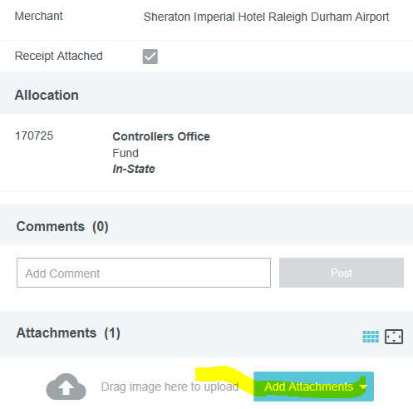

Submitting a Report
- To submit an open expense report, click SUBMIT in the lower right-hand corner of the Expense Entry Screen.
- To submit the expense report from the Draft Expenses List, highlight it in the grid on the Expense Dashboard. Click SUBMIT in the navigation bar.
- After the expenses have been added to the report, click SUBMIT if you are done and choose to match the expense to the Pre-Approval that was done for it. Or click SAVE/CLOSE to be taken back to the Expense Dashboard. 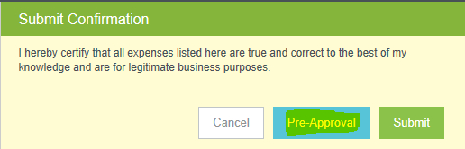

After you click SUBMIT, you will be prompted to certify that the expenses are correct and for legitimate business purposes.
- Clicking SUBMIT again will send the report to the first step in the approval routing process.

Policy Compliance Warnings & Violations
A breach of policy will trigger a warning or violation message when you click SUBMIT.
- A compliance warning indicates that additional information is required before the expense can be submitted for approval and processing. Click on the red warning symbol and either modify the data or enter a reply. Then click SAVE to proceed.
- A compliance violation indicates that the expense cannot be submitted for approval and payment based on the company’s policies as defined in the system. Click CANCEL on the Submit screen, make any required changes, and select CLOSE or SUBMIT again.

Report Tracking
Once the expense report has been submitted, it will appear in the Submitted Expense Reports list. From here, you can track its progress through the approval routing process by highlighting the report and clicking TRACKING.
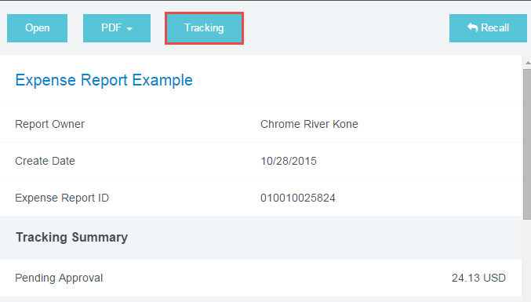
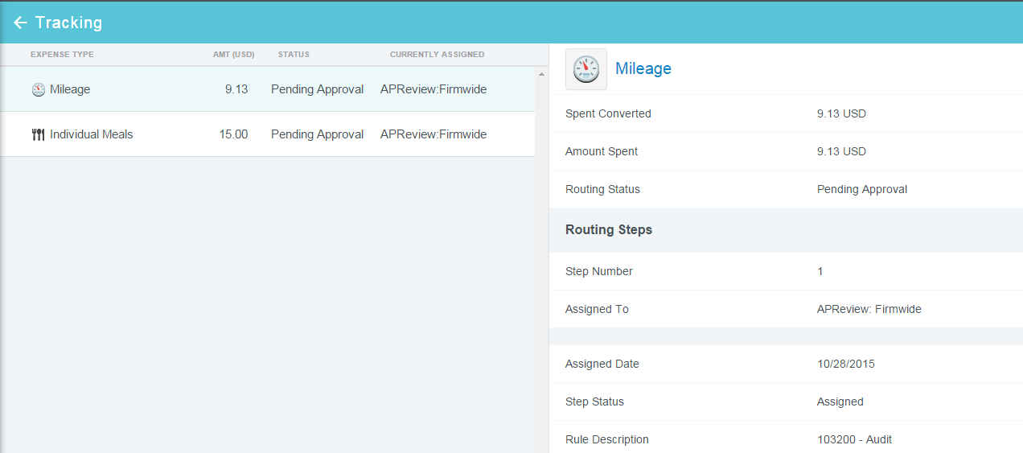

Inquiry Reports
The Inquiry Dashboard allows you to create reports and perform quick inquiries on all your activity by category: expense reports, expense items, delegates, calendar, credit card items, firm-paid items, approvals and paid expenses.
- Click on INQUIRY from any Dashboard.
- Under the Reports tab, select the report you would like to generate.
- Select the criteria for the report
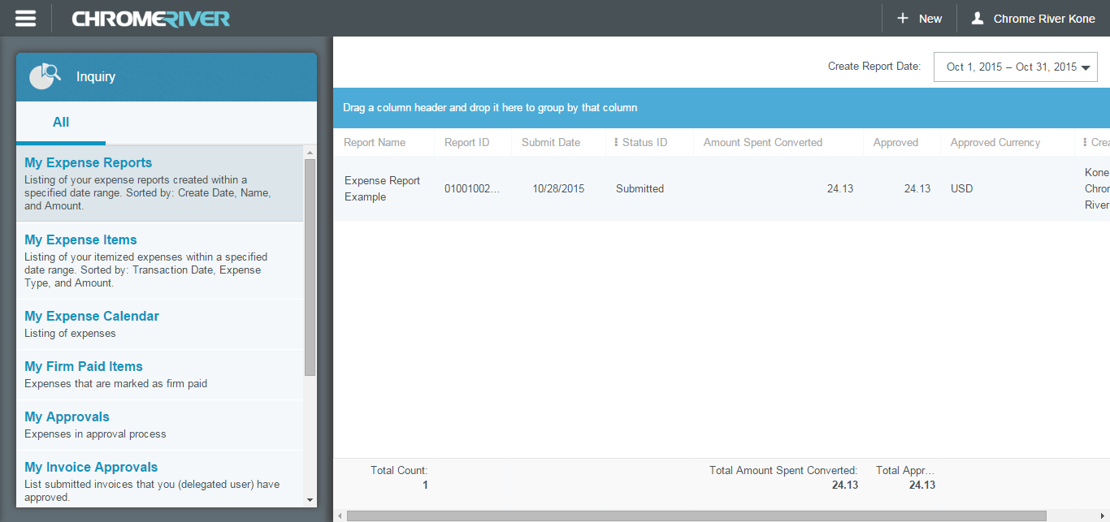

Expense Approval
If you are part of the approval process, Chrome River EXPENSE makes this very important task easy by allowing you to approve expenses online, by email, or via the mobile app. The first two methods are covered below; mobile app approval will be covered in the Mobile Expenses section.

Approve Online
- Log in to Chrome River EXPENSE and navigate to the Approval Dashboard.
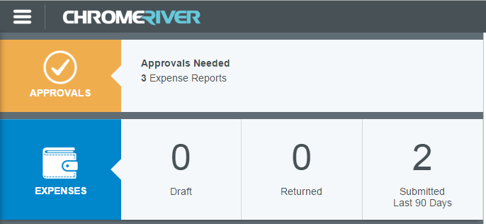
- The Approval screen shows all the reports waiting for your approval. Highlight an expense report and click OPEN to review it.
- The Expense Approval Screen lists each line item that requires your approval on the left and provides expense details, notes and receipt images on the right.
- You can review, adjust, or return each line item individually by highlighting it in the list.
  - Clicking ADJUST will open the expense item so that you can change the approved amount, business purpose, and/or cost center. You may also add a note.
  - Clicking RETURN will send the expense item back to the expense owner.
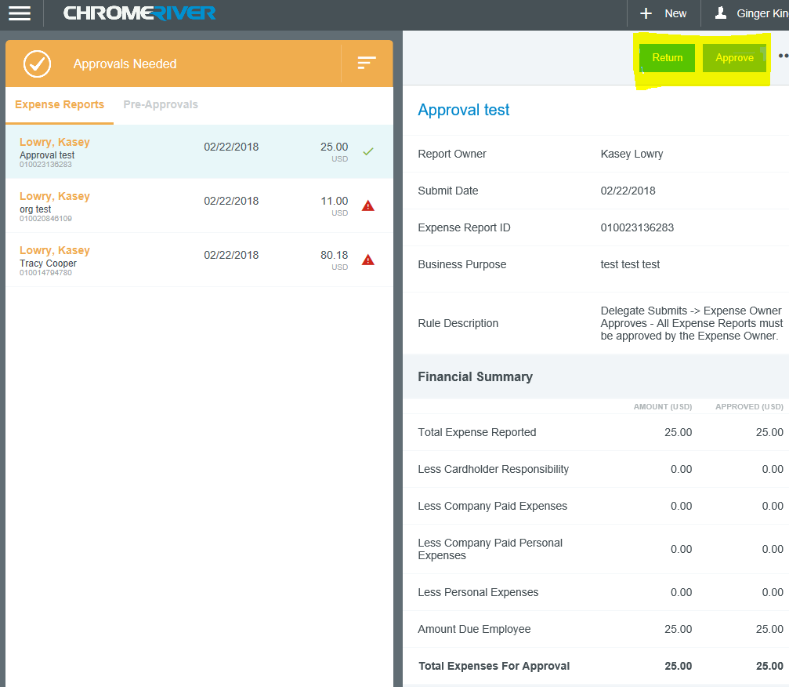

- When you have finished reviewing the expense, click SUBMIT to pass the approved expense line items on.
- Clicking RETURN REPORT will send the entire expense report back to its owner. You will be required to provide an explanation and click SUBMIT again.

Approve or Return by Email
Chrome River will email you expenses that require your approval. You can only approve or return them with notes via this method—any adjustments must be made in Chrome River online. (Please excuse the fact that fictitious receipts were used for examples so they do not match the report)
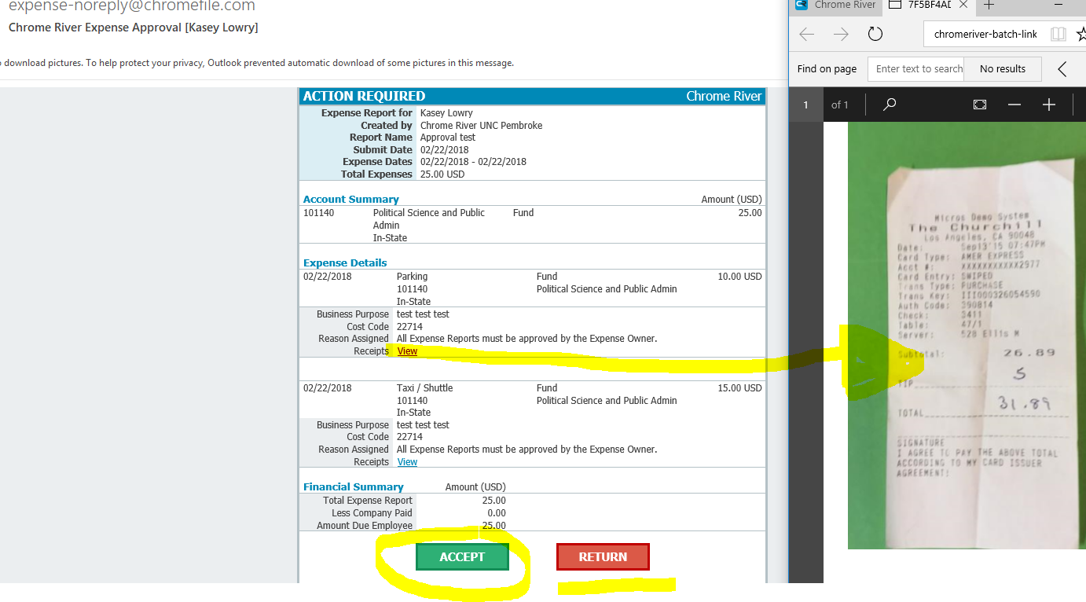
- Forwarding the email to approve@chromefile.com is equivalent to clicking SUBMIT in Chrome River EXPENSE online.
- Forwarding the email to return@chromefile.com is equivalent to clicking RETURN ALL in Chrome River EXPENSE online.
If you receive approval emails in HTML format, you can approve or return expenses by clicking the green ACCEPT button or the red RETURN button in the email itself.

Using Chrome River on your phone for quick access

Simply go to the www.uncp.edu Quick Links to log in.

