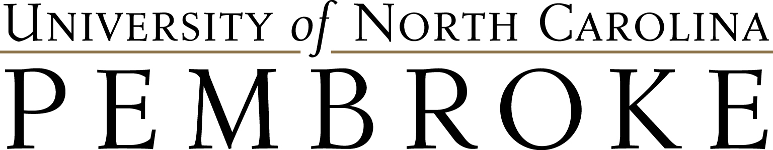

Safeguarding Our Natural Heritage
Youth Program

Sponsored by the United States Department of Agriculture’s Animal and Plant Health Inspection Service (APHIS) and the University of North Carolina at Pembroke

Date: July 12-16, 2021 Location: Virtual Camp

About the Program:
- The free week long virtual program is seeking 20 American Indian high school students who are rising freshmen, sophomores, juniors and seniors that have an interest in science, technology, engineering, and mathematics (STEM), as well as agriculture, veterinary, plant, food, environmental sciences, and natural resources, wildlife biology, and related fields.
- The intensive program will be held virtually through UNC Pembroke.
- The program will expose students to STEM and related fields, the college environment at UNC Pembroke, and American Indian history and culture, as well as potential career opportunities for college graduates in the tribal community and with the USDA-APHIS.

About UNC Pembroke:
- Located in Pembroke, North Carolina, UNC Pembroke was founded in 1887 to train Lumbee Indian teachers. Between 1939 and 1953 it was the only state-supported four-year institution for American Indians in the United States. Designated North Carolina’s historically American Indian university in 2005, UNC Pembroke is today the leading institution of higher education for American Indians of the eastern United States.

Application Deadline: Tuesday, June 15th, 2021, no later than 5 p.m.

Return completed application to:
- 1) Email to mary.locklear@uncp.edu or myia.reyes@uncp.edu; 2) mail to Southeast American Indian Studies Program, UNC Pembroke, PO Box 1510, Pembroke, NC 28372; 3) hand deliver to UNC Pembroke, Old Main, room 204 (Southeast American Indian Studies); or, 4) Indian Education YDS staff
Additional Information:
- Web: https://www.uncp.edu/sonh
- Mary Beth Locklear, Director of Regional Initiatives, Outreach Department
Email: mary.locklear@uncp.edu | Phone: 910.775.4020
- Myia Reyes (Lumbee), Interim Program Coordinator, Southeast American Indian Studies Program | Email: myia.reyes@uncp.edu | Phone: 910.775.4663 | Fax: 910.522.5795

SONH Program Application

Student’s Full Name: _______________________________________ Preferred:
Parent/Guardian’s Name(s):
Mailing Address:
City: State: Zip Code:
Physical Address (if different):
City: State: Zip Code:
Parent/Guardian’s Home Phone: Cell: Work:
Parent/Guardian’s Email (if available):
Student’s Email: Student’s Cell:
Student’s Age: ____ Date of Birth (MM/DD/YYYY): ________________ Gender:
Student is a: ( ) rising freshmen, ( ) rising sophomore, ( ) rising junior, ( ) rising senior
High School: ________________________________ GPA: ______ T-Shirt Size:
Tribal Affiliation(s):
Are you participating in other summer programs this year? If yes, please list the name, date, and location of the program(s):
Will you be needing an iPad loaned to participate in the program? Yes ___ No ___

Please include the following:
- Copy of current high school transcript
- Brief biography (no more than 250 words)
- Short essay: Why are you interested in this opportunity? (no more than 250 words)

Contract
I __________________________________________________ (student’s full name) promise to abide by the rules and regulations, which govern the Safeguarding Our Natural Heritage Youth Program, and to make proper use of the educational advantages offered. If, for any reason, I violate any part of this contract, I acknowledge I may be dismissed from the Safeguarding Our Natural Heritage Youth Program.

Student’s Signature Date Student’s Printed Name

Parent/Guardian’s Signature Date Parent/Guardian’s Printed Name

Participant Conduct and Photo Release

The Safeguarding Our Natural Heritage Youth Program (SONH) seeks to engage participants with interactive, fun, rewarding, and safe learning experiences. UNC Pembroke makes reasonable accommodations for participants with disabilities. Every effort will be made to assist with any special needs.

Participant Conduct

UNC Pembroke believes it is important that participants act in a respectful manner toward other participants and staff. Consequently, there are certain standards and expectations to which participants must be held. The program’s goal is to promote strong morals, responsibility, and respect for self, culture, other program participants, and the environment.

Capturing Participant’s Smiles

Throughout the program, UNC Pembroke’s University Photographer and others may photograph and/or record program participants. Photos and videos may be used for publications, advertising, social media, and promotional materials. Please indicate your preference for the use of photos/videos of your child for promotional purposes by adding your initials to the desired line.

_____ I give permission to UNC Pembroke and the Southeast American Indian Studies Program to use photographs/videos of ____________________________________ (student’s name) while attending the SONH.

_____ I do not give permission.

Parent/Guardian’s Signature Date

Parent/Guardian’s Printed Name

