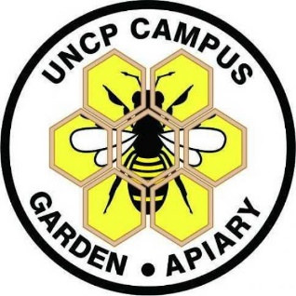
APPLY NOW – 25 STUDENTS WILL BE ACCEPTED TO THE PROGRAM
KIDS IN THE GARDEN
Apply online at - https://www.uncp.edu/departments/biology/kids-garden-program
The Kids in the Garden program (KIG), funded by Burroughs-Wellcome, is a STEM program for students to investigate plants, horticulture, pollinators, the mystery of colony collapse in honey bees, and engineering as it relates to growing food at the UNC Pembroke Campus Garden and Apiary and vicinity.
Students who participate in the program experience STEM related content to its fullest extent! Students conduct STEM experiments in a university laboratory and conduct research in agriculture in the field. Participants will take local field trips to the Bahr Biotechnology lab to see science in action and to a commercial bee operation to learn about the importance of honey bees, pollen, and pollinators. Engineering activities include Mindstorm Legos (make robots and sensors), Makey-Makey, and ozobots. All supplies are provided. Due to COVID the ENTIRE program will be held outside at the Campus Garden and Apiary.
FREE Summer Camp 2021 – for middle and high school students or those CURRENTLY in middle and high school when the program begins. The two-week summer camp experience called the “Bee Camp” will occur from June 21st to July 2nd, 2021.
The bee camp will be divided into two groups:
- A group (morning) from 9:00 AM – Noon with an activity sent home to do in the afternoon
- B group (afternoon) from 1:00 – 4:00 PM with an activity sent home to do the next morning
Even though the camp happens outside, students are required to wear masks at all times.
Are you interested in learning about science, engineering, and technology by doing tons of great science experiments and activities? Do you want to explore careers in science, technology, and engineering? Do you love flowers, insects, to go outside and explore, to learn about bees and beekeeping, and to go on field trips? Do you like to make crafts from natural objects? If so, then, our program is for you!
For additional information please contact Dr. Rita Hagevik at rita.hagevik@uncp.edu or take a look at the Biology Department website: https://www.uncp.edu/departments/biology/kids-garden-program. To apply for the free summer camp go to the Kids in the Garden website and scroll down to the bottom of the page where you will find an online camp application. 24 Students (12 in Group A and 12 in Group B) will be accepted into the program for summer 2021.

