Guide to running and reading a Degree Audit
- Log in to your Braveweb account.
- Click on Banner Self Service.
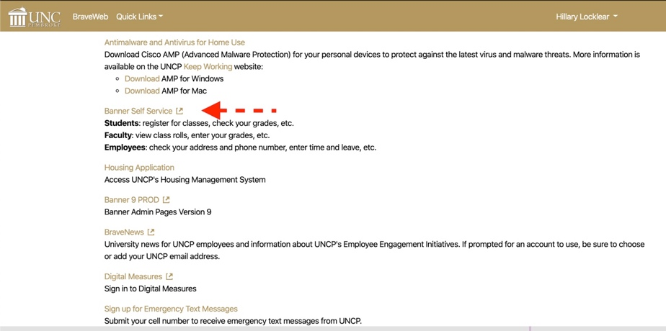

- Click Student or Student and Financial Aid link on the Main Menu Page. 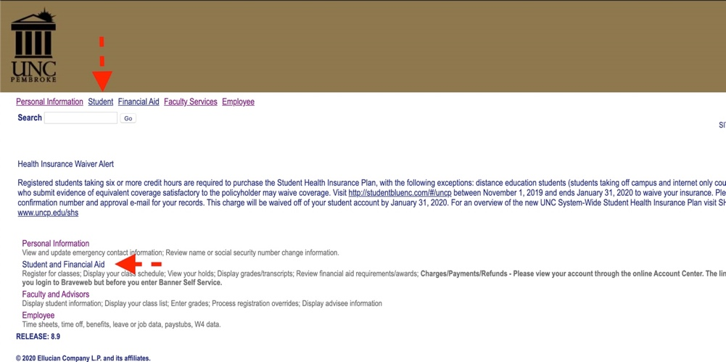

- Next Click on the Student Records link.
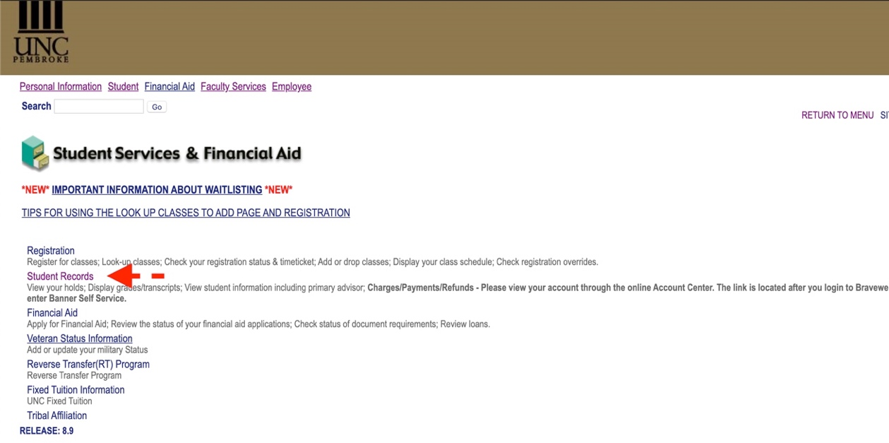
- Click Degree Audit Online Request.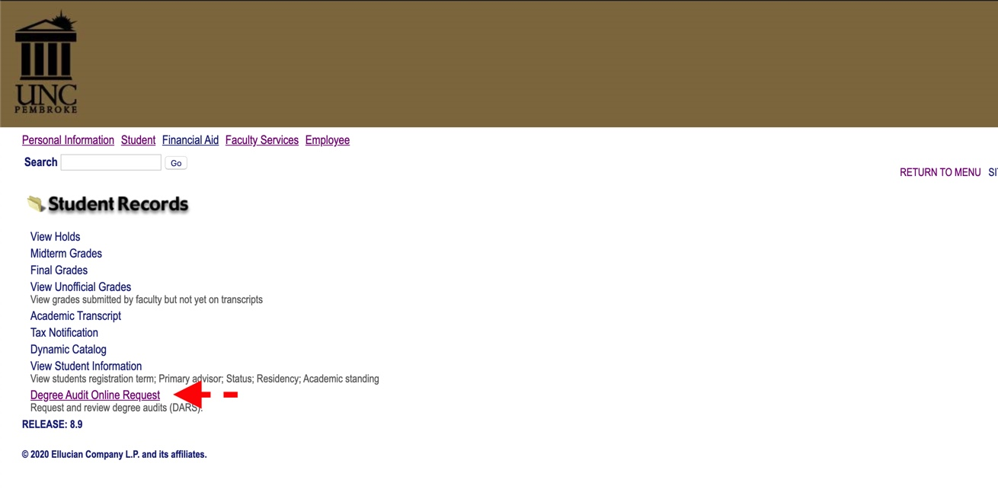
- U Achieve will open in a new window. Log-in using your UNCP login if prompted. Click Request Audit.
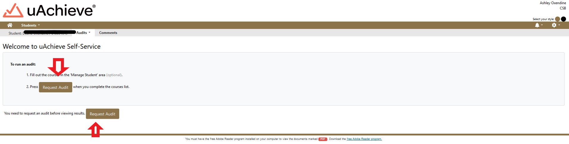

- If you are running an audit on your current degree click Run Declared Program. If you want to change the degree click Select a Different Program (If running a current degree audit skip to step 11.)
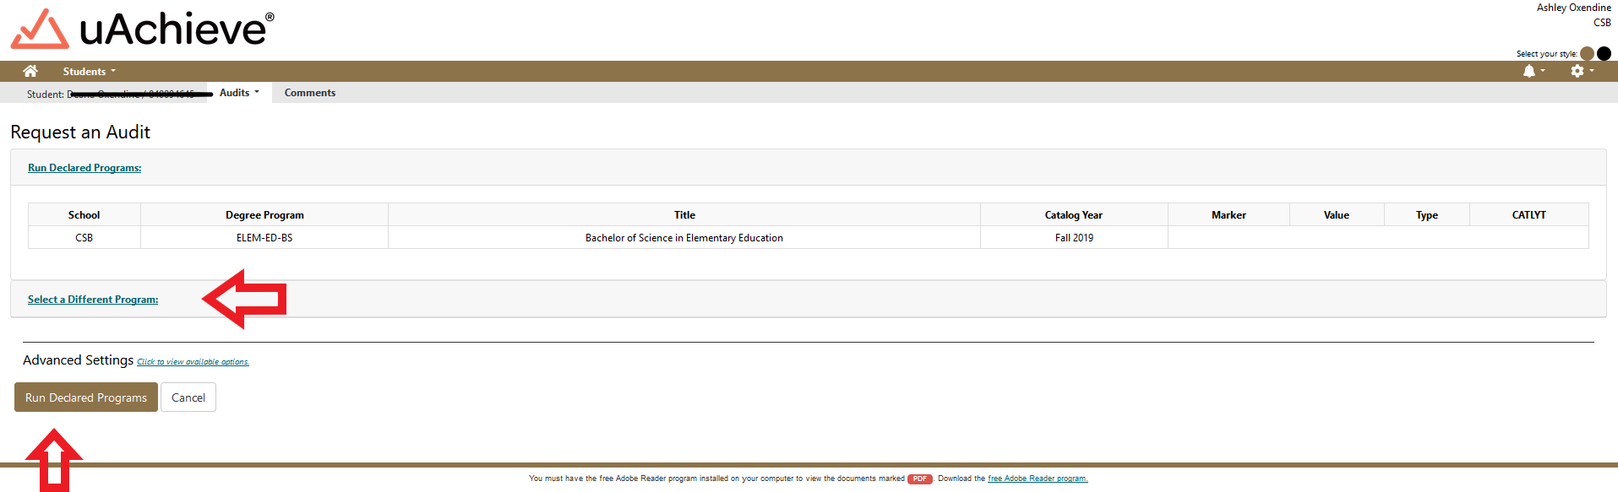

- Select New Program (Major) and Catalog Year from Drop downs.
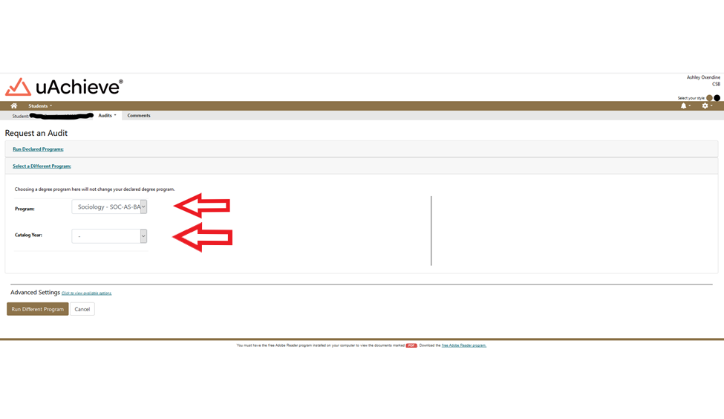

- Click Run Different Program.
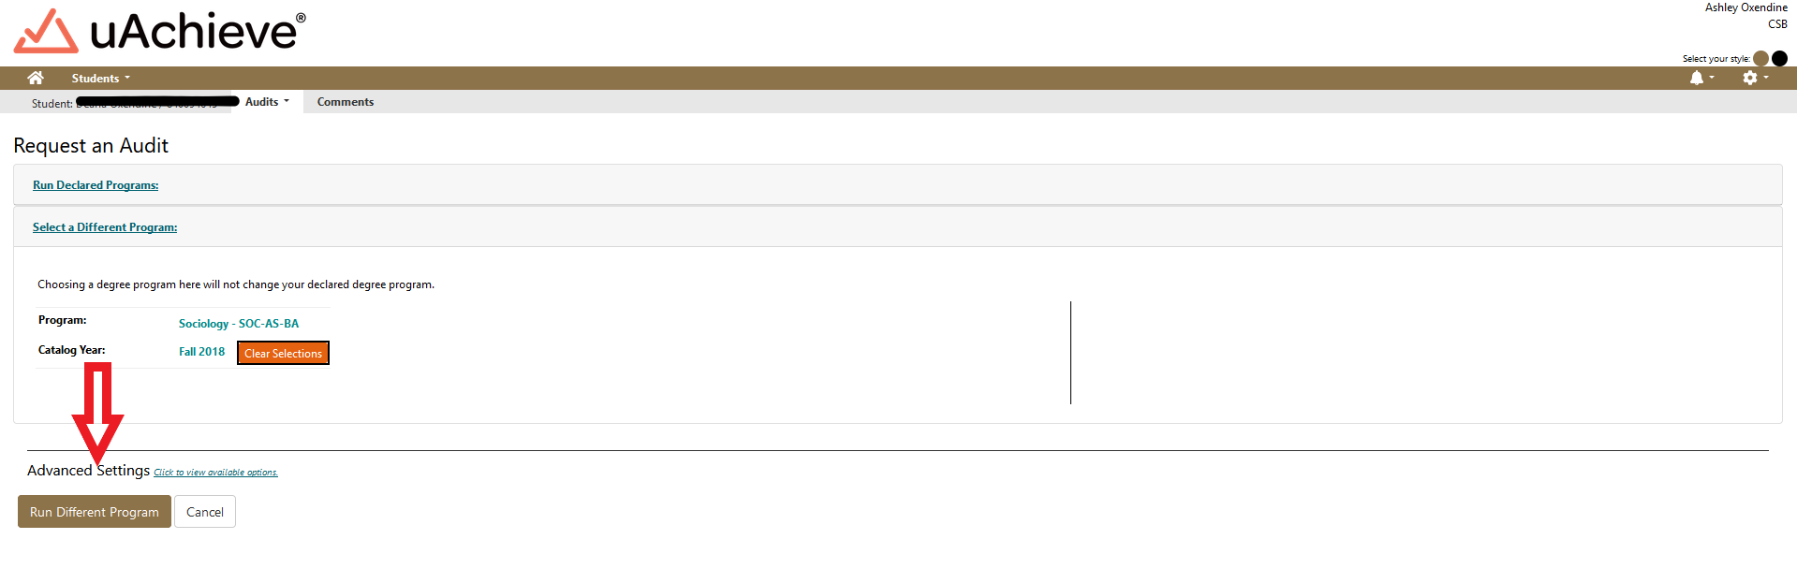

- The Audit will then propagate with the student information at the top that includes your name and Degree at the top Banner ID, Program Code, and Catalog year. 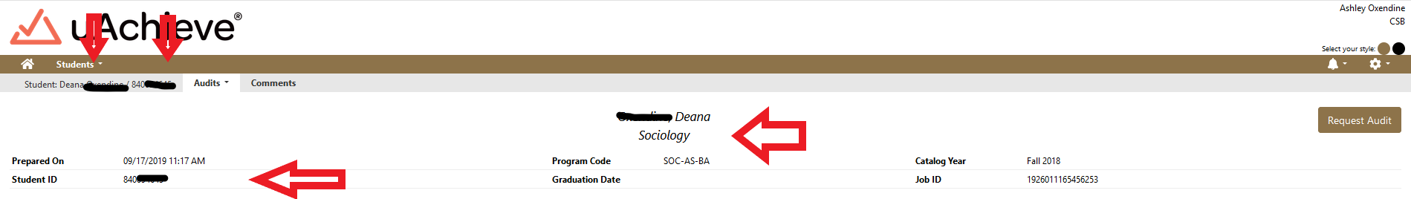

- Below your student information at the top is charts and graphs that represent your progress towards degree completion. There is a legend that is color coded to represent each of the following: complete (green), in progress (blue) and unfulfilled (red). Planned (purple) is located here as well but we do not use this feature.
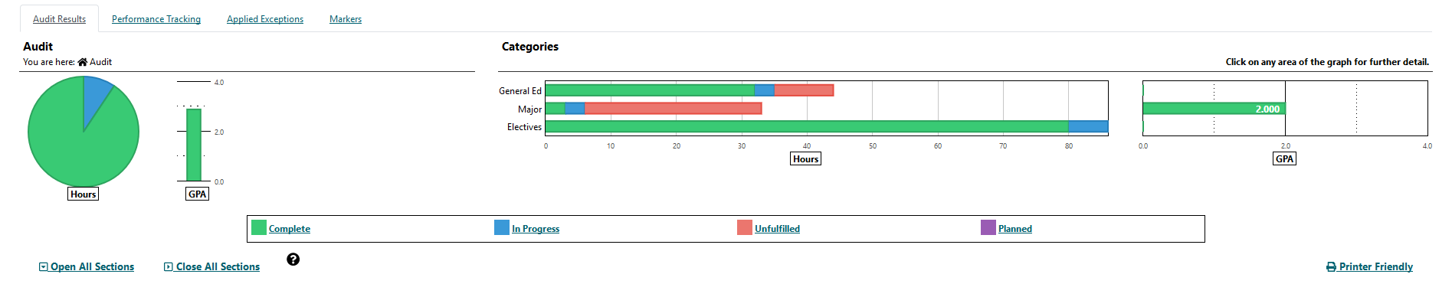

- You can hover over the colored sections of the charts and grafts to see the number of hours related to that section either completed, in progress or unfulfilled.
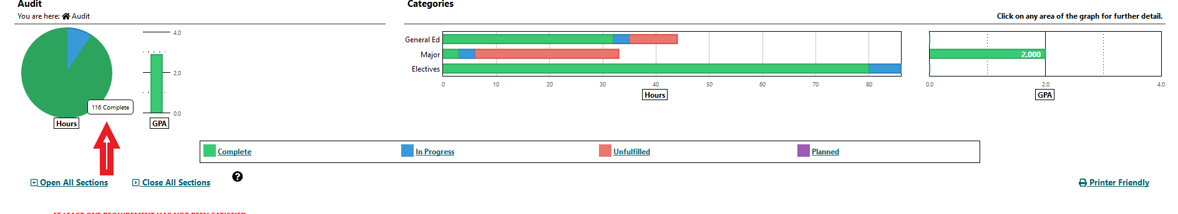

- You can click on bar in the categories table below to go directly to that related section on the Degree Audit.
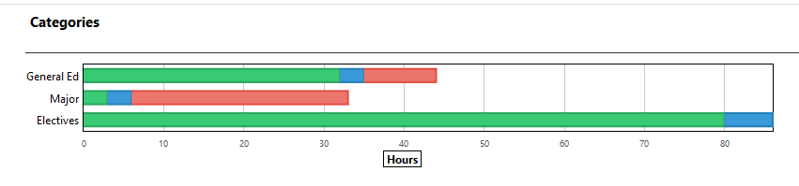

- In the category section we selected Major. Below you will see a screen shot of the major requirements which include completed, in progress and unfulfilled requirements. 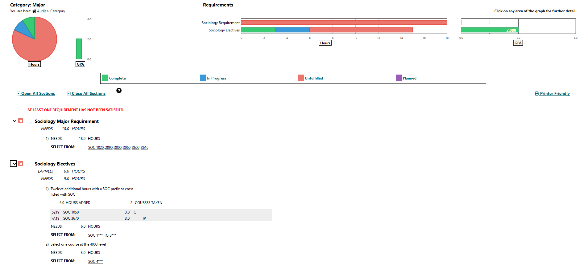

- When the Audit is initially opened, All sections are closed. Click open all sections to see all requirements in each section. 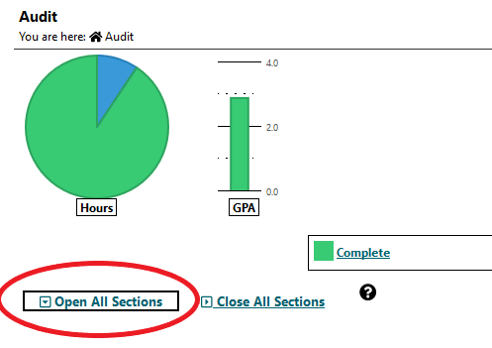

- When reviewing the Degree Audit. = completed requirement, = In progress requirement, = unfulfilled requirements.
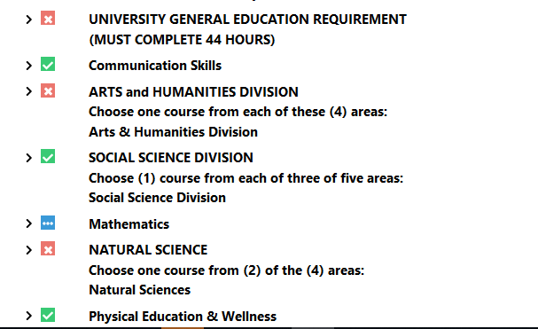

- You can then scroll through each section of the DARS if you want to review more information. There are sections on In-Progress Courses, Total Hours/GPA, Residence, Major GPA, General Education, Major, Minor and Track Requirements. 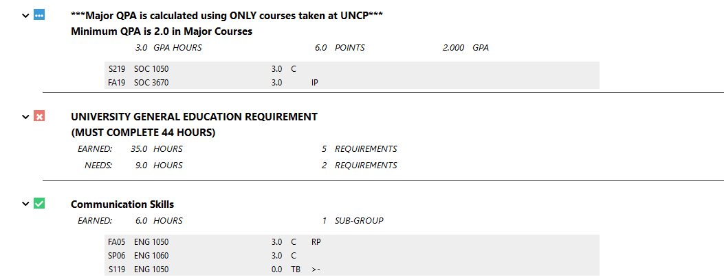

- If courses cross list or the course names change they will show up MATCHED AS: ABC 1XXX in the system.
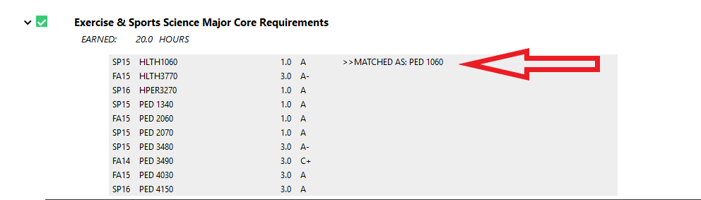

- If you have not met a requirement for a section it will be indicated beside NEEDS: X.X Hours indicating the number of hours and the courses needed will be located under the courses taken Indicated the by the SELECT FROM: ABC 1XXX 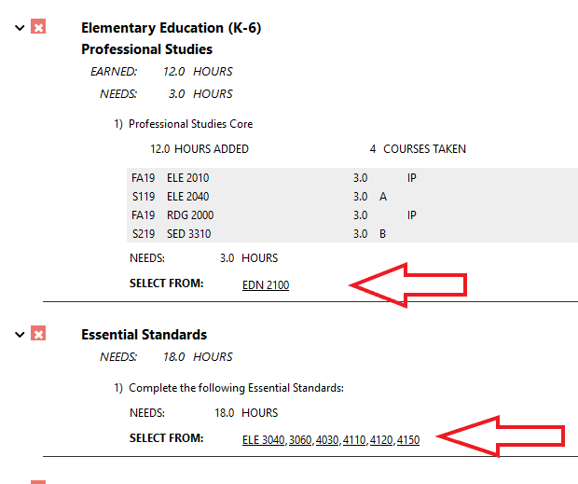

- University Electives are located towards the bottom of the Degree Audit. Make sure to review this area especially if you are required to have a certain number of elective hours. ***Please review this section carefully. Elective hours may not always be accurate. Anything not counting as a requirement for the major will fall here.***

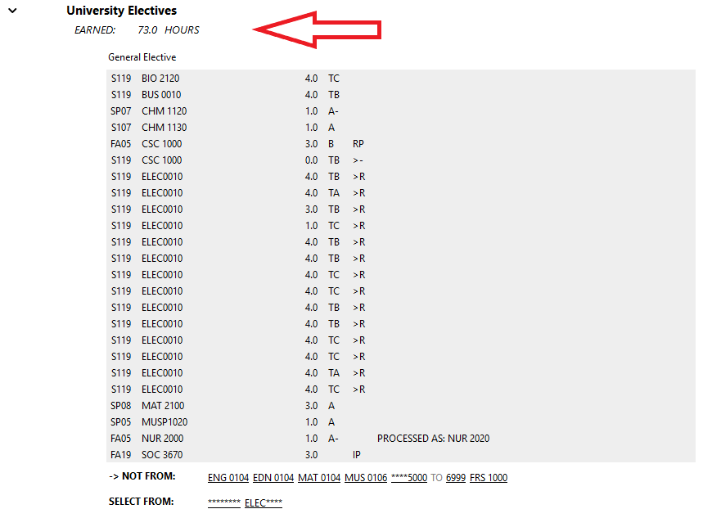
- Work not Applicable appears at the bottom of the Audit. This includes ENG 104, MAT 104, any course withdrawals or any course removed from overall GPA due to special readmission policy.
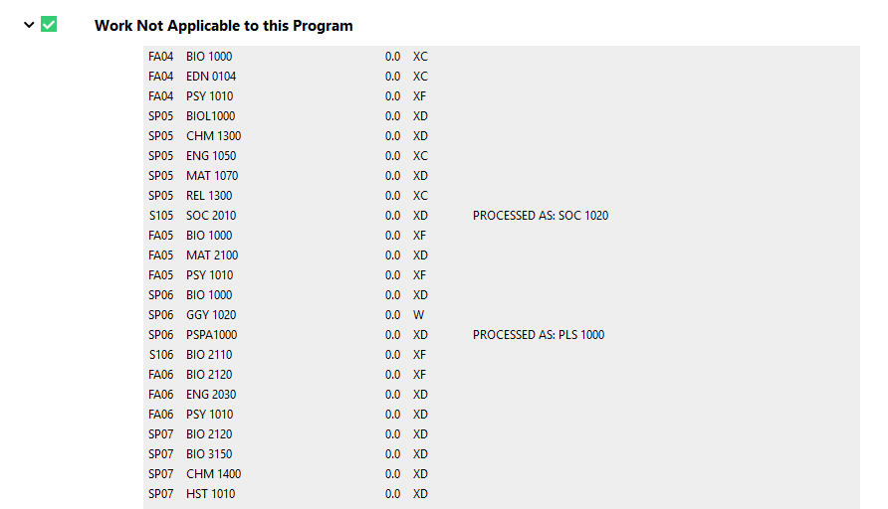

- uAchieve also includes a legend at the bottom for your reference. >X is a grade replacement. 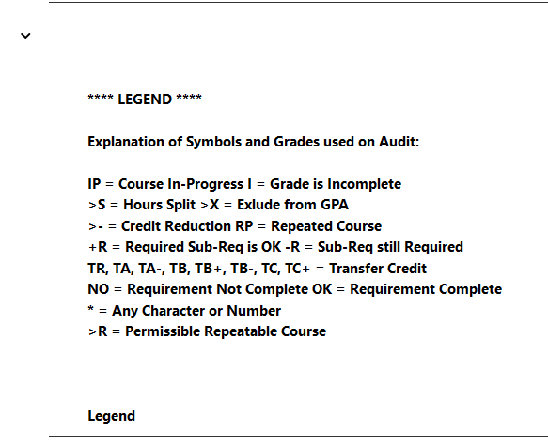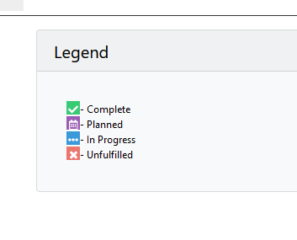
- Click Audits and then click Request new to request a new audit.
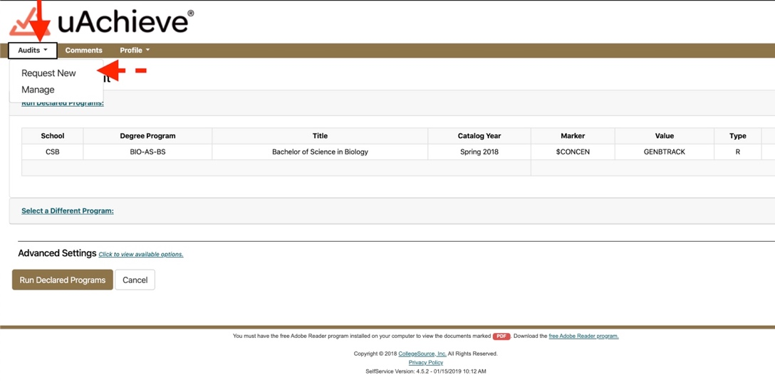
- Click Audits and then click Manage to see all of your audits.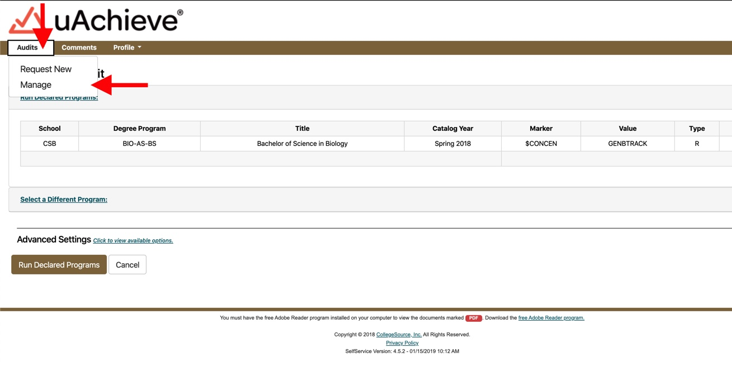
- You can now click the underline link to view to Audit. The one labeled What-If is the one that is different than your current declared major. 