A. On the top this form, clic the ‘Sign’ fountain pen Icon…

B. Click ‘Add Signature’…

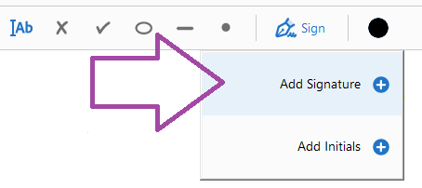

C. (1) Click the ‘Draw’ Icon (NOTE: This must be a cursor/mouse drawn signature…all typed signature will not be accepted), (2) Draw your signature with your cursor/mouse, (3) Click the blue ‘Apply’ Icon…
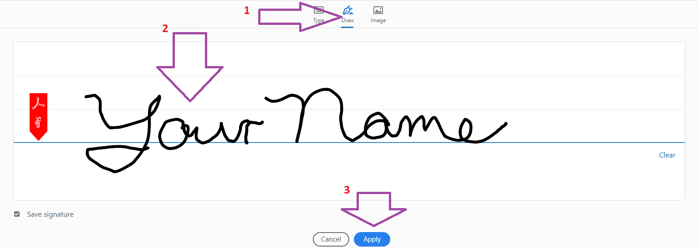

D. Drag your new signature to the appropriate location and release the cursor. Your document is now signed!

