UNC Pembroke

EAB Student Success Collaborative

H.A.W.K. Alert/KUDOS Training

There are 2 ways to issue a H.A.W.K. Alert/KUDOS...Professor Home Page and Class Listing

But first, log-in to EAB by going to uncp.edu/css ===> Click the ‘HAWK Alert’ link on the right of our home page and log-in with your Staff/Faculty credentials ===> Once at your home page, click the ‘Advisor Home’ drop-down arrow and select ‘Professor Home’...
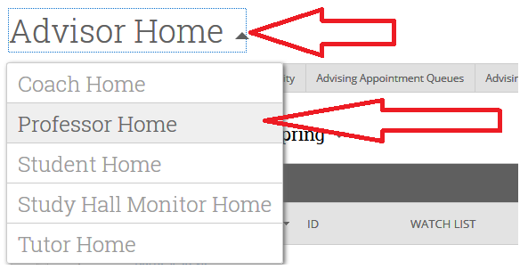

And then.....

1. Professor Home Page
Step A: From your Professor home page, select “Issue an Alert”... then (Skip to step B) (Note: This option allows you to issue a referral for a non-roster student or your advisee)
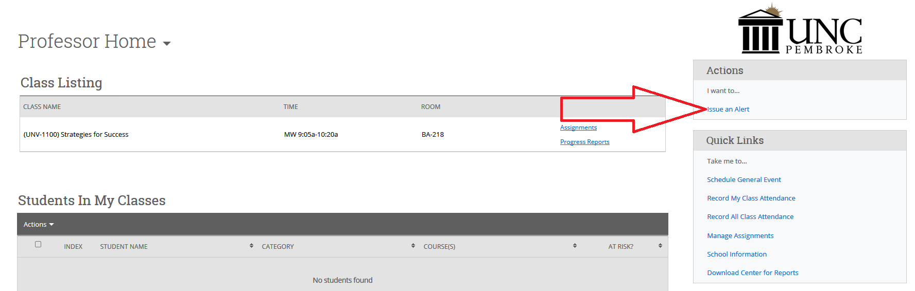

2. Class Listing
Step A: From your Professor Home page, check box next to student’s name under “Students in My Classes” and select “Issue Alert” then (skip to step B) (Note: Only one student can be selected per referral)

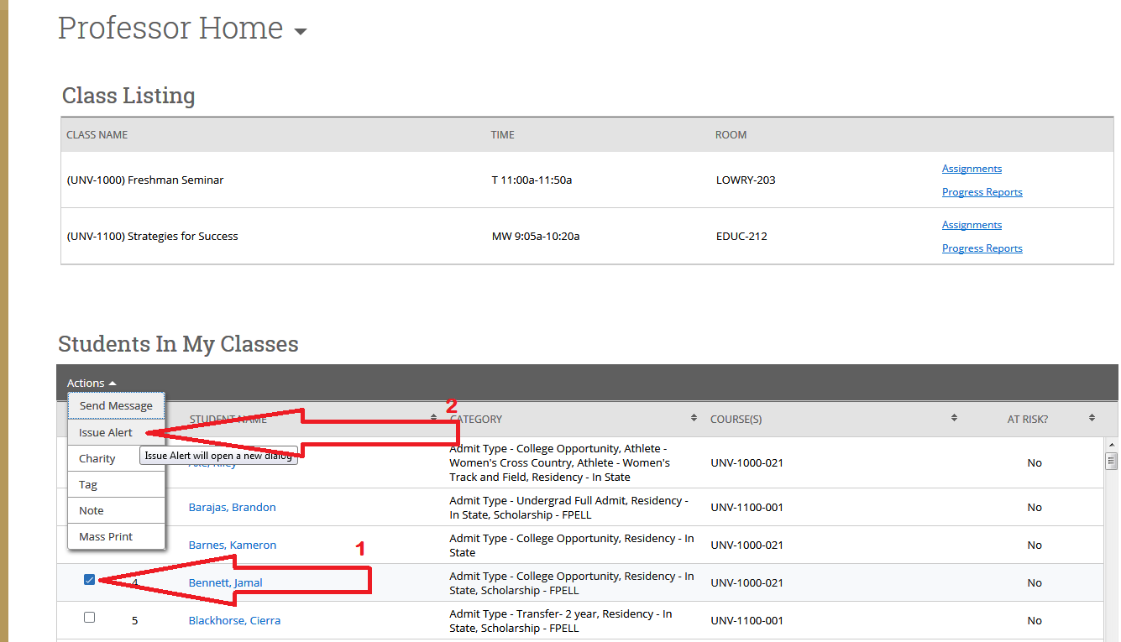

Step B: Alert Reason – Search for your student and select the alert reason...both H.A.W.K. Alerts and KUDOS reasons are imbedded within this dropdown (Note: You can select multiple reasons or KUDOS)
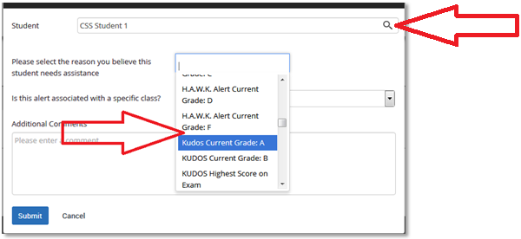

Step C: Associated with a Class? – Select associated course
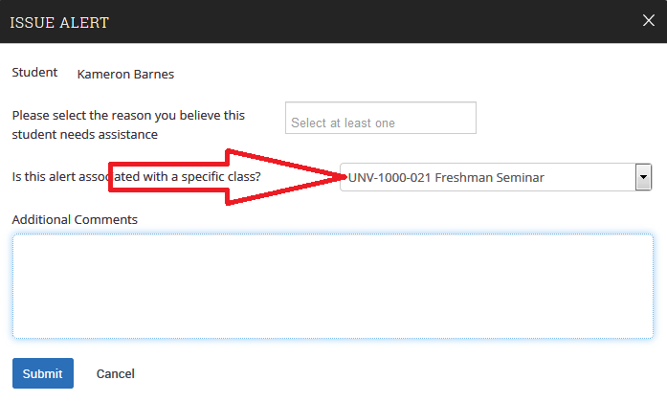
Step D: Additional Comments / Submit – Explain reason for referral and/or your recommendations and click “Submit”
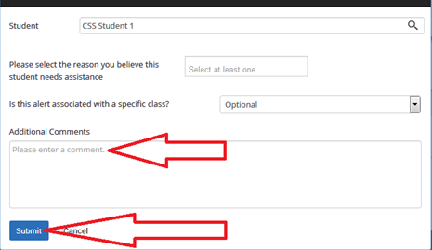

Once submitted, you will receive a confirmation email and your student will receive an email similar to this:
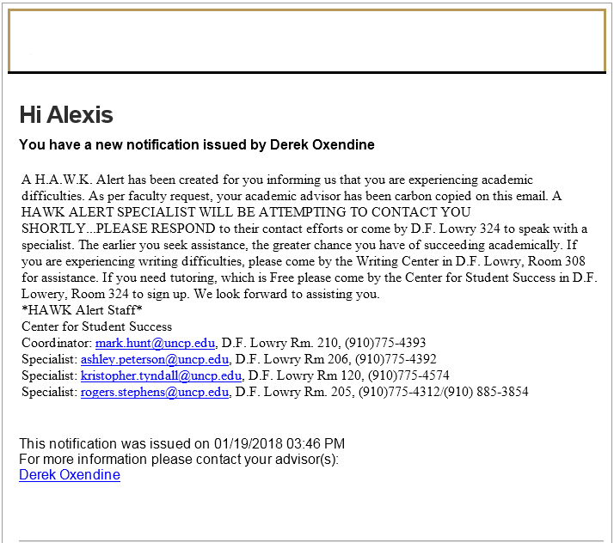

Follow-Up
To determine our progress with your referral,...
1. Select ‘Professor Home’ from the drop down ‘Staff Home’ at your home page
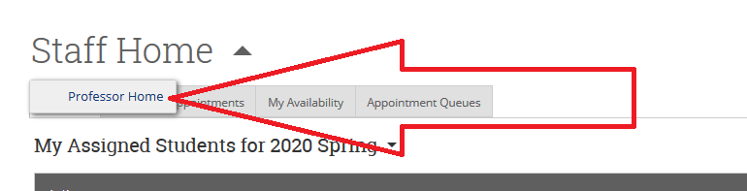

2. Scroll to the bottom of the screen to ‘My Issued Alerts’ and click your referred students ‘Blue’ hyperlinked name
(also note that this screen informs you whether your case is still open or closed and your totals)

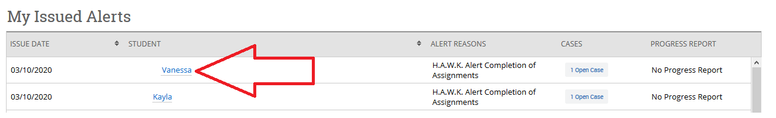

Follow-Up Continued...

3. At the your students profile screen, search to the right of this screen, click on the yellow ball under the UNC Pembroke logo and click ‘Open Case’

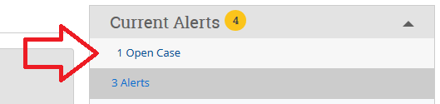

4. Click (1) ‘Open Cases’ to view a HAWK Alerts that are currently active or click (2) ‘Closed Cases’ to see those that have been completed and click (3) ‘View Case’ to see our progress

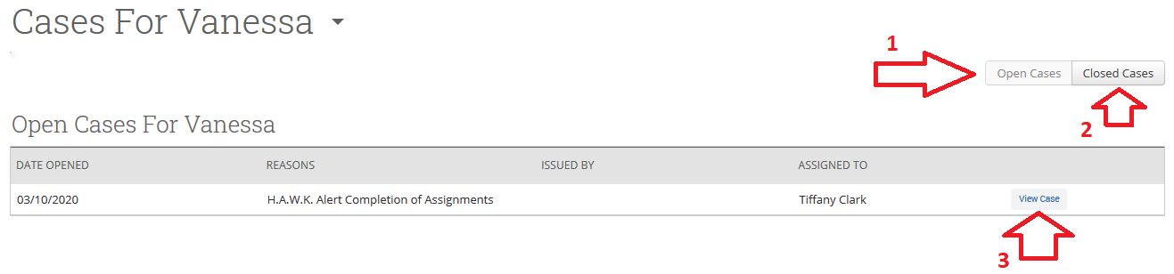

Follow-Up Continued...

5. At this screen you will be able to view our progress with your referral and our resolutions.
(please note that certain text has been redacted)

