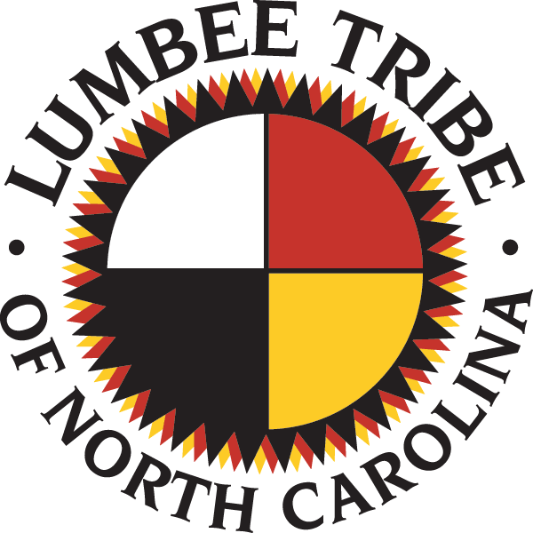
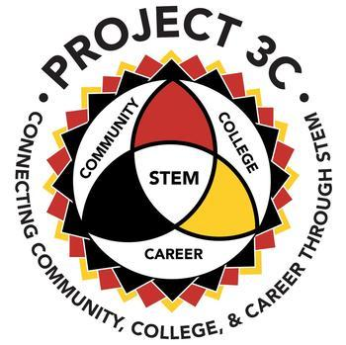
Unlocking Silent Histories
Fall Camp Opportunity
Unlocking Silent Histories cultivates young leaders, preparing them to facilitate youth-led, youth-envisioned learning engagement designed to honor Indigenous knowledge and traditions by immediately including youth in defining what and how they learn, as well as what films they create. Burgeoning young filmmakers and local leaders, ages 15-18, gain the capacity to lead young people in exploring themes that they identify as important to their communities and our future, direct their own video investigations, and produce their own stories in the form of short films. This is achieved through a critical media literacy, technology, and leadership curriculum toolkit that develops youths’ analytical, technical, and leadership skills. Unlocking Silent Histories is funded by Project 3C.

- Program participants are expected to:
  - attend all virtual sessions
  - produce a film, and
  - create a community impact plan.

Dates | Times
September 12 | 9:30-1:30
September 19 | 9:30-1:30
September 26 | 9:30-1:30
October 3 | 9:30-1:30
October 10 | 9:30-1:30
October 17 | 9:30-1:30
October 24 | 9:30-1:30
October 31 | 9:30-1:30

APPLICATION

Name______________________________ Date of Birth____________________________

Address_________________________ City______________________________________

State__________ ZIP_______________ Home Phone_____________________________

Cell Phone_________________________ Parent Email____________________________

School____________________________ Student Email__________________________

Grade Level in Fall 2020________ Indian Education 506 Number____________________

Accidents and Emergencies, Participant Conduct, and Photo Release

Unlocking Silent Histories (USH) seeks to engage participants with interactive, fun, rewarding, and safe learning experiences. UNC Pembroke makes reasonable accommodations for participants with disabilities. Every effort will be made to assist with any special needs.

Accidents and Emergencies
The Emergency Phone Numbers Section of the Parental Consent, Assumption of Risk and Release from Liability section of this form must be filled out completely. It is recommended that all participants have medical coverage prior to attending the USH. In case of an emergency or accident involving a participant, the parent/guardian will be contacted following notification of the appropriate emergency personnel. Staff will make requisite provisions to ensure a safe experience.

Participants are required to wear the safety equipment for applicable activities.

Participant Conduct
UNC Pembroke believes it is important that participants act in a respectful manner toward other participants and staff. Consequently, there are certain standards and expectations to which participants must be held. The program’s goal is to promote strong morals, responsibility, and respect for self, culture, other program participants, and the environment.

Capturing Participant’s Smiles
Throughout the program, UNC Pembroke’s University Photographer and others may photograph and/or record program participants. Photos and videos may be used for publications, advertising, social media, and promotional materials. Please indicate your preference for the use of photos/videos of your child for promotional purposes by adding your initials to the desired line.

_____ I give permission to UNC Pembroke and the Southeast American Indian Studies Program to use photographs/videos of ____________________________________ (student’s name) while attending the USH.

_____ I do not give permission.

______________________________________________________ ______________
Parent/Guardian’s Signature Date

_____________________________________________________
Parent/Guardian’s Printed Name

Parental Consent, Assumption of Risk, and Release from Liability

The following information will enable the Unlocking Silent Histories staff and/or local healthcare facilities to provide prompt care to participants in case of an emergency. We must have on file the parental consent information requested below.

Student’s Full Name:

Insurance Company’s Name:

Medical/Hospitalization Insurance Policy #:

Phone Number of Office Holding Policy:

Emergency Phone Numbers - Local Person Only):

Parent/Guardian’s (Home): Parent/Guardian’s (Home):

Work: __________________ Work: __________________

Cell: __________________ Cell: __________________

Email: __________________ Email: __________________

Additional emergency contact in case the parent/guardian(s) cannot be reached:

Name: __________________ Relationship to student: __________________

Home Phone: __________________ Cell: __________________

Email: __________________ Physical Address: __________________

I voluntarily agree to allow my child to participate in this activity and hereby accept and assume all such risks, known and unknown, and assume all responsibility for the losses, costs and/or damages following such injury, disability, paralysis or death, even if caused, in whole or part, by the negligence of UNC Pembroke with the exception of willful or gross negligence.

In consideration of allowing my child to participate in this activity, as well as the use of any of the facilities and the use of the equipment, I hereby agree as follows:

- I certify that my child, __________________________________________________, who is enrolled with this agreement, is in excellent health, and may participate in strenuous physical activities associated with the Unlocking Silent Histories hosted by the University of North Carolina at Pembroke.

- TO WAIVE AND RELEASE ANY AND ALL CLAIMS based upon negligence, active or passive with the exception of intentional, wanton or willful misconduct that I may have in the future against any of the following named persons or entities and their officers, directors, employees, representatives, agents and volunteers.
  - Unlocking Silent Histories and Staff
  - Southeast American Indian Studies Program
  - The University of North Carolina at Pembroke

- To release UNC Pembroke, their officers, directors, employees, representatives, agents and volunteers, from liability and responsibility, whatsoever, for any claim of action that I, my estate, heirs, executors or assigns may have for any personal injury, property damage or wrongful death arising from this activity whether caused by active or passive negligence of UNC Pembroke or otherwise with the exception of gross negligence. By executing this document, I agree to hold UNC Pembroke harmless for any injury, including, but not limited to, paralysis or permanent disability, or loss of life, which may occur to my child during this activity and/or instruction.

- Permission is granted in the agreement for my child to receive emergency medical treatment, if needed, and I certify that there are no limits to my child’s participation in Unlocking Silent Histories activities, except as stated in writing, and included with the Health History/Emergency Medical Information Form which is included.

- I understand and acknowledge that the 2020 Unlocking Silent Histories does not offer any medical insurance to protect against injuries, makes no claims to do so, and has no responsibility for any medical expenses incurred. I understand that each participant must assume the risk, and any related financial responsibility that could result from participation in any of these activities. I agree to assume any risk and financial responsibility.

- By entering into this agreement, I am not relying on any oral or written representation or statements made by UNC Pembroke, other than what is set forth in this agreement. I further agree that this Agreement shall be governed by and interpreted in accordance with the laws of the State of North Carolina, United States of America.

- If any provision of this release is found to be unenforceable or invalid, that provision shall be severed from this contract. The remainder of this contract will then be construed as though the unenforceable provision had never been contained in this document.

I hereby authorize the director, assistants, or other persons responsible for my child’s care to act on my behalf, according to their best judgment, for said minor in any emergency requiring medical attention, and I hereby waive and release the USH, staff, the Southeast American Indian Studies Program, and UNC Pembroke of all liability for any illness or injuries incurred while at, or in transit to and from the program.

______________________________________________________ ______________
Parent/Guardian’s Signature Date

______________________________________________________
Parent/Guardian’s Printed Name
Health History/Emergency Medical Information Form

- Student’s Full Name:

- Are there any special needs or accommodations required? _____ Yes _____ No
  - If yes, please specify:

- Are there any activities to be limited as recommended by student’s physician? _____ Yes _____ No
  - If yes, please specify:

- Any allergies? _____ Yes _____ No
  - If yes, please specify:

- Allergic Reactions:

- Any prescribed medication being taken? _____ Yes _____ No
  - If yes, please specify:

- Any food/dietary restriction? _____ Yes _____ No
  - If yes, please specify:

- Date of last tetanus shot:

- Past illness or other information that would be useful in the event treatment is necessary:

Please provide the following information:

- Copy of Immunization Record from physician or local health department
- Proof of health insurance coverage

I affirm that the information provided above is true to the best of my knowledge. The student herein described above has permission to engage in all activities relative to the 2019 Unlocking Silent Histories, except as noted, and receive services from Student Health Services (if necessary).

______________________________________________________ ______________ Parent/Guardian’s Signature Date

______________________________________________________
Parent/Guardian’s Printed Name

