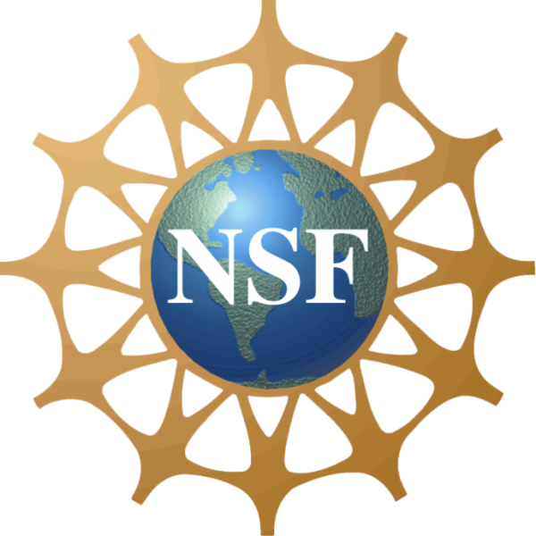
C MPASS2

Creating Opportunities for Students in Sciences
An NSF Sponsored Scholarship program at UNCP
Scholarship overview
The main goal of the COMPASS2 Scholarship Program at the University of North Carolina at Pembroke is to attract academically talented students, who have demonstrated unmet financial need, including underrepresented minorities (URM) and first-generation students, as Biology, Environmental Science, and Chemistry majors and provide them financial assistance. The award will provide 30 students (3 cohorts of 10) with an average of $6000.00/year ($3000.00 per semester) from their freshman year until graduation, all while preparing them for the STEM workforce or graduate/masters programs through intense mentoring and tutoring, research experience opportunities, internships, professional development, and career advising.
The S-STEM program was established by the National Science Foundation to address the need to substantially increase the number of graduates in the STEM fields.
Scholarship Requirements
Eligibility criteria
To apply for the scholarship for the 2020-2021 academic year, students will have to satisfy the following criteria:
- Plan to enroll as a freshman for the 2020-2021 at UNCP in one of the following majors: Biology, Environmental Science, or Chemistry.
- Or transfer student with no more than 60 credits.
- Competitive GPA and SAT scores.
- Must have demonstrated financial need as determined by their FAFSA application.
- Must be a U.S. citizen or permanent resident.
Scholarship Requirements to maintain eligibility status
Students who receive scholarships must maintain the following scholarship requirements. If these requirements are not met, scholarships may be put on a probation status or terminated.
- Full-time enrollment at UNCP in one of the following majors: Biology, Environmental Science, or Chemistry.
- Maintain a minimum GPA of 3.0.
- Meet with their mentors monthly.
- Attend a Math-readiness summer mini-course. Recipients will be strongly encouraged to participate in a 1-week mini-course the summer before they enter the COMPASS2 program.
- Attend a number of science seminars, workshops for career development, talks by STEM professionals and site visits to companies and graduate schools, professional meetings.
- Attend tutoring when advised by their mentors.
- Attend annual 2-day retreat.
- Optional academic year and summer research/internships.

Selected candidates will be contacted for a virtual interview. Offers will be made by the end of June/beginning of July.
For information about this program, please visit our website or contact:
Dr. Maria Santisteban, PI; Phone 910-775-4274
Email maria.santisteban@uncp.edu
Office address: Oxendine Science Building Room 2112A
C MPASS2

Creating Opportunities for Students in Sciences
An NSF Sponsored Scholarship program at UNCP

Deadline: Thursday, May 28th, 2020
How to apply
To apply for the COMPASS2 scholarship, please submit the following:
- Personal information form, including ethnicity, citizenship status, if you are a first generation student, and career plans.
- Copy of your transcript
  - High school students should contact their counselor and have them send their transcript.
  - Current Community College students: Unofficial CC transcript.
- Personal Statement indicating why you are interested in the program, what makes you a good candidate, and why your family’s financial circumstances justify consideration for the S-STEM Scholarship. Essays should be typed, double-spaced, and approximately 500 words.
- 2 sealed letters of recommendation addressing your academic achievements, leadership experiences, and character. One letter of recommendation should be from a STEM teacher. Letters or recommendation can be addressed directly to Dr. Santisteban.
- Financial Aid release form, allows Financial Aid Office of UNCP to provide the results of your financial need analysis to the COMPASS2 scholarship committee for the purpose of consideration for this scholarship.
- Confirmation of having filed your FAFSA application.

Please mail the completed application no later than 5:00pm on Thursday, May 28th to Dr. Santisteban’s. Because the coronavirus pandemic, you are encouraged to submit your application electronically by filling out the Personal Information, Financial Aid Release form, and upload your essay on line at the COMPASS2 Scholarship Program website and have the letters of recommendation and transcript sent to

Maria Santisteban
UNC at Pembroke
One University Drive, PO Box 1510
Pembroke NC 28372-1510

Or by email at maria.santisteban@uncp.edu

C MPASS2

Creating Opportunities for Students in Sciences
An NSF Sponsored Scholarship program at UNCP

Deadline extended: Thursday, May 28th 2020
Personal Information:

Name: ___________________________________ Banner ID if applicable: __________________
What is your current gender identity?:
__ Male
__ Female
__ Trans male/Trans man
__ Trans female/Trans woman
__ Genderqueer/Gender non-conforming
__ Different identity (please state):
What sex were you assigned at birth, on your original birth certificate? ___ Male ____ Female
Birthday: ___________________
Address: __________________________________________________________________________
City, State, Zip Code: ________________________________________________________________
Home/Permanent Phone: __________________- Cell Phone: ______________________________
Preferred e-mail: ____________________________________________________________________

Ethnicity (check all that apply):
__American Indian/ Alaskan native __African American __Asian __Hispanic/Latino
__Native Hawaiian/Pacific Islander __White/Caucasian __Don’t wish to provide

Citizenship:
U.S. Citizen: __Yes __ No
Permanent resident: __ Yes __ No Country of birth: _________________

School Information:
For High School Students; school name:_________________________________________________
SAT scores: Math_______ Evidence-Based Reading and Writing _________Composite _________
or ACT: English_______Math________Reading________Science_________Composite _________
# Credits transferred (if applicable): _________

For transfer students, Community College name: _________________________________________
# Credits transferred _________
For UNCP students:
College level (as of this past Fall) ____Freshmen ____ Sophomore ____Junior ____Senior
# Credits completed________
Current GPA: _________ weighted GPA (if applicable)_______
Major/Intended Major: ________________________________________________________________
Area of interest/career goals: __________________________________________________________
First generation college student: __Yes __No Are you a veteran? __Yes __No
Provide the names and contact details of two faculty members who will provide recommendations on your behalf. Make note that at least one recommendation letter must be from a STEM faculty. The letters received must match the names below. If you use a different referee you must notify us in writing.
Reference #1:
Name_______________________ email______________________________Phone________________
Reference #2:
Name_______________________ email______________________________Phone________________

Signature: ________________________________ Date: ___________________________

Printed name: _______________________________________________________________________
C MPASS2

Creating Opportunities for Students in Sciences
An NSF Sponsored Scholarship program at UNCP

Deadline extended: Friday, May 8th 2020

Financial Aid Release Form

First Name: ___________________________________________________________________
Middle Initial: ____________ Last Name: _________________________________________
Preferred Email: ________________________________________________________________
Phone (XXX-XXX-XXXX): ________________________________________________________
Address: ______________________________________________________________________
City: __________________________________ State: ________ Zip Code: _______________
Status at the beginning of the 2020-2021 school year at UNCP:
__Freshmen __Sophomore __ Junior __ Senior
Major/Intended Major: ___________________________________________________________

Financial Analysis Approval
I request that the Financial Aid Office of UNC Pembroke provide results of my need analysis to the COMPASS2 scholarship committee for the purpose of consideration for this scholarship.

Signature: ___________________________________ Date: ____________________________

