Faculty Senate Chair Mann’s Note (sent originally with agenda announcement for 4/1 meeting):

Because we have had considerable discussion about the ICC proposal, I wanted to make sure to address the issue here so it would reach the maximum audience. First, I want to say I am thrilled about the level of feedback: this is, indeed, as many have pointed out, a proposal that will affect all of our students and as such, the more feedback and expertise we bring to the issue, the better. Already the questions raised have guided the committee in creating clear precis on much of the information they had previously gathered but had not had available in their short form recommendation: all of these materials, as well as statements from SGA, will be available on a webpage that should be completed by the end of the next week (the webmaster is locked in a house with me at the moment, so I have some pull). This site will also have a space for public comment and I hope and expect to see a robust discussion. The issue was tabled by Academic Affairs, so we have several weeks for that discussion.

What I ask is that you read these documents on their own merit [I understand some of you are not happy with the timeline of when documents were made available. I went through the timeline in the academic affairs announcement addenda last week and am happy to discuss further one on one.] I see tremendous opportunity in this proposal. The opportunity for our students, who requested this in the first place, and have indicated their approval as a governance body, to embrace the unique history of this region and have meaningful, experiential, learning around it as they develop in their chosen degree paths. The chance for departments, if they desire, to develop cross-listed courses that are built around disciplinary knowledge and connect to larger issues that students will have connections: such courses already exist in art, education, english, history, religion, social work, and sociology, and I know that several of our faculty members in other departments are doing fascinating work that would create strong, meaningful, experiences for their majors. The chance for our students to continue to participate in service opportunities, which are known to build student connection and success. The opportunity for students to take advantage of the rich programming already happening on this campus, and to do so within a structuring set of experiences that will give them context and connection.

Let me be clear: I am not demanding that this get passed. I have no power to do that, and I think my performance this year has made it clear that supporting faculty governance and increasing participation is my guiding principle. I am impressed by the work and thought a number of our colleagues put into developing this proposal. I am also, now, as the senate chair, the person bringing forward this proposal. The ad hoc committee has completed their charge and the executive committee voted to accept their report and dissolve the committee. As such, please direct questions and ire, if you have it, to me: I will, I promise, do my best to answer and may do so in an even more long winded way.

Indigenous Cultures & Communities Graduation Requirement
Final Report of the Ad-Hoc Committee
April 3, 2020

The following report seeks to clarify faculty concerns and questions surrounding the proposed Indigenous Cultures and Communities (ICC) Graduation Requirement. The report is organized as follows:
- Background
- The Proposal with an added Appendix
- Feasibility Explanation for Each Option (course, service, and programming)
- Direct Response to Faculty Questions
- Potential Paths
- Statements of support from Student Organizations

I. Background:
In response to a resolution from SGA, in the fall of 2018, the Faculty Senate, chaired by Mitu Ashraf, convened an ad hoc committee made up of all of those who expressed an interest with the charge of exploring an AIS requirement. The ad hoc committee convened January 14, 2019. Early meetings nominated and elected a chair, and the exploration for a requirement began. The committee researched similar requirements at historically black colleges and universities (HBCU) in North Carolina, and Native-serving institutions (designated as universities) across the United States. The committee’s findings are as follows:
- No Native-serving institution, of the 29 surveyed (based on the criteria above) has any specific Indigenous culture or community requirement. The committee saw this as an opportunity for UNCP to set an innovative example for experiential learning opportunities among Native-serving institutions.
- Of the HBCUs in North Carolina, North Carolina A&T State University requires a class in African American history. Shaw University has a general-education elective requirement in which two of the three choices are African American History (I & II). NC Central University has a community service graduation requirement (120 hours). Other North Carolina HBCUs surveyed did not appear to incorporate specific requirements.
The ad hoc committee submitted the following report to The General Faculty Meeting on May 3, 2019 to make faculty aware of our progress to that point:

Committee members include: Mary Ann Jacobs, Jane Haladay, Zachary Laminack, William Puentes, Conner Sandefur, Kim Sellers, Al Bryant, David Oxendine, Robert Canida, Scott Hicks, Christian Reeves, and Jamie Mize.

The committee met once a month beginning in February.

We have researched general education and graduation requirements for culture specific content in HBCU and Native-serving institutions. Our research led us to conclude than an AIS graduation requirement would be the easiest to implement (rather than a general education requirement). We also discovered that such a requirement would make us innovators in higher education, particularly among Native-serving institutions.

The committee will continue its work next academic year as we shift our focus to determining how to rollout an AIS graduation requirement with the resources we have. We will also consider how such a requirement will be implemented during our current period of planned growth. We plan to have a specific recommendation for faculty senate next academic year. Our intent is that this recommendation will include the details of what exactly the requirement will be, how UNCP can implement the requirement, and considerations for the future.

Jane Haladay represented the committee at this meeting to answer questions, and make note of concerns. Faculty raised no questions or concerns at this meeting.

This progress report was also submitted to the Faculty Senate for its September 4, 2019 meeting (distributed agenda and appendix, but no official meeting due to the hurricane); and included and discussed for the October 2 Faculty Senate Meeting, in which no discussion or questions were raised.
The committee continued its work in September 2019. A principal concern of the committee’s work in Fall of 2019 was making sure that the proposal offered options for students while not increasing faculty workloads or significantly altering degree paths.
In November 2019, the committee agreed upon the plan that we ultimately proposed to Faculty Senate.

While crafting the proposal, it became clear that the requirement needed a more inclusive scope, and so the decision was made to shift from “American Indian Studies” to “Indigenous Cultures and Communities.” This decision was made to maintain the charge to celebrate the University’s unique heritage while also including Indigenous peoples* around the globe Additionally, an Indigenous requirement was warranted to respond to three important needs:
- The need to encompass the full scope of existing student programming opportunities some of which focus on Native communities beyond the United States and North America.
- The need to look ahead to future programming opportunities.
- The need to encourage departments from all colleges and schools to consider how existing or future courses and/or programming could contribute to the requirement.
*Indigenous peoples are inheritors and practitioners of unique cultures. Indigenous peoples have retained social, cultural, economic, and political characteristics that are distinct from those of the dominant societies in which they live. Despite their cultural differences, Indigenous peoples from around the world share common problems related to the protection of their rights as distinct peoples.
The committee completed the proposal in January 2020. The committee voted to approve the proposal and submit it to the Faculty Senate Chair in February 2020.

II. The Proposal & Appendix:

Indigenous Cultures and Communities Graduation Requirement*
Undergraduate Students entering the University in Fall 2020 or later, as a requirement for graduation, shall complete the Indigenous Cultures and Communities Requirement. Students may satisfy the requirement through completing approved courses, attending approved programming, and/or completing approved service projects as outlined below:
Undergraduate Students with 0 – 30 credit hours from other degree granting institutions will complete 80 hours of cultural or community experiences. Students can accumulate hours in any of the following ways:
- AIS or cross listed course = 40 contact hours.†
- University Programming as approved by the Council = 2 hours per event (students will swipe their Braves Card at the beginning and end of events to receive credit for these hours).
- Service Projects = hours determined in partnership with CCE (these include short- and long-term community service projects and/or internships).

Undergraduate Students with 31 – 60 credit hours from other degree granting institutions will complete 60 hours of cultural or community experiences (as defined above).

Undergraduate Students with 61 or more credit hours from other degree granting institutions will complete 40 hours of cultural or community experiences (as defined above).

†Number of contact hours were derived from the typical lecture course contact time of 150 minutes per week across fifteen weeks of instruction.

Proposed Organization and Charter of the
Indigenous Cultures and Communities Requirement Council
The Indigenous Cultures and Communities (ICC) Requirement Council shall be responsible for assuring that every candidate for baccalaureate graduation meets the requirement of significant engagement with, study of, research in, and/or community service to Indigenous communities, such that all baccalaureate graduates of the University experience and appreciate the histories, diversities, cultures, and/or sovereignties of Indigenous people.
The Council shall be composed of five voting members selected from among the faculty and affiliate faculty of the Department of American Indian Studies.
The council shall be supported and advised by the following ex officio members:
Director, Office for Civic and Community Engagement
Associate Director for Service Learning, Office for Civic and Community Engagement
Director (or designee), Campus Engagement and Leadership
Faculty Advisor, Native American Students Organization
President (or designee, pending approval by the council), Student Government Association
Director, Teaching and Learning Center
Chair, Student Affairs and Campus Life Committee, Faculty Senate
American Indian Liaison to the Chancellor
The chair of the American Indian Studies Graduation Requirement Ad-Hoc Committee of the Faculty Senate, at the approval of the Provost and Vice Chancellor of Academic Affairs and in consultation with the Chair of the Department of American Indian Studies, shall appoint members of the first ICC Council to three-year terms with the possibility of renewal. The chair of the ad-hoc committee, or designee, shall serve as first Council Coordinator. The Council Coordinator is responsible for overseeing and creating agendas for Council meetings. The Council Coordinator shall serve a term of four years with the possibility of renewal.
Faculty members of subsequent Councils shall be appointed or renewed by the Council Coordinator, at the approval of the Provost and Vice Chancellor of Academic Affairs and in consultation with the Chair of the Department of American Indian Studies, to serve three-year terms with the possibility of renewal. Subsequent Council Coordinators shall be elected from among the Council members, in consultation with the Chair of the Department of American Indian Studies and subject to approval by the Provost and the Vice Chancellor of Academic Affairs, to a four-year term.
The Provost reserves the right to terminate or suspend the membership of any individual who fails to attend more than one Council meeting per academic year. Only the faculty members of the Council shall have the right of voting, and the Council shall regularly inform the Academic Affairs Committee of the Faculty Senate of its actions and recommendations.
The Council shall meet at the beginning of each semester during the traditional academic year, and a quorum of faculty member appointees must be present for the conduct of official business.
The Council shall fulfill its responsibilities through the following activities:
- Ensuring that programming aligns with the stated student learning outcomes the graduation requirement seeks to produce;
- Defining the varieties of curricular, cocurricular, and/or extracurricular activities and/or experiences (hereafter, “programming”) aligned with these learning outcomes that may satisfy fulfillment of the graduation requirement;
- Calling for and supporting the development of outcomes-driven and -aligned programming that supports students’ mastery of these learning outcomes;
- Reviewing such programming so as to determine its appropriateness for the graduation requirement and designating approved programming;
- Overseeing all programming for the purposes of ensuring fidelity to student learning outcomes and assuring the quality and significance of students’ learning.

Proposed Additions to the Undergraduate Catalog

Indigenous Cultures and Communities Requirement
Undergraduate Students entering the University in Fall 2020 or later, as a requirement for graduation, shall complete the Indigenous Cultures and Communities Requirement. Students may satisfy the requirement through completing approved courses, attending approved programming, and/or complete approved service projects as outlined below:
Undergraduate Students with 0 – 30 credit hours from other degree granting institutions will complete 80 hours of cultural or community experiences. Students can accumulate hours in any of the following ways:
- AIS or cross listed course = 40 contact hours.*
- University Programming as approved by the Council = 2 hours per event (students will swipe their Braves Card at the beginning and end of events to receive credit for these hours).
- Service Projects = hours determined in partnership with CCE (these include short and long term community service projects and/or internships).

Undergraduate Students with 31 – 60 credit hours from other degree granting institutions will complete 60 hours of cultural or community experiences (as defined above).

Undergraduate Students with 61 or more credit hours from other degree granting institutions will complete 40 hours of cultural or community experiences (as defined above).

*Number of contact hours were derived from the typical lecture course contact time of 150 minutes per week across fifteen weeks of instruction.

Appendix
Mission Statement: UNCP, as North Carolina’s only historically American Indian University, expects its graduates to learn about the cultures and histories of Indigenous peoples to honor and deepen their connection both to the university and to the American Indian communities who founded UNCP. The Indigenous Cultures and Communities Graduation Requirement allows graduates to: (1) develop a greater awareness of the diversity of Indigenous peoples and tribal culture; (2) develop an appreciation of the social, political, economic, and sovereignty issues facing Indigenous people; (3) all through experiential learning opportunities concentrated around the languages, literatures, arts, music, and/or spiritualties of Indigenous people.
The goal of the Indigenous Cultures and Communities graduation requirement is to ensure that graduates of UNCP, North Carolina’s only four-year university designated by the U.S. Department of Education as American Indian and Alaska Native-Serving Institution, leave UNCP with an increased awareness and appreciation of the diversity of Indigenous peoples and tribal cultures. In accord with the history and mission of the University, and in alignment with the University’s core values, the Indigenous Cultures and Communities Graduation Requirement (ICC) establishes the following Student Learning Outcomes.

Goal 1: Awareness
Students who complete the ICC Graduation Requirement will develop an awareness of the diversity of Indigenous peoples and tribal cultures.

Goal 2: Experience
Students who complete the ICC Graduation Requirement will experience the languages, literatures, arts, music, and/or spiritualties of Indigenous peoples.

Goal 3: Appreciation
Students who complete the ICC graduation requirement will develop an appreciation of the social, political, economic, and sovereignty issues facing Indigenous peoples.

Measuring Student Outcomes
Student mastery of the ICC Student Learning Outcomes will be assessed cumulatively through a one-time survey triggered by a student’s application to graduate. Members of the Indigenous Cultures and Communities Council (ICCC) will meet to review the results of the assessment surveys. If necessary, the ICCC will review, revise, or realign Learning Outcomes based on the results of annual assessments.
Programming activities, service opportunities, and/or courses that have been approved by the ICCC may be assessed individually or on an ad-hoc basis to measure the successful implementation of the ICC and student progress toward the ICC Student Learning Outcomes. The Council shall determine the need for and frequency of these ad-hoc assessments.
Example Exit Survey Questionnaire
- How did you fulfill the ICC requirement?
- Explain how your experiences through service, programming, and/or instruction increase your awareness of the diversity of Indigenous peoples and tribal cultures?
- Explain how your experiences through service, programming, and/or instruction allow you to develop an appreciation of the social, political, economic, and sovereignty issues facing Indigenous peoples?
- Which single experience helped you have an awareness and appreciation for Indigenous cultures and their communities that you did not before coming to UNCP?

III. Feasibility Explanation:
(It is important to note here that a staged rollout is already incorporated into the proposed implementation of the requirement. We will be able to grow into the demand with each additional incoming class.)

Instruction:
Between Fall 2017 – Fall 2019, a total of 94 sections of AIS and AIS cross-listed courses were offered (on average, this was 18 sections per semester and 38 sections per academic year). The majority of AIS classes (61%) are cross-listed. AIS is interdisciplinary so having a variety of cross-listed courses is appropriate and allows students to pursue interests in any given area of study under the larger umbrella of AIS. Additionally, departments have an opportunity to add to such cross-listed offerings if they have a desire or interest and the appropriate expertise.
Concerns have been raised about online only students. AIS is offering four classes online in Fall 2020 with the possibility of a fifth. Additional online courses could be offered to meet increasing demand: there is a pool of qualified adjuncts.

Service:
UNCP Office of Civic and Community Engagement (CCE) staff have compiled a list of 60 community partners already registered in UNCP Serve whose service is to American Indians. In order to provide oversight, CCE would request an additional staff position to monitor students’ completion of service-hours and maintain relationships with community partners in explicit support of the requirement.

CCE Director Christie Poteet suggests that the ICC Council approve sites and partners rather than projects. CCE staff will monitor the alignment of voluntary service projects or hours with the requirement and will facilitate service-learning activities in courses housed in departments other than American Indian Studies.

In conclusion, CCE is prepared to implement this requirement in fall 2020. Moreover, it is also possible for students to complete ICC service hours while enrolled in relevant service learning-designated classes and/or internships as a part of their program requirements.

Programming:
American Indian Studies, the Native American Students Organization (NASO), the office of Campus Engagement and Leadership, GPAC, and other campus divisions and partners regularly produce programming that is focused on Indigenous peoples or that highlights concerns pertinent to Indigenous communities. If the existing schedule and frequency of events continues (and there is no indication that it would not), and using the ICC’s proposed metric of 2 hours per event, estimates suggest that students, if they desired, could meet roughly 68 hours of their requirement by attending just the events included below. Some of these symposiums and exhibits offer multiple event possibilities: the ICC Council (ICCC) would determine how to appropriately count such offerings.

Here is a selection of Indigenous programming that took place on UNCP’s campus between August 2018 – and March 2020.
- American Indian Read-In (Native Heritage Month (NHM) 2018 & 2019)
- Made in God’s Image (NHM 2019)
- Book Talk with Sean Sherman: The Sioux Chef’s Indigenous Kitchen (NHM 2018)
- N-Design Fashion Show (NHM 2018)
- Brave Dialogue Series: Local Roots, Global Bonds, Exploring Intersections with Indigenous and Global Nations (NHM 2018)
- Regalia Showcase (NHM 2019)
- Brave Nation Powwow (March 2019—this is an annual event)
- #NoMore: Missing, Murdered, and Abused Indigenous Women Walk (March 2019—this was also scheduled for March 2020, but was cancelled due to the current health crisis. NASO plans this as an annual event in March.)
- #RepYourNation: Tribal Showcase (NHM 2019)
- Return: Native American Women Reclaim Foodways for Health and Spirit (NHM 2019)
- Native Foodways (NHM 2018 & 2019—this is an annual event)
- Night of All Nights (August 2018)
- Indigenous Peoples’ Day Observances (October 2019—this is now planned as an annual event)
- Panel Discussion: What Does Indigenous Mean to You (NHM 2019)
- Native Speaker Series (both AIS and CEL sponsored speakers listed below):
  - Martin Tensmier (September 2018)
  - Wes Studi (NHM 2018)
  - Joy Harjo (March 2020—rescheduled to September 2020)
  - Dr. Marshall Price (NHM 2019)
  - Dr. Richard Grounds (September 2019)
  - Dr. John E. Charlton (March 2019)
- Dr. Ryan Emanuel (PURC Keynote Speaker, April 2019)
- The Southeast Indian Studies Conference (this is a two-day long event with distinguished keynote speakers held annually in March)
- Lumbee Genealogy Symposium (October 2018 & October 2019—an annual event)
- The Cherokee Warriors of Anikituhwa (NHM 2019)
- Exhibits & Other Programming Provided by the Museum of the Southeast American Indian
  - Exhibits:
    - Return From Exile Exhibition Public Program (Art Night Out, Screen Printing workshop, Daily Exhibit Public Program Activities, student tours) – 2018
    - Lumbee Indians: A People and A Place Exhibition (Public Programs: Artists discussion, self-portrait make and take, tours for students about concepts of identity.) – 2019
    - Visual Voices Exhibit (Art Night Out, student tours, thematic experiences) – 2020
  - Other Programming:
    - Community Art Exhibition (Curated around concepts of home)
    - Traditional Arts Workshops (Beading, pottery, weaving)
    - Welcome Back Bash Activities (Corn Husk dolls, Native Ghost Storytelling)

IV. Direct Reponses to Faculty Questions:
The committee appreciates the opportunity to answer questions about this proposal. The following questions represent those that were forwarded to or shared with the committee, most of which arose before, during, or after the March 2020 meeting of the Academic Affairs Committee of the Faculty Senate. If a member of the University has a concern that is not addressed here, the committee encourages them to share it; any oversight is unintentional.
- Q1: Eighty hours is a lot of hours. Other campuses that have a similar requirement (e.g. NC A&T) require far less. A&T requires a single course with some sort of emphasis on African American culture. While I think folks understand that the UNCP proposal offers flexibility in that it allows for a course or courses and/or attendance at events and/or service in the community, some feel 80 hours may be too much for students who already struggle to graduate on time, who work, etc.
  - The committee appreciates the time demands and commitments that UNCP’s students navigate. Thus, the committee was dedicated to creating a plan that would be flexible and accommodating to the needs and schedules of UNCP students.
  - The proposed 80 hours (prorated based on credit hours upon enrollment at the University) unfolds over the course of eight semesters, which breaks down to ten hours per semester (the equivalent of attending 1 UNCP programming event every three weeks), excluding additional opportunities to complete hours during summer coursework, study abroad, and service.
  - The committee researched various service learning and community service requirements in place at other universities to establish a reasonable requirement. Here is a sample of our findings:
    - NC Central requires 120 hours community service for graduation.
    - University of the Cumberlands requires 40 hours of community service and attendance at lecture events for graduation.
    - Lee University requires 10 hours community service per semester.
    - University of Texas, Dallas requires 100 hours community service for graduation.
    - Jackson State University requires 120 hours community service for graduation.
  - The committee also received the assurance from CCE that 80 hours was well within a reasonable range among such requirements across the country. In fact, 80 hours is actually 20-40 hours less than the average of community/service learning requirements. Furthermore, this proposal offers students multiple ways, apart from service to complete this requirement—this is truly a unique experience we are proposing for UNCP students.

- Q2: Some faculty believe that this is going to be a logistical nightmare, and that no one really knows how it will all work. One person noted that we already have issues with systems/programs/applications on campus not "talking" to one another, and to take someone's word that this will be worked out is a risk.
  - A report from AVC Lois Williams is appended [note—it should be ready early in the week of 4/6] about the functionality of tracking the different options and displaying totals in U-Achieve (the degree audit used for advising). The report results from multiple meetings incorporating Enrollment management, CCE, Student Affairs, DoIT, and representatives of the AIS ad-hoc committee and Faculty Senate. Both Enrollment Management and DoIT have affirmed the necessary connections can be made over the summer and committed to doing so.
- Q3: How might this graduation requirement impact graduation rates? We are already concerned about retention.
  - The committee stands in unity with all faculty in seeking the retention and persistence of all students toward graduation and fulfilling post-graduation lives and careers.
  - This proposal establishes the framework for a unifying campus experience built on high-impact practices (HIP). According to educational research, HIPs foster a greater sense of community among students across campus and lead to improved success rates. For example:
    - In the early 2000s a study “affirmed that historically underserved students benefited significantly from engaging in HIPs, and that participating in multiple HIPs had cumulative, accentuating effects.”
    - According to recent scholarship, programming that foregrounds diversity in the United States, in world cultures, or both—like the ICC— provides opportunities to explore engaged citizenship around the globe with consideration to the affirmation of human rights, freedom, and the sharing of power. It is recommended that such programming be supplemented by experiential learning in the community. Research suggests that implementing such high-impact practices “increase[s] rates of student retention and student engagement.”
    - According to the literature the key to implementing a high-impact learning experience like the ICC is to ensure equitable access. The flexibility built into the ICC proposal allows for access to all UNCP students.
    - The University College has been working to increase such HIPs, and UC Dean Beth Hunter has suggested that service events and programming could be incorporated into welcome week and Freshmen Seminar classes to support this endeavor, supporting experiential learning and helping students plan for this requirement from the start.
- Q4: Another person noted that this may decrease enrollment in some courses (the example was foreign language) because students have to "trade off" course slots to meet their ICC requirement.
  - The committee’s proposal includes options for service and programming in anticipation of this exact concern. The decision to make courses an optional way to satisfy the proposed graduation requirement was made specifically to avoid putting students in the position the question describes. While some students may elect to satisfy the requirement through coursework, some will choose to satisfy the requirement through service and/or programming and will continue to take the courses that best fit their interests, meet their goals, and assist in their timely completion of degree requirements.
  - To further address this concern, the committee anticipates the growth of availability of AIS cross-listed courses that allow students to fulfill requirements within their degree paths or general education interests (such courses already exist in Art, Education, English, History, Religion, Social Work, and Sociology). Such courses would be approved through the current faculty senate curriculum process, ensuring full faculty governance.
- Q5: Yet another noted that voluntary participation in and attendance at events that are not AIS affiliated may decrease because students are being required to attend AIS programming in order to graduate and students have to choose/cannot attend everything (because of time).
  - The committee’s proposal includes options for service and coursework in addition to programming, and students remain free to choose to how and where to invest their time and interests. The list of events included in section III of this report spans two academic years and, in that time period, provides enough opportunity for students to complete 85% of the requirement through programming alone. If students were to complete the requirement solely through programming at an average of 1.67 events/month in a given semester, the committee believes students would still have ample opportunity to attend other events and participate in other opportunities.
  - To further address this concern, faculty and coordinators of campus programming and events that address issues of import to Indigenous peoples are invited to submit proposals to the ICCC to have their events marked as fulfilling the requirement.
  - The committee believes that student engagement in campus events is an important part of a student’s university education and experience. Participating in campus events as a part of the ICC requirement will hopefully encourage students to become more aware, attentive, and engaged in the broader range of events scheduled throughout the academic year.
- Q6: Faculty noticed that “Number of contact hours were derived from the typical lecture course contact time of 150 minutes per week across fifteen weeks of instruction” equals 37.5 hours rather than 40.
  - The committee rounded up to 40 hours for two reasons:
    - To encourage students to participate in all areas of the requirement, not solely coursework.
    - To acknowledge the practical reality that even numbers make for more straightforward math.

V. Potential Paths
  - Scenario 1: Across eight semesters, students complete:
    - One course (40hrs)
    - 8 short-term service opportunities (one per semester) of two hours each (16 hrs)
    - Attend 12 events (1.5 per semester, or 2 in one semester and 1 in the other) (34hrs)
  - Scenario 2: Across eight semesters, students complete:
    - Two courses (80hrs)
  - Scenario 3: Across eight semesters, students complete:
    - 16 service short-term opportunities (2 per semester) of two hours each (32hrs)
    - Attend 24 events (3 per semester) (48hrs)
  - Scenario 5: Across eight semesters, students:
    - Attend 40 events (5 per semester) (80hrs)
  - Scenario 6: Across eight semesters, students complete:
    - 8 short-term service opportunities (one per semester) of two hours each (16 hrs)
    - One long-term service opportunity (such as an internship required for a major), (64+hrs)
VI. Student Statements of Support
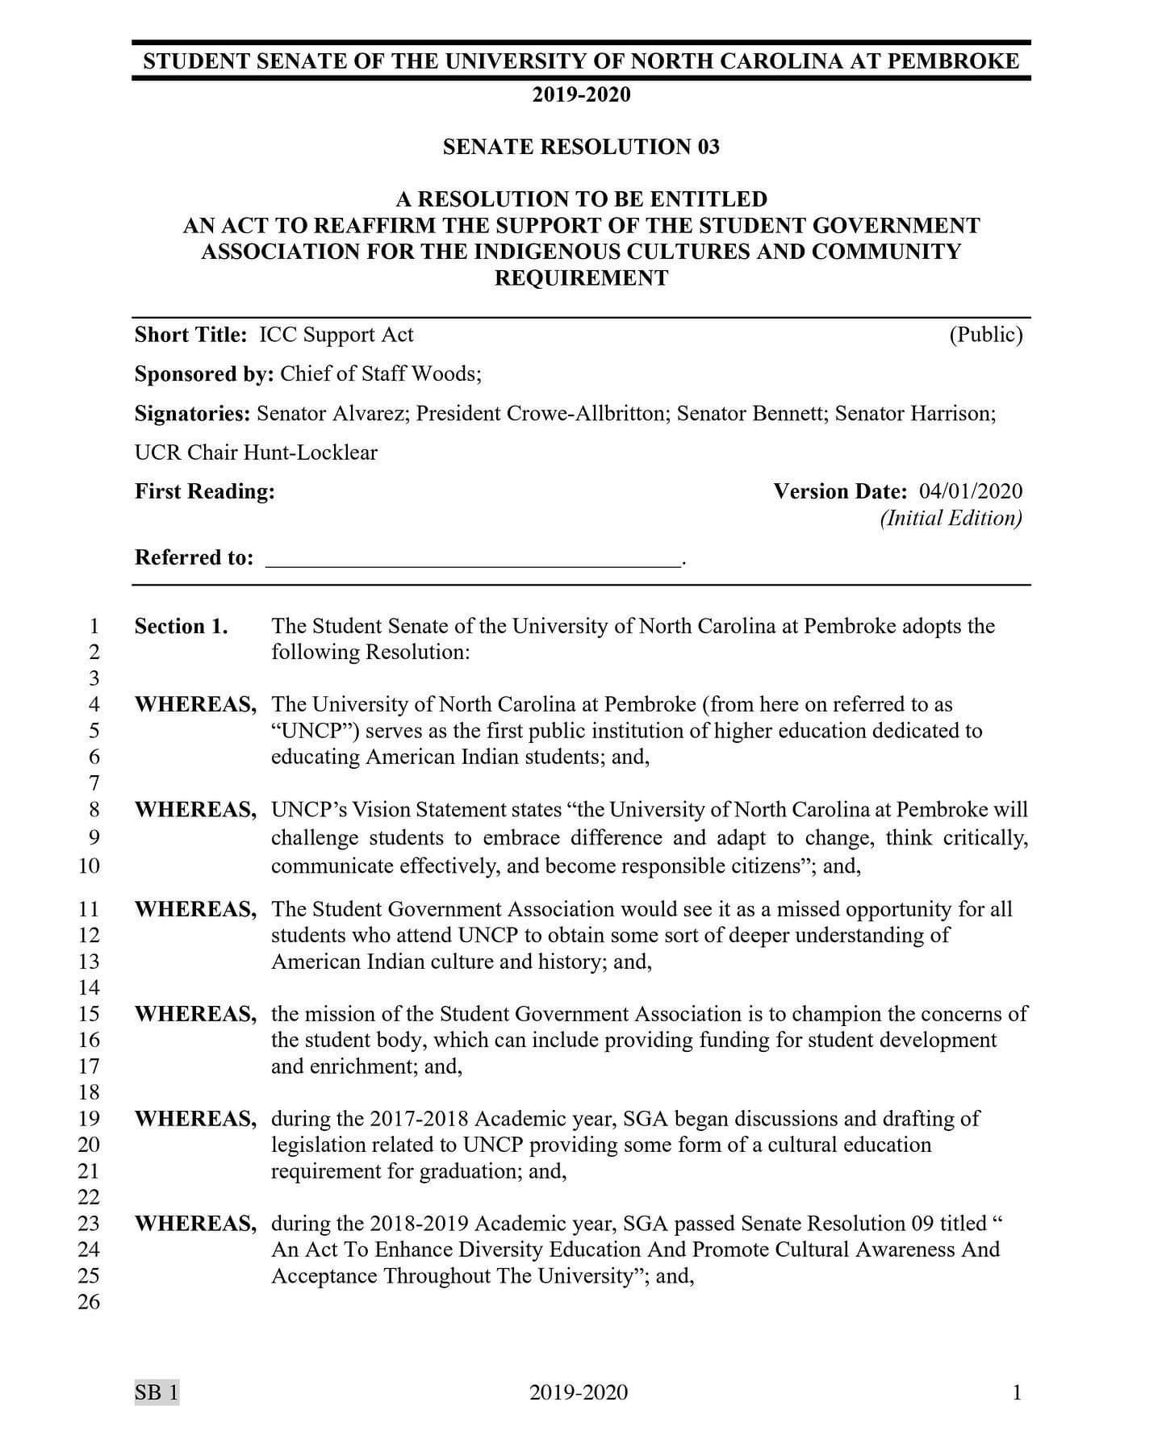
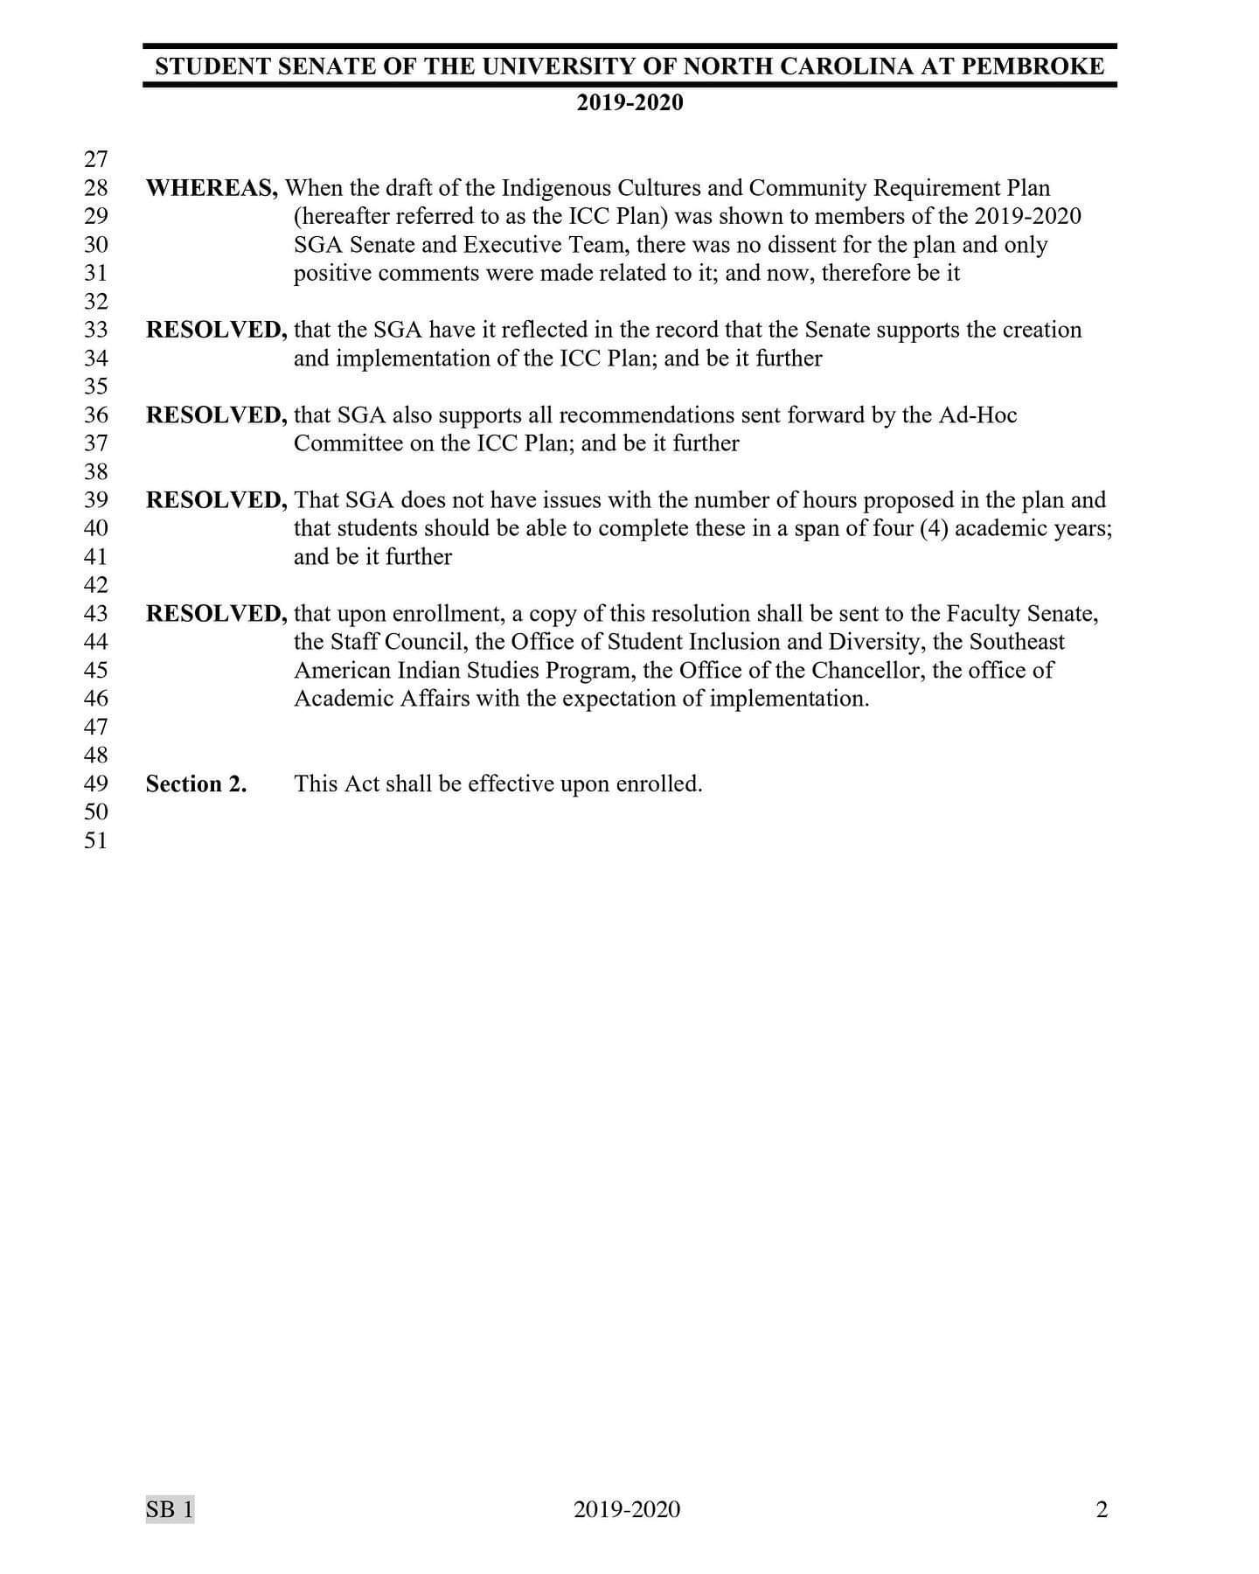
To the UNCP Faculty & Other Stakeholders,

NASO writes to offer their full support of the Indigenous Cultures and Communities (ICC) Proposal. Below are NASO’s thoughts on the need for a graduation requirement centered on Indigenous history and culture:
- UNCP was founded by Indigenous Peoples for Indigenous Peoples, we all know this; it is evidenced by the very names of the buildings we walk into every day. As UNCP evolved from an Indian Normal School to an UNC-System University the number of students representing different ethnicities and backgrounds have increased. This diversity has been welcomed, but the Indigenous history of the university and the culture of the Indigenous community in which it is located continue to inform the identity of the institution. NASO, other student organizations, and staff members in offices across campus contribute to this continuation by organizing and supporting various programming throughout the year (ex. Spring Powwow, M.M.A.I.W. walk, #RepYourNation Tribal Showcase, etc.). Although these efforts are wonderful and we believe that they have educated many students about Indigenous history and culture, we do not think they are enough. Plenty of students graduate UNCP without really knowing what it means to be Indigenous. Sure, they know a little about the history of UNCP, but they have no idea about the struggles Indigenous Peoples are facing today. Many students do not even realize the existence of the Indigenous community on campus; this is partially due to the societal belief that Indigenous Peoples are a thing of the past, that we were mere characters in a story that was told to us around Thanksgiving in Kindergarten. If it is not our duty as an institution to correct that falsity, whose is it?
- It is our understanding that University faculty have raised concerns that students do not want such a requirement. Our question to faculty is this: do students really want any requirements? Are students thrilled about having two P.E. requirements? Do we want to take two writing enriched classes and a writing in the discipline to graduate? No. Surely there has been protest over any new developments in the graduation requirements. The difference is that the University has deemed those requirements necessary and some seem to suggest that this one is unnecessary. This brings us to our third point,
- We are not the first institution in the country to impose a cultural requirement to graduate, we are not even the first institution in the state to do so. North Carolina Agricultural and Technical State University has a graduation requirement that necessitates students take a minimum of three general education credit hours from courses in African-American Studies. The ICC, therefore, is not a new idea, and it should not be a controversial one. Other schools have already implemented the institutional ideals they value in their curriculum, why not UNCP?
- Finally, we want to point out that there are multiple ways for students to satisfy the ICC Graduation Requirement. You can take two classes, you can swipe into events, you can even do a service-learning project or an internship. You can also do a combination of all of these things. Not only does this make the requirement accessible, it turns it into an opportunity to build student’s resumes. Students are provided with an opportunity to learn about the community that they are in and the people who fought tirelessly for the school they attend, students also get an opportunity to learn about the diversity of Indigenous cultures, what it means to be Indigenous in the 21st century, and they get to use this knowledge to further their academic career and broaden their academic interests.
A graduation requirement centered on Indigenous history and culture, like the ICC, should have been implemented long ago; let us not impede progress. Let us remember where we are and honor those who paved the way for UNCP to be a safe-haven for students who value diversity and inclusion. UNCP’s motto is, “You can get there from here.” Let us remember and appreciate exactly where here is.

https://www.insidehighered.com/views/2018/05/01/kuh-and-kinzie-respond-essay-questioning-high-impact-practices-opinion
https://www.aacu.org/leap/hips

