Cisco WebEx inside Canvas.
Helpful Tips
Students who access the Live Meeting via Canvas, Cisco WebEx, and Virtual Meeting tab will not be prompted for a password.
When the Reminder Bot has been enabled the student will receive a meeting invite, which will prompt for a password. It is preferred that the student login to the meeting using the Canvas link or the link inside the Meeting Information found when editing the meeting.
How to set a default password for meeting.
Log into your personal room uncp.webex.com
Click on Meetings
Locate and click on the meeting you wish to edit
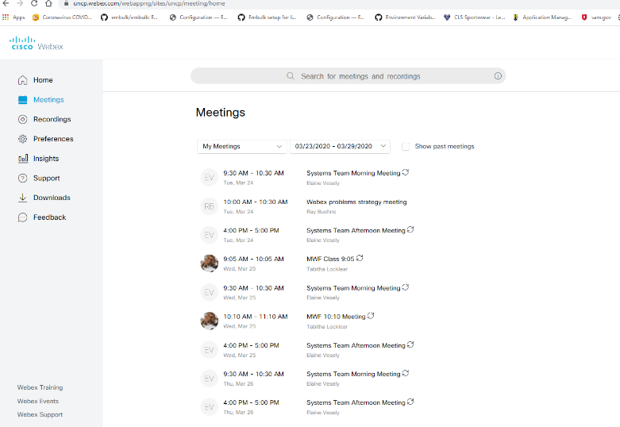

Click Edit icon located near the top (Pencil Icon)
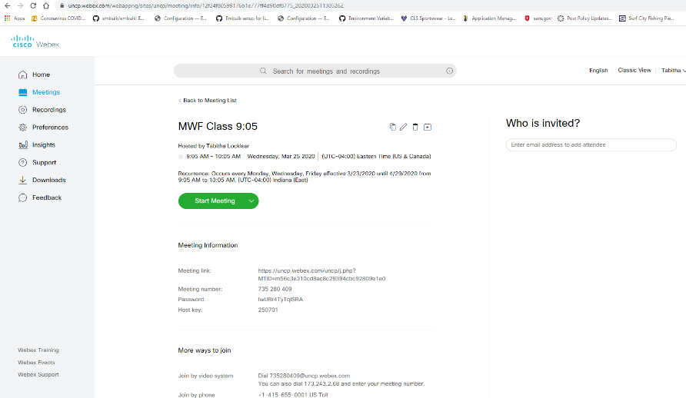
If this is a reoccurring meeting a prompt to edit the series or the one meeting will display.
Locate Meeting Password
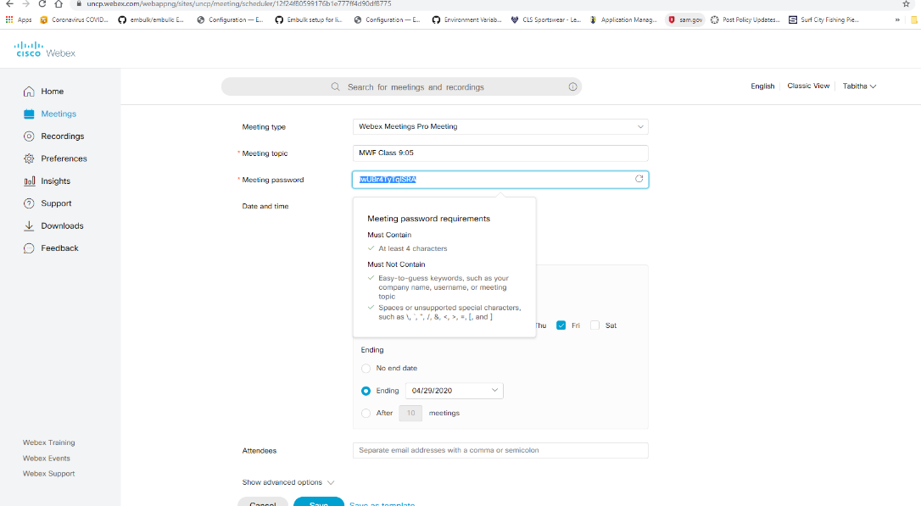
Make desired changes. Save and Exit

How to locate the recorded meeting password.

Log into your personal room uncp.webex.com
Click Recordings
Click the Share icon

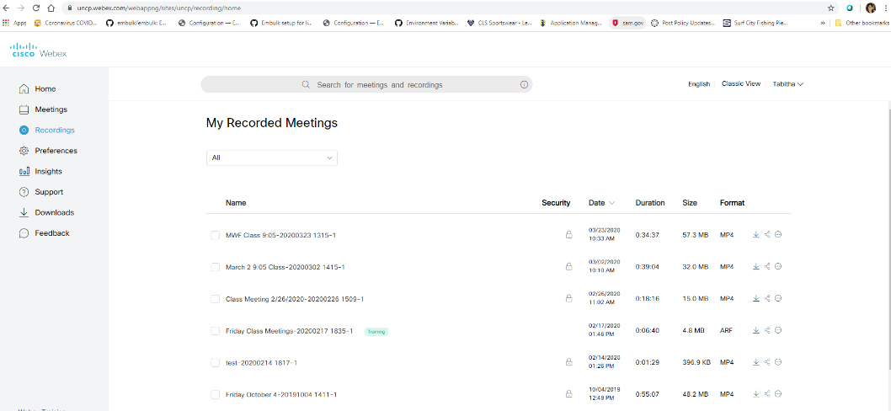

The popup menu allows the user to edit the meeting description, invite others, share the meeting and set a password.
Edit the password or copy the password to share with students. Click on save. Students will use this same password for reoccurring meetings.

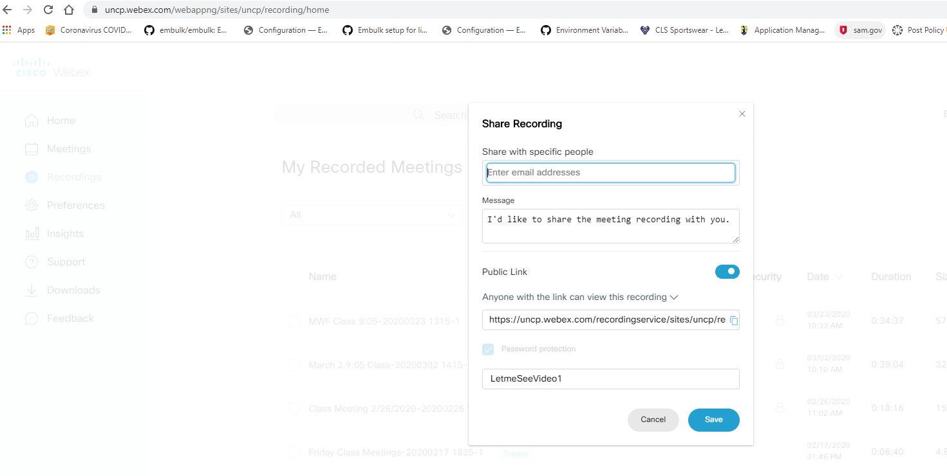

Locate attendees after meeting.
Run a report using the Report feature inside your personal room at uncp.webex.com
View a list of students who logged in using Canvas.
Inside Canvas click on Cisco WebEx, Virtual Meetings, and Past Meetings.
Select the meeting. A list of attendees is displayed.

