SIXTEENTH ANNUAL SOUTHEAST INDIAN STUDIES CONFERENCE
www.uncp.edu/ais
Museum of the Southeast American Indian, Old Main
March 19-20, 2020

Name: ______________________________________________ Email: _______________________________________
Organization: _____________________________________________________________________________________

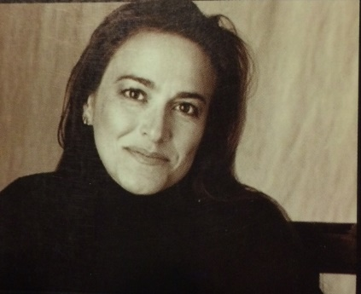
Devon Mihesuah is an enrolled citizen of the Choctaw Nation of Oklahoma and is the Cora Lee Beers Price Professor in the Humanities Program at the University of Kansas. A historian by training, she is the author of numerous award-winning non-fiction and fiction books, including Ned Christie; Choctaw Crime and Punishment: 1884-1907; American Indigenous Women: Decolonization, Empowerment, Activism, and Recovering Our Ancestors’ Gardens: Indigenous Recipes and Guide to Diet and Fitness. Her 18th book, Indigenous Food Sovereignty in the United States: Restoring Cultural Knowledge, Protecting Environments, and Regaining Health, co-edited with Elizabeth Hoover, was published last fall. She is former Editor of the American Indian Quarterly and the University Nebraska Press book series, “Contemporary Indigenous Issues.” She oversees the American Indian Health and Diet Project at KU and the Facebook page, Indigenous Eating.

Check appropriate box for Registration Fees |  | Registration | Meals
□ | Thursday and Friday | $50.00 | Lunch included
□ | Thursday only | $30.00 | Lunch included
□ | Friday only | $30.00 | Lunch included
□ | UNCP student/faculty/staff | Free | Lunch/packet not included
□ | Community | Free | Lunch/packet not included
□ | Dinner Thursday – local restaurant | Pay @ restaurant

Holiday Inn Express Pembroke (910) 521-1311

TOTAL AMOUNT ENCLOSED: (Make check payable to UNC Pembroke) $____________
VISA/MC # _______________________________ Exp. Date ____________________
Mail registration and payment to:
Alesia J. Cummings, Department of American Indian Studies, P.O. Box 1510, Pembroke, NC 28372
For more information, contact Alesia J. Cummings at 910-521-6266 or alesia.cummings@uncp.edu

