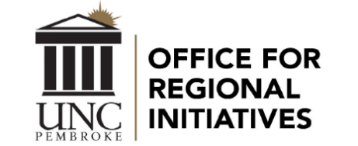
2020 Women’s Empowerment Summit
March 27, 2020
Our Vote. Our Voice.

The UNCP Women’s Empowerment Summit is a day-long experience that includes a mix of dynamic speakers, networking opportunities, information sharing, and education. Our mission is to provide a platform for women of all ages and backgrounds to connect with peers and become informed on issues relevant to today’s women. This year’s event celebrates the 100th anniversary of women gaining the right to vote.

This annual event is made possible through financial support from local businesses, organizations, and community members. Please consider partnering with us to empower the women of our community.

SPONSORSHIP OPPORTUNITIES

Fearless - $1,500
- Prominent sponsorship recognition on the conference website
- Prominent sponsorship recognition in the conference program (name and/or logo)
- Special sponsorship recognition at the keynote and plenary events
- Sponsorship recognition in all media correspondences
- Four registrations included

Brave - $1,000
- Sponsorship recognition on the conference website
- Sponsorship recognition in the conference program (name and/or logo)
- Sponsorship recognition in all media correspondences
- Three registrations included

Confident - $500
- Sponsorship recognition in the conference program (name and/or logo)
- Sponsorship recognition in all media correspondences
- Two registrations included

Bold - $250
- Sponsorship recognition in the conference program (name)
- One event registration included

Thank you in advance for your support.

