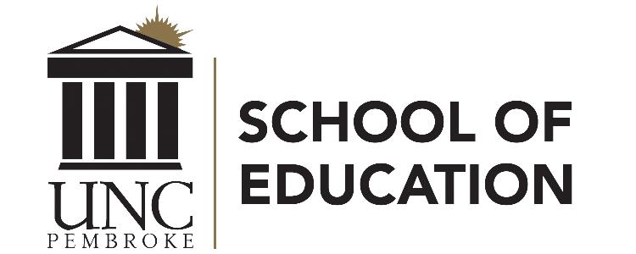 Residency Pathways to Licensure at UNCP
UNCP’s Residency Licensure Pathways enables students who hold a bachelor’s degree to earn a NC teaching license. Residency at UNCP is designed to support residency candidates in their first years of teaching to meet the NC Residency License requirements.

The NC Residency License is a new licensure pathway that is replacing what was known as lateral entry and is defined in (§ 115C.270.20.a.5) as:
A one-year license, renewable twice, that meets both of the following requirements:
- Is requested by the local board of education and accompanied by a certification of supervision from the recognized educator preparation
program in which the individual is enrolled.
- The individual for whom the license is requested meets all of the following requirements:
  - Holds a bachelor's degree.
  - Has either completed coursework relevant to the requested licensure area or passed the North Carolina State Board of Education (NCSBE)
required content area examination(s) for the requested licensure area.
  - Is enrolled in a recognized educator preparation program.
  - Meets all other requirements established by the State Board, including completing preservice requirements prior to teaching.

NCDPI requires that candidates
- be hired by an LEA (residency internship is completed in the candidates own classroom),
- have earned a bachelor’s degree, and
- must have 24 semester hours in the licensure area or have passed all NCSBE required assessments.
Additional Information may be found on the NC Department of Public Instruction website.

NOTE: Beginning September 1, 2019, all candidates seeking initial licensure in North Carolina will be required to submit qualifying scores on the appropriate edTPA performance-based, subject-specific assessment. Your UNCP licensure program will address these requirements. Check with your faculty advisor about program-specific edTPA requirements.

To Apply:
- Residency candidates must first be hired by a Local Education Agency (school system), which will complete the LEA-EPP Verification form.

- The candidates can apply for one of two options at UNCP:
Option 1: Apply to The Graduate School (gradapply.uncp.edu). These residency pathways lead to NC teaching licensure and to a Master of Arts in Teaching (MAT) degree*
Option 2: Apply for licensure only (bridge2brave.uncp.edu). Residency pathways for licensure only in Art, Birth-Kindergarten, Music, Science and Spanish
- Admission considerations for either option:
  - Applicants should have a cumulative GPA of 2.7 or higher for admission, but may be provisionally admitted with a cumulative GPA below 2.7
  - Applicants should have 1) prior relevant degree or b) 24 hours in the requested licensure area, or c) passing scores for all NCSBE required content area examination(s) for the requested licensure area.
For more information, contact Mrs. Mary Klinikowski UNCP School of Education Licensure Officer 910-521-6417 mary.klinikowski@uncp.edu
Option 1: Residency Pathways leading to initial licensure
and all courses count toward an approved Master of Arts in Teaching degree
Online pathways:
Elementary Education K-6
& Special Education K-12

30-Hour (10 course) pathway to initial licensure

- Secure an appropriate teaching position in a school system and obtain the LEA-EPP Verification form
- Complete UNCP Graduate School application (gradapply@uncp.edu)
- Upload the LEA-EPP Verification form with application

Content area contacts:
Art Education K-12: Program Coordinator Dr. Naomi Lifschitz-Grant 910-521-5792 naomi.lifschitz-grant@uncp.edu
Elementary Education K-6: Area Director Dr. Kelly Ficklin 910-775-4037 kelly.ficklin@uncp.edu ONLINE PROGRAM
English Education 9-12 & Language Arts 6-9: Area Director Dr. Roger Ladd 910-521-6624 roger.ladd@uncp.edu
Health & Physical Education K-12: Area Director Dr. Thomas Trendowski 910-521-6342 thomas.trendowski@uncp.edu
Math Education 6-9 or 9-12: Area Director Mrs. Latoya Brewer 910-521-6798 latoya.brewer@uncp.edu
Science Education 6-9 or 9-12: Area Director Dr. Rita Hagevik 910-21-6652 rita.hagevik@uncp.edu
Social Studies Education 6-9 or 9-12: Area Director Dr. Serina Cinnamon 910-521-6641 serina.cinnamon@uncp.edu
Special Education K-12: Area Director Dr. Gretchen Robinson 910-521-6452 gretchen.robinson@uncp.edu ONLINE PROGRAM

*Graduate coursework in the Residency Licensure Pathway meets the requirements for a Master of Arts in Teaching (MAT) degree pending approval from SACSOCS.
Graduate residency programs include nine 3-hour courses (including the Residency Education Core) & 3-hour internship that can be completed in your classroom with edTPA

Option 2: Residency Pathways leading to initial licensure (licensure only)
Art Education K-12 Birth-Kindergarten Education Music Education K-12 Science Education 6-9 or 9-12 Spanish Education K-12
Residency candidates for licensure only will complete the Residency Education Core and licensure area courses. Note: Residency Education Core (4 courses) are master’s level courses. Teaching in your classroom can fulfill the internship requirement while completing the edTPA. Each content area may require a different number content courses and all will include an internship for the initial licensure pathway.
- Secure an appropriate teaching position in a school system and obtain the LEA-EPP Verification form
- Apply at bridge2brave@uncp.edu as a licensure student
- Upload the LEA-EPP Verification form with application
Online pathway:
Birth-Kindergarten Education

Content area contacts:
Art Education K-12: Program Coordinator Dr. Naomi Lifschitz-Grant 910-521-5792 naomi.lifschitz-grant@uncp.edu
Birth-Kindergarten Education: Program Coordinator Dr. Irina Falls 910-775-4386 irina.falls@uncp.edu
Music Education K-12: Program Coordinator Dr. Jose Rivera 910-521-6290 jose.rivera@uncp.edu
Science Education 6-9 or 9-12: Program Coordinator Dr. Mary Ash 910-775-4369 mary.ash@uncp.edu
Spanish Education K-12: Program Coordinator Dr. Cecilia Lara 910-521-6359 cecilia.lara@uncp.edu

