**FIFTEENTH ANNUAL SOUTHEAST INDIAN STUDIES CONFERENCE**

[www.uncp.edu/ais](http://www.uncp.edu/ais)

**Museum of the Southeast American Indian, Old Main**

**March 21-22, 2019**

**REGISTRATION (12 CONTACT HOURS)**

**Name:** ______________________________________________ **Email:** _____________________**__________________ Organization:**______________________________________________________________________________________

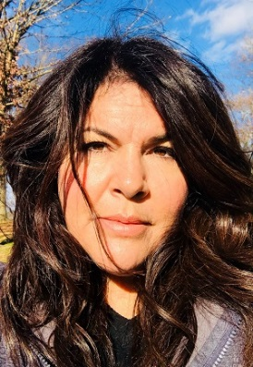**KEYNOTE SPEAKER Stacey Halfmoon** is a citizen of the Caddo Nation and is also a Choctaw Nation and Delaware Nation descendent. She holds a Bachelor’s Degree in Anthropology from the University of Oklahoma and over her 20 year career has completed innumerable trainings and courses in museum studies, cultural resource management, tribal consultation, and American Indian Federal Law. Shortly after, in 1994, she began her career working for the Caddo Nation in Binger, Oklahoma in the Cultural Preservation Department. In 2001, Stacey served on assignment to the U.S. Department of Defense in the role of the Senior Tribal Liaison in the Office of the Deputy Under Secretary of Defense (Installations and Environment). She returned to Oklahoma and served as Director of Community Outreach and Museum Programs at The American Indian Cultural Center and Museum until 2015. Stacey relocated to Columbus, Ohio in 2015 to serve as the Director of American Indian Relations for the Ohio History Connection. At the Ohio History Connection, she promotes knowledge and understanding of American Indians history in Ohio and fosters collaborative relationships with the many federally-recognized tribes who hold deep connections to Ohio. Under her leadership, the organization has established an annual Tribal Nations Conference, implemented a guidance document for the American Indian sites managed by the Ohio History Connection, and is developing its first American Indian Policy.

|  |  |  |  |  |
| --- | --- | --- | --- | --- |
| Check appropriate box for Registration Fees | | Registration | **X** for  Contact  Hours | Meals |
| **□** | Thursday and Friday | $45.00 |  | Lunch included |
| **□** | Thursday only | $25.00 |  | Lunch included |
| **□** | Friday only | $25.00 |  | Lunch included |
| **□** | UNCP student/faculty/staff | Free |  | Lunch/packet **not** included |
| **□** | Community | Free |  | Lunch/packet **not** included |
| **□** | **Thursday at 5:45 pm Chancellor Dining Room** (Amaranth and Dried Cranberry Salad/Cider Braised Beans/White Hominy/Maple Sage Vegetables/Wild Rice Cakes/Cider Braised Turkey/Cranberry Sauce/Sweet Corn and Maple Pudding) | $15.00 |

**Holiday Inn Express Pembroke (910) 521-1311**

**TOTAL AMOUNT ENCLOSED**: (**Make check payable to UNC Pembroke)** $____________

**VISA/MC #_______________________**

**Exp. Date_________________________**

Mail registration and payment to: Alesia J. Cummings, Department of American Indian Studies, P.O. Box 1510, Pembroke, NC 28372

***For more information, contact Alesia J. Cummings at 910-521-6266 or*** [***alesia.cummings@uncp.edu***](mailto:alesia.cummings@uncp.edu)