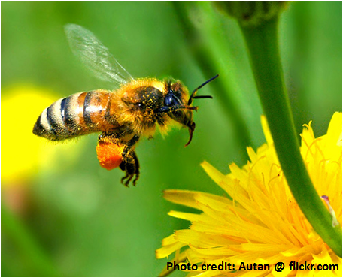
KIDS IN THE GARDEN

Program in Field Science for
Middle/ High School Students
at the University of North Carolina of Pembroke

The Kids in the Garden program, funded by Burroughs-Wellcome, is a STEM program for rising 7th – 12th grade students from Bladen, Cumberland, Richmond and Robeson Counties as well as the surrounding area to investigate the mystery of colony collapse in honey bees at the UNCP campus garden and the importance of pollen and pollinators in the environment. Students who participate in the program experience STEM related content to its fullest extent! Students conduct research in a college setting; take field trips such as to Bayer’s Bees, the Bahr lab, visit a commercial bee operation, Cape Fear Botanical Gardens, to learn about the importance of honey bees, pollen, and pollinators, conduct research at Sampson’s Landing, Lumber River Conservancy and the UNCP Campus Garden. Snacks, supplies, transportation, activity fees, and equipment used during the program are provided. Parents are responsible for transportation to and from UNCP. The Saturday morning program from 9:30 AM - 12:30 PM begins on January 19- March 30, 2019. On Saturday mornings we focus on bee and pollen research with UNCP scientists. The two week summer camp experience called the “bee camp” will occur from June 17 to June 28, 2019, Monday through Friday, 9:00 AM – 3:30 PM (lunch and snacks provided). For additional information please contact Dr. Rita Hagevik at rita.hagevik@uncp.edu or Anastasia Oxendine at anastasia.oxendine@robeson.k12.nc.us or visit https://www.uncp.edu/resources/sustainability/engagement/campus-garden for application forms. Applications will be accepted through May and twenty-four students will be selected to participate in the summer program. Parents will be notified at the end of May of acceptance.
Tell your friends and apply now!
Activities/opportunities include: UNCP Campus Garden – Kids in the Garden Outreach Booth
Academic year program on Saturday mornings at UNCP
Bee Camp last two weeks of June at UNCP
BEE the Change Teacher Workshops – Focus on Literacy
BEE the Change Science Curriculum – Middle and High School
Demonstration Pollinator Gardens – Robeson Co. Early
College/Robeson Community College (Robeson Co.), Jack Britt High
School (Cumberland), Tar Heel Middle School (Bladen Co.)
For additional information contact the Kids in the Garden team – Dr. Rita Hagevik at rita.hagevik@uncp.edu

