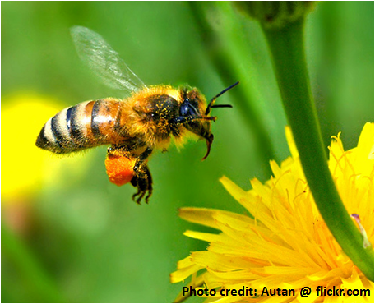
KIDS IN THE GARDEN

Program in Pollinator Conservation for
Elementary School (3rd-5th grade) Students
University of North Carolina at Pembroke

The Kids in the Garden program, funded by Burroughs-Wellcome, is a STEM program focused on pollinator conservation for students from Bladen, Cumberland, Richmond and Robeson Counties and vicinity. This spring we are offering four programs for 3rd-5th graders on one Saturday each month (1:00-4:00pm). Each program is filled with fun hands-on activities, games, crafts, and great information about how you can help pollinators!
Participants can attend any or all of the programs available on the following themes:
- Jan 26th - Saturday (1:00-4:00pm) - Pollinators and Food
- Feb 23rd - Saturday (1:00-4:00pm) - Good bugs, bad bugs
- Mar 23rd - Saturday (1:00-4:00pm) - Colors for Pollinators
- Apr 13th - Saturday (1:00-4:00pm) - Honeybees and Beekeeping

-Snacks, supplies, transportation, activity fees, and equipment are provided.
-Parents responsible for transportation to and from UNCP.
How to Apply: Application forms can be found here ______________.We will accept applicants on a first come first serve basis, up to a week prior to each event (max 24 applicants per event). We will confirm at least a week prior to the event. Tell your friends and apply now!
Questions?
Please contact:
Dr. Kaitlin Campbell, Kaitlin.Campbell@uncp.edu (Program Coordinator) or
Anastasia Oxendine, anastasia.oxendine@robeson.k12.nc.us (Program Director)
or visit https://www.uncp.edu/departments/biology/campus-garden-apiary.

Additional Campus Garden and Apiary Related Activities:
- UNCP Campus Garden – Kids in the Garden Outreach Booth
- Academic year program on Saturday mornings at UNCP- Middle and High School Students
- Summer Bee Camp last two weeks of June at UNCP- Middle and High School Students
- BEE the Change Teacher Workshops – Focus on Literacy
- BEE the Change Science Curriculum – Middle and High School
- Demonstration Pollinator Gardens – Robeson Co. Early College/Robeson Community College (Robeson Co.), Jack Britt High School (Cumberland), Tar Heel Middle School (Bladen Co.)
For additional program info contact the Kids in the Garden Director: Dr. Rita Hagevik at rita.hagevik@uncp.edu

