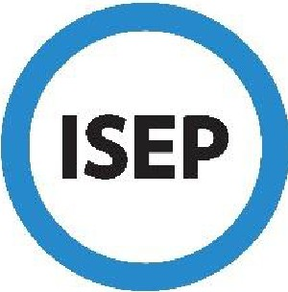
ISEP PORTAL:
Student & Coordinator Journey...
- A student creates an ISEP account at www.isepstudyabroad.org/apply and uses the Program Finder
to explore programs and save them to their account. The student then begins an ISEP application.

- The student completes all parts of the application and submits it to their home ISEP Coordinator.

- The home ISEP Coordinator reviews the application and approves or declines it.

- If approved, the student pays the $100 application fee (if required by the home institution) to submit their application to ISEP by the September 1 or February 15 priority deadlines.

- Following the priority deadline, ISEP begins reviewing applications and making placements. Placement decisions are based on space available at the host institution and academic fit for the student. ISEP aims to notify students of their placement within 3 - 5 weeks of the priority deadline.

- Once the student receives their placement notification, they complete a course list for their host institution. Course lists are due 1 week from the placement notification.

- When the student submits their course list, the host ISEP Coordinator receives the student's ISEP application and course list. The host Coordinator reviews the student's application materials and confirms or denies their admission to the program. Confirmations are due within 3 weeks of receiving the incoming student's application.

- Once admission is confirmed, the student receives their acceptance package. Students have 3 weeks to complete their acceptance package. Students must also enroll in ISEP insurance at least 45 days prior to their program start date, or earlier if required for visa purposes. Home ISEP Coordinators also review and sign the acceptance package.

- The student receives pre-departure and health and safety information from ISEP Global, as well as welcome information and an official acceptance letter from their host ISEP Coordinator. If necessary, the student applies for a visa to study in their host country.

- The student departs for their host country! Upon return home, the student completes a post-program evaluation. Host institutions mail student transcripts to ISEP Global for processing and forwarding.

