Export to Excel in Banner 9
First, navigate to your desired screen and retrieve your results:
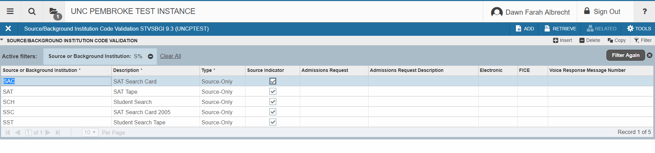

Next, select the TOOLS menu and EXPORT:
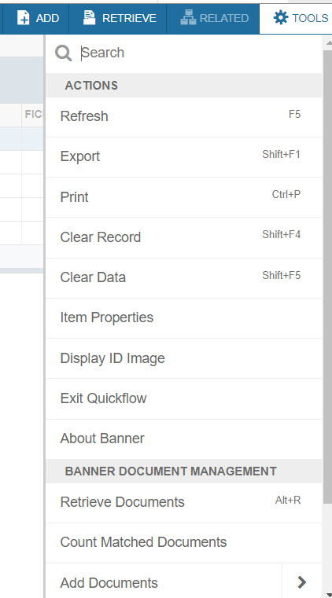

This will produce the results to open at the bottom left corner of the
CHROME browser:
