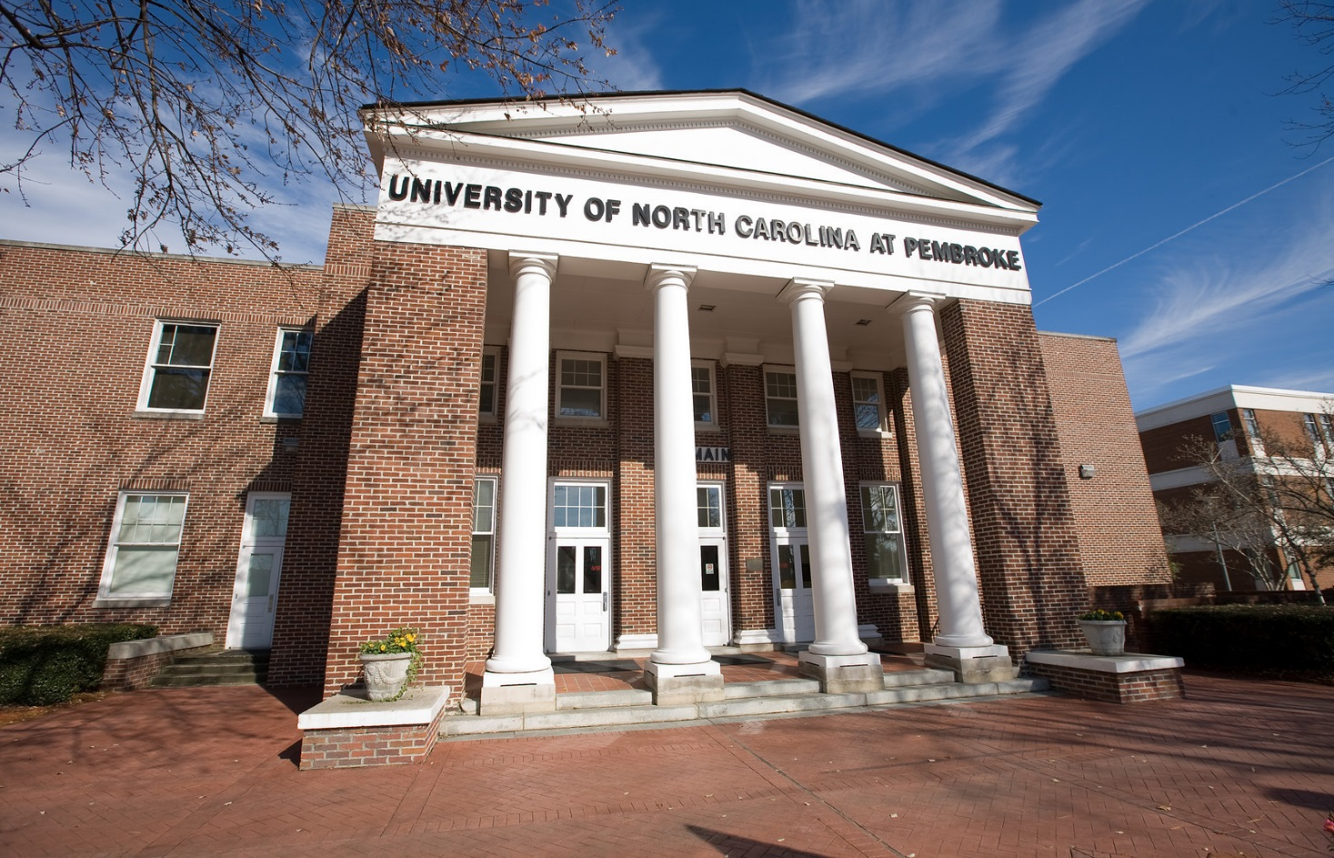
Welcome to UNC Pembroke
NAME

