International Student Guide
  - The University of North Carolina at Pembroke
Changing Lives through Education

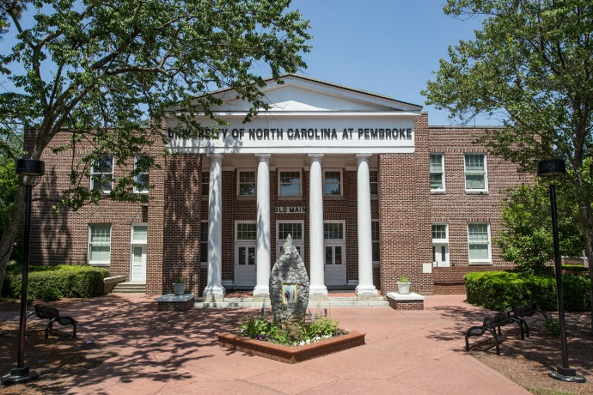
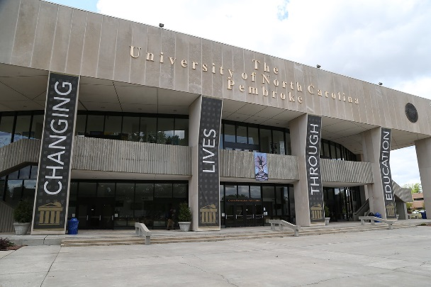
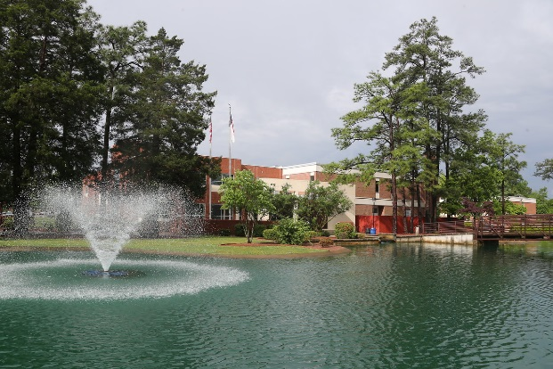
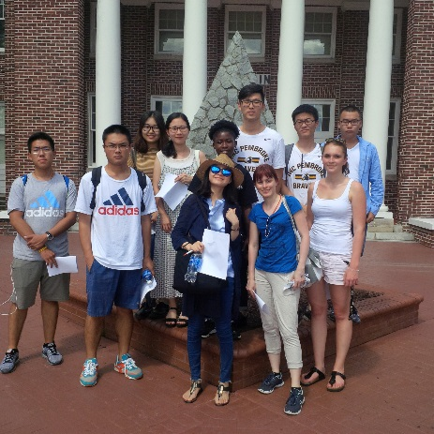
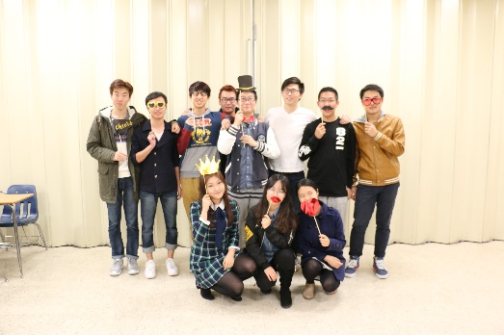
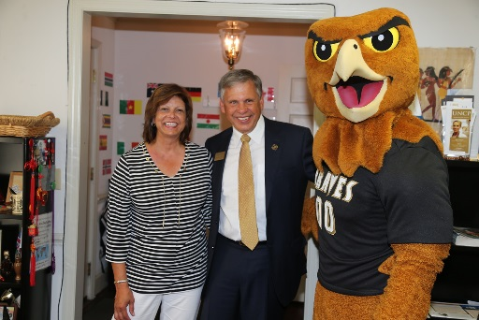
Contents
Welcome to UNCP! 3
Your First Week at UNCP 4
Fall 2017 Orientation 4
UNCP Academics 6
Academic Conduct 8
Academic Assistance 9
Student Life at UNCP 10
International Programs 11
Activities 11
Cultural Exchange 11
Transportation 13
Driving in North Carolina 15
Banking and Finances 15
Shopping 16
Hotels and Restaurants 17
U.S. Culture and Customs 19
Health, Wellness, and Safety 22
Culture Shock 22
Health Care 23

Welcome to UNCP!
Please use this guide as you settle into life in Pembroke, NC and keep it on hand for reference as you continue through your time here. We hope that it will answer your basic questions, but please ask if you need additional information or if a topic isn’t addressed. We’re here to help.
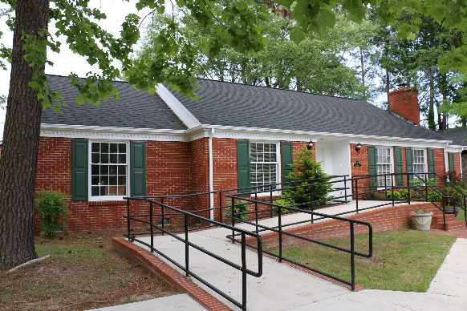
Office of International Programs (IP)
902 Dogwood Lane
ip@uncp.edu
910.775.4095
www.uncp.edu
Brave Connect: https://uncp.campuslabs.com/engage/

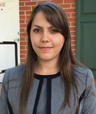
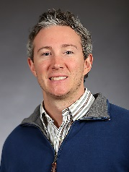
Alexander Brandt
Interim Director,
Study Abroad Coordinator
alexander.brandt@uncp.edu
910.521.6573
Jessica Hall
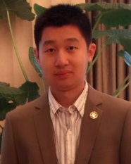
Assistant Director,
Immigration Advisor
(PDSO/ RO)
Jessica.hall@uncp.edu
910.521.6865
Qi Liu (Larry)
Asian Program Coordinator
qi.liu@uncp.edu
910.775.4097
Kateryna Forynna
English Language Institute
Coordinator
Kateryna.forynna@uncp.edu
910.775.4389
Nami Montgomery
ESL Specialist,
English Language Institute
nami.montgomery@uncp.edu
910.775.4096
Amanda Goforth
University Program Associate
(Office Manager) (DSO/ ARO)
Amanda.goforth@uncp.edu
910.775.4095

Follow us on Social Media:
Find us at IP Braves #everywherealwaysbrave

Your First Week at UNCP

Arriving at UNCP
IP offers a complimentary shuttle from
Raleigh Durham International Airport (RDU) to campus.
Check our website for the latest dates and plan to meet the
shuttle at Terminal 2 at 5 PM.
We also have a shuttle that returns students to the airport at the end of each semester.
Check our website for the dates of our upcoming shuttles
(search for International Services on the UNCP website).
Housing
All international students have the option to live on campus and some are automatically placed in the Global Learning Community (GLC) for their first semester in order to provide them with opportunities for meaningful cultural exchange, which fulfills the requirements of the J visa. The GLC is located in the Village Apartments on campus.
All international students planning to live on campus should have filled out the housing application and paid their housing deposit before they arrived. If you were unable do this, go to the Housing office on campus to pay as soon as possible. (See the campus map included in this guide.)

Fall 2017 Orientation
During your first couple of days at UNCP the IP office will host an international student orientation that will focus on immigration requirements, student health forms and immunizations, campus safety, registering for classes and other important information that will help you get acclimated to UNCP. This orientation is mandatory.
August 11:
New International Student Orientation Health Sciences Building 261
7:45 AM- Meet staff from International Programs in front of the Village Apartments community building
8:00 AM- Breakfast and Registration
8:30 AM- Campus Orientation Sessions
10:00 AM- Campus Tour
11:30 AM- Campus Orientation Sessions
12:30 PM- Lunch (Health Sciences Building Dining Area)
1:15 PM- DoIT Technology Session (Health Sciences 258)
2:00 PM- Campus Orientation Sessions
3:30 PM- Group Campus Visits (Library, Writing Center, Braves Card Office)
4:30 PM- Free Time
5:30 PM- Game Night (Optional) Pine Cottage (IP Staff will meet you at Village apartments
Dinner will be provided at 5:20 if you would like a guide)
August 12:
10:00 AM- Walmart Shuttle (Optional) Meet the shuttle in front of Village Apartments
You will have several hours to shop and eat lunch. The shuttle will return to campus at 1 PM.
August 14:
New International Student Orientation Health Sciences Building 261
8:00 AM- Breakfast and Attendance Sign-in
8:30 AM- Immigration Session
10:00 AM- Group Campus Visits (Library, Writing Center, Braves Card Office)
11:00 AM- Campus Orientation Sessions
11:45 AM- Lunch with Dr. Robin Cummings, UNCP Chancellor (Faculty Lounge, University Center)
1:00 PM- Group Campus Visits (Library, Writing Center, Braves Card Office)
2:00 PM- Campus Orientation Sessions
4:30 PM- Free Evening
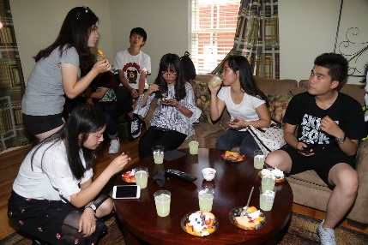
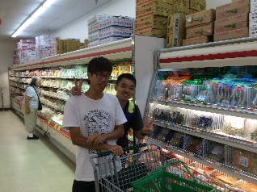
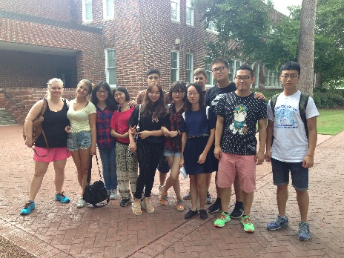
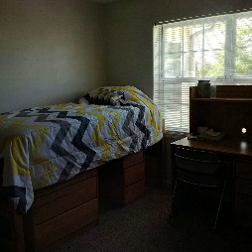
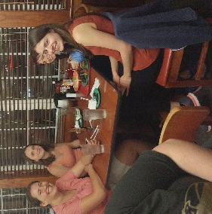
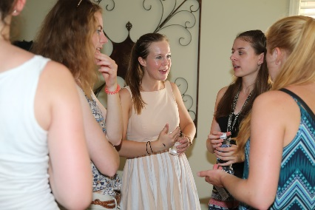
August 15:
8:00 AM- Immunization Shuttles
Meet the shuttle in front of Village Apartments
You will also have the opportunity to
purchase a cell phone SIM card in
Lumberton.
Walmart Shuttle
IP will schedule a shuttle to Walmart on the day after you arrive. Wal-Mart is a local all-purpose store where you can purchase bedding, toiletries, food, pharmacy items, and anything else you may need to get settled. You can pay with cash, a credit, or a debit card.
You can view the Walmart website (www.walmart.com) to help you decide what you may need.
Immunizations
Health forms and immunizations are required for every UNCP student. For more information about UNCP's health requirements visit the webpage for Student Health Services (search for Health Services on the UNCP website).
All International Students are required to take a PPD (TB Skin Test) after arriving on campus. These are offered at Student Health Services for $7.00 each.
We also offer a shuttle service for all students who need to obtain other immunizations after you arrive. Student Health Services will tell you if you need any additional immunizations when they review your health form during orientation.
Cell Phones
It is best for you to have a phone with an American phone number while you are here so that you can make and receive local calls.
There are a number of cell phone companies in the U.S. including: Verizon, AT&T, Sprint, and
T-Mobile. You can also buy “pre-paid” phone plans and pay for the entire expense of the phone up front.
Many students purchase SIM cards for their current phones and switch them out while they are in the U.S. You will have the opportunity to purchase a SIM card during the trip to Lumberton for Immunizations.
Be aware, if you continue to use an international phone plan while you are at UNCP, the U.S. country code is 1.

UNCP Academics
You may find American classroom culture to be different from that of your home country. Below you will find helpful information about classes and academics at UNCP.
Scheduling and Attendance
Most classes meet two or three days a week; typically on Monday, Wednesday, and Friday or on Tuesday and Thursday. Night classes generally meet for several hours one night a week. Attendance is expected, and exceeding the number of allowed absences in a class may result in your failing or being dropped from the class. Notify your professors of the reason for your absence, and be aware that it is your responsibility to get assignments that you missed when you were absent.
Course of Study
On the first or second day of class you will be given a syllabus of the course. It will give an outline of class assignments and homework. Follow the syllabus throughout the semester in order to stay aware of due dates and class expectations. The syllabus may also tell you which teaching methods the professor intends to use in the classroom (see below).
Assignments and Tests
Homework is usually assigned for each class and will usually consist of readings and occasional papers or activities. Tests can be organized in several ways, but most are in multiple choice and/or essay formats. Test questions are usually taken from both the readings and the class notes, and the professor will usually tell you what format to expect in the syllabus or before your first test. Many classes will also require students to make presentations, work on group projects, participate in lab work or case studies, or do peer evaluations.
Teaching Methods
Most classrooms in the U.S. are more learner-centered than classrooms in other parts of the world. This means that professors often use a combination of lecture and discussion in large and small groups. They will typically present content to the class and facilitate discussions while the students are expected to listen, take notes, and participate in the class dialogue. It is important that students analyze the materials they are given and show their understanding through their participation in class and on homework. The goal of a learner-centered approach is for students to gain knowledge and analysis skills that can be applied to situations inside and outside the classroom.
Most professors want their students to speak up with comments and questions during class. Be sure to speak with the professor if you are concerned about your English skills, or feel unprepared for this environment.

Computers in the Classroom
Many professors use technology in their classrooms or as a part of their homework assignments. Some classes are entirely online, while others use a mixture of technology and face-to-face teaching. For instance, some professors will require their students to participate in online chat forums outside of class or to turn in online assignments. The technology requirements for the class should be in the syllabus.
Faculty
The professors in U.S. universities are relaxed and approachable. Feel free to ask questions and share concerns with them regarding their classes. They want you to do well and are generally willing to listen. However, it is also important to realize that the professor-student relationship is a professional (not a personal) relationship and that a more relaxed style of dress or teaching does not mean that they also have relaxed standards for their students. Students are expected to come prepared for classes and meetings, to do their work well and on time, and to behave professionally.

Academic Conduct

In the United States, universities take academic honesty and integrity very seriously. Students are expected to produce their own work without cheating or copying from others. When other people’s ideas or words are used, they must be given credit according to the accepted rules of citation.
According to the UNCP Academic Honor Code, the following acts violate the honor code:
Cheating- “Cheating means the use of or attempted use of unauthorized materials and methods in any academic exercise, whether graded or otherwise.” (POL 02.05.05 2.1.a)
Plagiarism- “Plagiarism is defined as the representation of another’s words, thoughts, creative works, images or ideas as one’s own without proper attribution in connection with submission of academic work, whether graded or otherwise.” (POL 02.05.05 2.1.b)
Fabrication and Falsification- “Falsification is a matter of altering information or material, while fabrication is a matter of inventing or counterfeiting information or material for use in any academic exercise, whether graded or otherwise.” (POL 02.05.05 2.1.c)
Abuse of Academic Materials- “Abuse of Academic Materials is defined as the destruction, defacement, stealing, altering, or making inaccessible library or other academic material.” (POL 02.05.05 2.1.d)
Complicity in Academic Dishonesty- “Complicity means knowingly helping or attempting to help another person to commit any act of academic dishonesty.” (POL 02.05.05 2.1.e)
The consequences for violation of the honor code could be anything from a written reprimand to failure of the class, or even academic suspension.
Please be aware that the Academic Honor Code is enforced across campus, including the English Language Institute.
Normally, professors will tell you which citation manual you should use for their class; their chosen method for citation will normally depend on the subject they are teaching. Each citation style has a manual and some websites offer online help as well. The most common citation styles include APA, MLA, Chicago, and Turabian.
For help with citations, visit the Purdue Online Writing Lab at https://owl.english.purdue.edu/owl

Academic Assistance

The University of North Carolina at Pembroke provides several opportunities for you to receive help with your lessons outside of the classroom. The services are free to UNCP students.
Accessibility Resource Center
ARC works with students with disabilities to ensure that they receive appropriate classroom accommodations. ARC is located in the D.F. Lowry building.
STAR Program
Students who are having difficulty in their classes may participate in individual or group sessions with STAR. This program will help them to improve in topics such as time management, organization, study habits, and test taking skills. STAR is located in Wellons Hall.
Tutoring Program
Tutors will meet with students for hour-long sessions to help them better understand the materials presented in their courses. Students may request a tutor online at the Tutoring Program webpage at www.uncp.edu.
Writing Center
The tutors in the Writing Center will work with students to improve their writing assignments. They are available to help you at any stage of the process, from determining what to write to editing and citing your work. They are located in the D.F. Lowry building and in the Library.

Student Life at UNCP

Campus Recreation: provides students
with opportunities to participate in physical health
and wellness activities, such as intramural games, fitness classes,
and club sports. They also provide opportunities to go on local trips, such as
indoor rock climbing, zip lining, and white water rafting.
Community and Civic Engagement: helps students to get involved in the community through education and service opportunities. They will help you to find a place to volunteer throughout the semester and through special Days of Service and Alternative Break trips.
Diversity and Inclusion: seeks to make UNCP a place where every person’s individuality and identity are valued and respected. They provide regular programs and campus events to promote diversity and social justice within the UNCP community.
Fraternity and Sorority Life: Students interested in Greek life can join a fraternity or sorority. Many students join the organizations in order to form lasting friendships, build connections, practice leadership skills, and be a part of the classic American university experience.
Givens Performing Arts Center (GPAC): hosts several performing arts events throughout the year including concerts, the Broadway and More Series, and university productions.
Housing and Residence Life: offers residents a variety of programs and activities throughout the year that are intended to help students enjoy their life on campus and get involved in the community where they live.
Student Involvement and Leadership: encourages students to get involved in campus life. The office provides regular opportunities for involvement through fun activities, student clubs, and opportunities for student leadership on campus.
UNCP Athletics: The UNCP Braves participate in a variety of sports that are open to the public. Take some time to attend a sporting event while you are here, and cheer on the Braves!

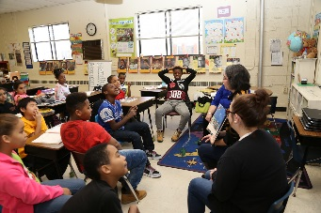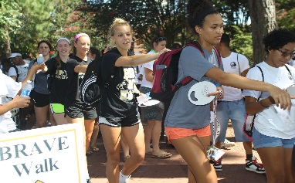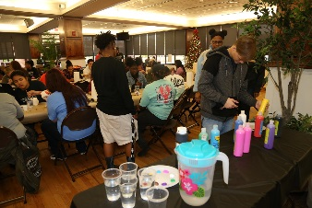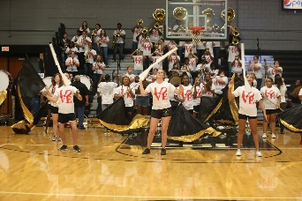

International Programs
18

Each semester IP offers international students the opportunity to participate in activities and cultural exchange opportunities on campus, in the community, and across the region.

Activities
August 19 - Myrtle Beach, 8:45 AM to 6:00 PM
Explore Myrtle Beach and the Boardwalk and shop at Tanger Outlets
September 7 – Dinner and a Movie, 5:00 PM to 11:00 PM
Millstone 14 Theater in Hope Mills
September 23 - International Folk Festival, 9:15 AM to 4:00 PM
Downtown Fayetteville
Fall Break – Asheville, NC, October 12 at 7:45 AM to October 15 at 4:00 PM
Spend the weekend exploring Asheville’s eclectic downtown and enjoying the NC Mountains
October 18 - Chancellor’s Fall Cookout, times to be determined
Chancellor’s residence on campus
October 31 – Halloween Party, 5:00 PM to 7:00 PM
Annual Pumpkin Carving Competition!!!
International Programs House
November 4 – Corn Maze, 10:15 AM to 4:00 PM
Hubb’s Farm Corn Maze and other autumn activities
Other activities will be planned throughout the semester. Watch your email and BraveConnect for more information and to sign-up for events.
The shuttle bus will meet students at Village Apartments community building for all off-campus trips. Be sure to arrive on time.

Cultural Exchange
School Visits – We will set up visits with local schools, which will give you the opportunity to present information about your country and culture to students in the Robeson County School System.

International Education Week- November 13 to 18
Information Fair: Prepare an information table about your country or an international issue and present it to students in the University Center Mall during the lunch period. Tables are available Monday through Friday from 11 AM to 2:30 PM.
International Food Festival: Share a favorite recipe with the cafeteria staff and they will prepare it for lunch on Monday (November 13). Students are encouraged to provide information about their recipes and to attend the food festival to speak about their dishes. Feel free to wear traditional dress if you have it. Recipes are due in the IP office by October 1.
International Trivia Night: This is a favorite IP event! Bring a team, or create one when you arrive, and test your international trivia knowledge. This event will be in the UC lounge on Tuesday, November 14 from 7:30 to 9:30.
Braves Dialogue: International Programs is co-hosting a special Braves Dialogue to give students the opportunity to discuss immigrant experiences and identities in the United States. This Braves Dialogue is co-sponsored with the Office of Diversity and Inclusion. Be a part of the conversation in room 251 of the UC from 3:30 to 5:00 PM.
Movie Night: International Programs and the Office of Diversity and Inclusion are co-sponsoring the showing of Amreeka, a fun and thought-provoking film about a mother and son who immigrate to the United States. Join us in the UC Lounge on Thursday from 7:30 to 9:30 PM.
International Festival: Join us for fun, games, and food from 11:30 AM to 2:00 PM on Friday, November 17 in the UC Lounge. Students are encouraged to sign up for a table and bring a game or activity from their country to share with the UNCP’s Brave Nation. Traditional dress is welcome.
Hawkidays Celebration: Happy Holidays Braves! We will end International Education Week by looking forward to the many holidays celebrated around the world during the winter months. The community and campus are all invited to attend and to celebrate their cultural traditions together. If you would like to share something special about a winter holiday in your culture or religion, sign-up to host a table and invite us to your celebration. Come to the UC Lounge in the evening to join in the celebration. Exact times will be announced soon. This event is co-sponsored by Student Involvement and Leadership.

Pembroke, North Carolina
  - And the Surrounding Area
Located in Southeastern North Carolina, Pembroke is a small town with a rich history. Pembroke is home to the Lumbee Tribe; therefore, much of Pembroke’s life and culture revolves around the heritage of the Lumbee people. UNCP’s history is also tied to the tribe since the university was founded as the Croatan Normal School that provided education of American Indian teachers. Every year, the Lumbee people gather in Pembroke on July 4 to celebrate their heritage and the annual pow wow is hosted in the area in May. UNCP is also a central part of the town and is strongly supported by the local community.
The closest city to Pembroke is Lumberton, which is about 15 minutes away. Lumberton is located on 1-95 (the major North to South road connecting the east coast) and it offers additional restaurant and shopping options.
Other local places you may consider are:
- Fayetteville- a larger city that has more options for shopping, entertaining and dining
- Laurinburg- a town slightly smaller than Lumberton that is to the west of Pembroke
- The Aberdeen, Southern Pines, Pinehurst area- small towns with good shopping, excellent restaurants, a charming small town feel, and a famous golf course.
Pembroke is also located near several places that you can travel to in 3 hours or less (Myrtle Beach, Wilmington, Raleigh, Greensboro, Charlotte, and Columbia.)

Transportation

One of the most challenging parts of living in Pembroke and Southeastern North Carolina is the fact that most people need cars to get from place to place. This area does not have an extensive public transportation system or a culture of walking, so sidewalks are limited, stores are spread out, and it can sometimes be difficult to get from place to place.
However, UNCP has recognized the need for student transportation and provides students with a few options for getting around Pembroke:
UC Shuttle Service (by SEATS) – The Braves Shopping Shuttle (search for UC shuttle on the UNCP website) will transport you to local stores on Tuesday and Friday from 3 to 6 PM. They have several pick-up sites around campus and will take students to Food Lion and Walmart. Students must register for the service, but the service is free for students with a valid ID.
Zip Cars – Become a Zip Car member and rent these electric cars by the hour. There is a $15 annual membership and each rental costs about $8 per hour. Students must be at least 18 years old and have been a licensed driver for at least one year. Zip Car will accept international driver’s licenses. (Search for zip car on the UNCP website)
Bike Rental – Students may rent bikes by the day at the University Center. There is no cost for students with a valid ID. Remember that cyclists must follow traffic regulations, and be careful since drivers may not be used to dealing with cyclists on the roads. (Search for bike share program on the UNCP website)
If you would like to travel outside of Pembroke consider one of these options:
Use SEATs for short trips within Robeson County. You may call SEATS at 910.618.5696 to make a reservation. Trips are $2.00 each way and must be paid in cash with exact change. The shuttle leaves Pembroke at 7:45 AM and returns at 3:30 PM Monday through Friday.
Rent a Car (Use Zip Car or see below for other possible rental options).
Catching a bus or train in Lumberton or Fayetteville if you would like to travel across the state or the region. (Bus and Train Station information is listed below.)
Take a flight out of Fayetteville (FAY), which is closer than Raleigh and provides the opportunity to fly directly to Atlanta, Washington D.C. and Charlotte, or to take a connecting flight through these three major hub airports.
Join university sponsored trips to regional destinations. Campus recreation plans regular trips and Community and Civic Engagement plans alternative breaks (see above).
At this time, Pembroke does not have Uber and other taxi services can be very expensive.
The cheapest and easiest way to travel (or to get to the bus station, train station, or airport) is to make friends at UNCP who have cars. Many people will be happy to have you come along when they go to the store or to do other errands, and your friends will probably be happy to go to the movies or for a night out as well. However, before you go, be aware of these tips for riding with others:
- It is considered polite to offer to contribute to gas expenses, especially if someone is going out of their way to help you.
- It is good to offer a few dollars for a short trip or to fill up their gas tank if you are constantly riding with them.
- Many college students can’t afford to drive all over the area to take you where you want to go, so be aware of what you are asking them to do and offer to pay when they agree to go out of their way to help. (Time is also valuable, so keep this in mind when you ask for help. You don’t want to take advantage of their generosity, even if you are paying for gas.)

Cars
Enterprise Rent-A-Car
https://www.enterprise.com/en/home.html
3409 Lackey Street
Lumberton, NC 28360

Buses
Greyhound
https://www.greyhound.com/en/
Lumberton Bus Station
301 E 2nd St
Lumberton, NC 28358
Fayetteville Bus Station
324 Person St
Fayetteville, NC 28301

Planes
Fayetteville Regional Airport (FAY)
400 Airport Rd
Fayetteville, NC 28306
Raleigh-Durham International Airport (RDU)
2400 John Brantley Blvd.
Morrisville, NC 27560

Trains
Amtrak
https://www.amtrak.com/home
Fayetteville Station
472 Hay Street
Fayetteville, NC 28301
Dillon Station
100 North Railroad Avenue
Dillon, SC 29536

Driving in North Carolina
If you plan to drive while you are here, you will need to get a driver’s license. International licenses are not valid except for short-term visitors. The North Carolina Department of Motor Vehicles (DMV) issues driver’s licenses in this state and their website will give you the information you need if you decided to apply for one.
When you go to the DMV, you should take a letter from the IP office certifying that you are a student at UNCP. You should also take your passport, immigration documents, and proof of car insurance.

Banking and Finances

Students should consider opening a bank account while they are here, especially if they will be staying at UNCP longer than one semester. If you plan to work on campus, you should open an account so that you will have the ability to accept pay through direct deposit.
There is an ATM located on campus outside university center.

First Bank
210 W. 3rd Street
Pembroke, NC 28372
910.521.9776

Lumbee Guaranty Bank
915 W 3rd Street
Pembroke, NC 28372
910.521.4210

Wood Forest National Bank
930 NC-711
Pembroke, NC 28372
910.521.8755
Western Union
913 W 3rd Street
Pembroke, NC 28372
(Inside Food Lion)

930 Hwy 711E
Pembroke, NC 28372
(Inside Walmart)

405 E 3rd Street
Pembroke, NC 28372
(At Piggly Wiggly)
1.800.325.6000

Shopping

Grocery/Department Stores

Food Lion
913 West 3rd Street
Pembroke, NC 28372
910-521-8734
https://www.foodlion.com/
Sunday-Saturday 7:00 AM to 11:00 PM

Piggly Wiggly

406 E Third Street
Pembroke, NC 28372
(910) 521-2760
http://idigthepig.com/
Monday-Saturday 7:00 AM to 10:00 PM

Wal-Mart

930 Hwy 711 East
Pembroke, NC 28372
(910) 522-1321
http://www.walmart.com/store/5489/whats-new
Sunday – Saturday 6:00 AM to 12:00 AM

Pharmacies

Walgreens

503 East 3rd Street
Pembroke, NC 28372
(910) 521-3910
http://www.walgreens.com/
Monday to Friday 8:00 AM to 8:00 PM,
Saturday 8:00 AM to 6:00 PM,
Sunday 10:00 AM to 6:00 PM
Wal-Mart Pharmacy
930 Hwy 711 East
Pembroke, NC 28372
(910) 522-5250
http://www.walmart.com/store/5489/details
Monday to Friday 9:00 AM to 9:00 PM,
Saturday 9:00 AM to 7:00 PM,
Sunday 10:00 AM to 6:00 PM

Hotels and Restaurants

Hotels
Holiday Inn Express
605 Redmond Road
Pembroke, NC 28372
Phone: 910.521.1311
Phone: 888.465.4329
www.hiexpress.com
D.F. Lowry House Bed and Breakfast
504 Lowry Street
Pembroke, NC 28372
Phone: 910.522.1030
Phone: 866.52.LOWRY (56979)
www.dflowryhouse.com
Restaurants
3rd and Main Restaurant
American Food
104 W. 3rd Street
Phone: 910.521.8222
China Eight
Chinese Food
913 W. 3rd Street
Phone: 910.522.1398

Domino’s Pizza
Pizza, pasta, salad, and chicken
412 W. 3rd Street
Phone: 910.521.2223
www.dominos.com
East Wind Restaurant
Chinese Food
406 E. 3rd Street
Phone: 910.522.1383
Jersey Mike’s
Sandwiches
409 W. 3rd Street
Phone: 910.521.4055
Linda’s Restaurant
Traditional Southern Food
408 E. 3rd Street
Phone: 910.521.8127
Michael’s Restaurant
Italian Food
601 W. 3rd Street
Phone: 910.521.7600
Mikoto Express
Japanese Hibachi
412 W. 3rd Street
Phone: 910.521.0068
Papa Bill’s Barbeque
Barbeque
10114 NC-711
Phone: 910.521.3666
Pizza Hut
Pizza, pasta, salad, and chicken
832 W. 3rd Street
Phone: 910.521.0210
San Jose
Mexican Food
938 E. 3rd Street
Phone: 910.521.3011
Sheff’s Seafood & Co.
Fish
100 W. 3rd Street
Phone: 910.521.4667
Subway
Sandwiches
963 Prospect Road
also located in Walmart
Phone: 910.522.0111
The Wing Company
Chicken wings, hamburgers, and sandwiches
703 W. 3rd Street
Phone: 910.703.8009
Zenos Italian Grill
Italian Food
938 E. 3rd Street
Phone: 910.775.9393

*The drinking age in the U.S. is 21. Be prepared to show identification to drink at any establishment that serves alcohol.
Tipping Etiquette in the U.S.
In the U.S. it is customary to give a tip (additional money as a personal thanks) to waiters and taxi drivers. Often the people who work in these jobs rely on their tips to supplement their regular income, and you should tip in all restaurants except fast-food or most cafeteria-style restaurants.
In general, you should tip 15 to 20% for sit-down restaurant service and 10% at a buffet. Tips should be figured out from the amount you spend before taxes are added. You should tip food delivery people as well.
Taxi drivers should also get 15 to 20% of the fare as a tip.

Read reviews for restaurants and other local businesses at these websites:

www.angieslist.com
www.citysearch.com
www.google.com
www.tripadvisor.com
www.yelp.com
www.zomato.com

U.S. Culture and Customs
You will discover many cultural differences between the U.S. and your home while you are here; that is part of the fun of studying abroad. Yet, these differences can also be a source of anxiety and can lead to feelings of isolation. For this reason, we have prepared some general explanations of some of the differences you may encounter while you are here. Keep in mind that while these explanations are generally true for U.S. culture as a whole, individuals in the U.S. may or may not demonstrate each of these traits
Time
People in the U.S. view time as a valuable and limited resource that can be saved, used wisely, or wasted. As a result, they focus on getting things done and finishing tasks. In the U.S., it is important to be on time because it shows that you place value on the person you are meeting or the event you are attending. This varies between different cultures in the U.S., but, if you are not on time, it could be seen as a sign of disrespect. In fact, people often arrive early to activities so that they will not be considered “late”. For instance, International Programs trips leave on time, so it is important that you arrive early and are ready to go with the rest of the group.
It can be difficult to get used to the way that people view time in the U.S., but it is important to learn to respect other people’s time while you are here, and to avoid missing out on activities you want to participate in because you are running late.
Communication
Just as time is considered a valuable commodity, communication in the U.S. is often clear and direct, and speakers are encouraged to “get to the point.” Americans rarely focus on nuances when they communicate; instead most say what they want to say directly and without subtlety. For instance, if an American says “no” to a request, then they really mean no and do not intend to negotiate with you. Many people will also miss cues and indirect messages when you use them because they are not accustomed to listening for them. Eye contact is also considered an important part of communication and is considered a sign of respect. If you don’t make eye contact, people may assume that you are rude or are not interested.
People in the U.S. are also taught from a young age to ask questions and consider this an important part of the learning process. As children, Americans are taught that “there is no such thing as a stupid question.” Professors will often consider the questions you ask in class when they grade you for participation. They want you to ask questions when you don’t understand.
It is also important to realize that even though Americans are generally open, direct, and friendly, there are some topics that they don’t speak about with people they don’t know well. Some of these topics include: money and how much a person earns, family, religion, and politics. On the other hand, the following topics are considered “safe” to speak about with people you don’t know: the weather, your classes or job, sports, music and movies, fashion and shopping, cars, and your travel and commuting experiences. People in the U.S. also use humor in order to make people feel more comfortable or to make a point. Sometimes this humor can be directed to specific individuals, situations, or cultural behaviors (“inside jokes”), which you may not understand right away. Just remember that this is okay (there are probably some Americans who don’t understand such jokes either), and soon you will have your own humorous things to say.
Status and Diversity
One of the founding values of the U.S. is that “all people are created equal”. We may or may not always live up to this ideal, but it is still an important principle to remember. People in the U.S. expect to be given equal treatment. For instance, diversity and inclusion are important principles on our campus; therefore, we consider it extremely important to be respectful and courteous of all members of our campus community regardless of their culture, ethnicity, physical ability, religion, gender, disability, veteran status, sexual orientation, or social class.
Americans are also informal when they speak to one another. Most people will refer to one another by their first names. However, since you are in the south, you may also hear people referring to one another as ma’am or sir, or they might add Ms. or Mr. to someone’s first name when that person is older than them or when they are in a business environment. Normally, you should address your professors with their title (Dr. or Professor) and their last name, but if they ask you to address them less formally, then feel free to do so. If you don’t know how to address someone, it is best or observe what others do or ask them what they would prefer.
The staff and workers in the International Programs office normally prefer to be addressed by their first names only.
It is important to remember that informality does not impact a person’s authority. A professor or staff person at the university may sit down and eat with you or ask you to call them by their first name, but this does not change the fact that they have authority on campus and in your relationship with them. For example, Jessica is the Designated School Official for immigration at UNCP. Her authority as an immigration officer is not impacted by her informality or the fact that you call her by her first name. Within the south, it is also common for people to call you nicknames, even when you don’t know them. So don’t be surprised if a waitress calls you “honey” or “sweetie”, or a person at a Walmart cash register calls you “baby” or “mama”. It’s not personal; it’s just the way people communicate here.
Friendships
People in the United States are often friendly and open, but it can be difficult to form more than a casual or surface level friendship. Many Americans have friendships that exist in certain areas of their lives (such as school, or work, or at the gym), but these friendships do not necessarily grow beyond the level of casual friendship and friends from the gym may not even know your friends from work. This can be frustrating and seem superficial to international students, but it is possible to get beyond the casual friendship stage if you give it some effort. Get involved on campus and join organizations where people have the same interests you do. Make some effort to get to know the people in your dorm and your academic department. If someone suggests meeting for lunch sometime, follow up with them and suggest a time to meet. Americans aren’t uninterested in close friendships, but building these friendships may take a bit more effort than you are used to.
Dating and Relationships
Within the United States there are many different ideas about dating, relationships, and sex. Do not assume that relationships depicted in U.S. media represent the actual relationships of the people. People from different religious and cultural traditions view their personal lives in a variety of ways. Some Americans look for a long-term commitment from the person they are dating, others form relationships but don’t intend to commit for the long-term. Some go out with many different people, and others go out in groups or as friends without romantic expectations. Likewise, university students adhere to a variety of practices regarding sexual behavior. It may be helpful to ask your friends for information about dating in the U.S., but remember that you may get a variety of answers depending on who you ask, and this is not normally an appropriate topic for a casual conversation.
In the end, you should always trust your own feelings and beliefs about dating and sexual conduct.
It is also a good idea to discuss this with your roommates since you may have different ideas about what is appropriate and will want to make plans that are respectful of everyone.
There are some laws and rules that you should be aware of while in the United States and on the campus of UNCP.
“The university prohibits its faculty, staff and students from engaging in any form of discrimination, protected-status harassment, sexual harassment, and sexual violence, and retaliation and expects these individuals to refrain from committing acts of discrimination, bias, or sexual violence”
(The Office of Title IX and Clery Compliance)
- Do not pursue someone who expresses no interest in developing or continuing a relationship with you.
- Do not make personal comments or touch someone in a personal manner without their consent.
- Consent must be demonstrated by “clear actions, words, or writings.” It also must be freely and voluntarily given, without coercion. “Consent can be withdrawn at any time.”
- Sexual offenses include, but are not limited to bullying, coercion, domestic violence, harassment, hazing, assault, exploitation, and stalking.
For more information on these and other related rules visit the website for the office of Title IX and Clery Compliance on the UNCP website, or contact the Title IX office at 910.521.6281 or titleixcoordinator@uncp.edu
Additionally, Student Health Services on campus can provide information and assistance regarding birth control, sexually transmitted diseases, and pregnancy. Student Health Services, Counseling and Psychological Services, and the Office of Diversity and Inclusion can also provide support for students LGBTQ and other gender related needs.
Student Health Services: 910.521.6219, shs@uncp.edu
Counseling and Psychological Services (CAPS): 910.521.6202, counselors@uncp.edu
Office of Diversity and Inclusion: 910.521.6508, odi@uncp.edu

Health, Wellness, and Safety

Staying healthy is an important part of the cultural adjustment process. Be sure to get enough sleep, eat regular and nutritious meals, stay active, and manage your stress as you settle into life at UNCP.

Culture Shock
Settling into life in a new culture takes time. Be aware of the stages of culture shock and work to practice healthy behaviors as you progress through each stage.

Overcoming Culture Shock
- Practice Healthy Behaviors - get enough sleep, eat healthy foods, exercise
- Connect With Others - create friendships with Americans and other international students
- Get Involved - Participate in activities, clubs, and organizations on campus, with International Programs, and in the community.
- Balance Study and Leisure – Be sure to attend class and keep up with assignments, but don’t burn out on work. Be sure to make time for fun and leisure time as well.
- Use Campus Resources – Seek help from campus resources such as the writing center, STAR, CAPS, Student Health, and International Programs

Health Care
Student Health Services
Is located in the Brave Health Center and open Monday through Friday, 8:00am-5:00pm.
International Students are required to enroll in our student health Insurance plan, Student Blue. Student Blue offers a variety of benefits, including health and wellness programs, member discounts and access to the larger provider network in state. This insurance will give you access to all our services including: sick visits, immunizations, gynecological exams, pregnancy/STD testing, and lab tests.

In Case of Emergency
Dial 911 for emergencies. This will call an ambulance, police officer, fire fighter, or other rescue workers.
You can also call the campus safety, if needed. It is a good idea to keep their phone number store in your phone. 910.521.6235
What is an emergency? Some symptoms of an emergency include:
- Loss of consciousness
- Difficulty breathing
- Severe chest pain
- Sudden severe headache
- Bleeding that won’t stop
- Vomiting or coughing blood
- Serious Injury such as a broken limb or head injury
- Poisoning (Call Poison Control at 1.800.222.1222)
- A severe allergic reaction
- Suicidal feelings
Non-Emergency Health Care
*Under United States law the information you share with health care professionals, on and off-campus is confidential and may not be shared with anyone else without your prior consent.
It is often easiest to use Student Health Services on campus. If they are unable to help they will be happy to help you find a medical facility that can help.
For minor problems you can also purchase remedies “over the counter” at a local pharmacy (see the list above). These health care products are available without a prescription and pharmacists are often willing to help you find what you need.
Many people search for medical information online. Be cautious about which sites you visit since many contain incorrect or misleading information. It is always better to speak with a health care professional.
Health Care Providers
This is not a complete list of health care providers in the area, nor are these providers recommended by UNCP. They were included on this list to their proximity to campus and the urgent care or immunization services they provide.
Southeastern Urgent Care Pembroke
923 W. 3rd Street, Pembroke
Phone: 910.521.0564
Hours: 8 AM to 5 PM, Monday through Friday
Closed for lunch from 1:00 PM to 2:00 PM
Southeastern Health Mall Clinic
2934 N. Elm Street, Suite B, Lumberton
Phone: 910.272.1175
Hours: 8 AM to 5 PM, Monday through Friday
Closed for lunch from 1:00 PM to 2:00 PM
Southeastern Regional Medical Center
Emergency Room
300 W. 27 Street, Lumberton
Phone: 910.671.5000
Hours: Open 24 hours, 7 days a week
FastMed Urgent Care
5080 Kahn Drive, Suite 120, Lumberton
Phone: 910.738.5588
Hours: 8 AM to 8 PM, Monday through Friday
8 AM to 4 PM, Saturday and Sunday
Lumberton Family and Urgent Care
309 N. Roberts Avenue, Lumberton
Phone: 910.739.0272
Hours: 9 AM to 6 PM, Monday through Friday
Closed for lunch from 12 PM to 1 PM
9 AM to 1 PM, Saturday
Robeson County Health Department
460 Country Club Road, Lumberton
Phone: 910.671.3200
Hours: 8 AM to 5:30 PM, Monday through Friday

Immunizations
North Carolina state law requires students to have up-to-date immunizations in order to attend classes at UNCP. Student immunization records must be recorded with Student Health Services within 30 days of the first day of class. If you lack immunizations when you arrive, Student Health Services will information you of this.
All international students must be tested for Tuberculosis at Student Health Services when they arrive on campus. A complete list of required immunizations is available on the Student Health Services website.
International Programs has arranged a shuttle to a Lumberton clinic during orientation. This will be the easiest way to bring your immunizations up to date. If further immunizations are required throughout your program, IP will send out periodic emails informing you that you are due for another dose. IP has provided transportation instructions on the Health page of our website.

Information gathered from a variety of sources and experiences. However, we owe special thanks to NAFSA Association of International Educators for providing much of this information, and more, in their US Culture Series Guides, which you can read in the International Programs office.

