UNAPPROVED MINUTES
UNCP Graduate Council Meeting
Monday, May 17, 2021, 3:00 p.m.
Virtually (https://uncp.webex.com/meet/grad)

Present: Irene Aiken (chair), Whitney Akers, Christine Bell, Kirill Bumin (secretary), Serina Cinnamon, Rick Crandall, Susan Edkins, Michele Fazio, Kelly Ficklin, Brandy Geary (GSO president), Rita Hagevik, Julie Harrison-Swartz, Shenika Jones, Roger Ladd, Naomi Lifschitz-Grant, Marisa Scott, Kim Sellers, Tom Trendowski, Bryan Winters, and Summer Woodside

Absent: Latoya Brewer, Loury Floyd (CEPP chair), Lisa Mitchell (MAT director), Emily Sharum, and Velinda Woriax
Guests: none

Meeting started at 3:01 pm

- Graduate Faculty Nominations

Last Name | First Name | Degree | Dept | Program | Status | CV | Votes
Schneider | Matthew | PhD | History | SSE | Full |  | 18-0-0
Beese | Gayle | MAEd | Counseling | CMHC | Prof Aff |  | 18-0-0
Dobens | Sarah | MA | Counseling | CMHC | Prof Aff |  | 18-0-0
* For-against-abstain

- Proposals – Course Deletion (SPE 5230 – Spoken Communication) – approved 18-0-0
  - Rationale: ETFL does not have a speech specialist on faculty, and the course has not been taught in many years.

- Proposals – Change of concentration name (MSN) – approved 18-0-0
  - Proposed Change: Change name of MSN specialty track (Rural Case Manager) to "Clinical Prevention and Population Health."
  - Rationale: we have discovered that prospective students are confused about the focus of this specialty track. This specialty track focuses on clinical prevention of illness and disparities and also on population health within a rural population.
  - There are no revisions needed to required courses. This is a name change proposal only.

- Graduate School Items/Report
  - Dr. Aiken discussed some of the ongoing efforts to reach out to prospective applicants and to convert current applicants into admitted students. She also asked program directors to reach out to incompletes and in-progress applicants, as well as to maintain helpful communications to current students over the summer.
- Graduate Research Symposium – Dr. Bumin provided an update on how this year’s Virtual Graduate Symposium unfolded. He also noted that award recipients were from MPA, English Education, MSW, Science Education, PSC, CMHC, and MBA programs. Altogether, the Graduate School awarded $2,400 this year in competition prizes.
- Number of participants in the Symposium and various competition categories:
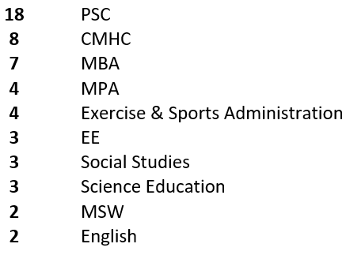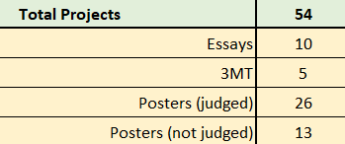

- Announcements/Reminders
- Grad Council Meeting for 21-22 academic year, at 3:00 pm: September 20, 2021; October 18, 2021; November 15, 2021; January 24, 2022; February 21, 2022; March 21, 2022; April 18, 2022.
- Graduation Application Deadlines:
October 1, 2021 for spring 2022 graduation
March 1, 2022 for fall 2022 graduation

Meeting ended at 4:01 pm

