Cross-listing Course Sections in Canvas
In Blackboard this was referred to as Course Combinations and the designated course was a COMB or C1. In Canvas this is referred to as Cross-listing but an additional course is not created; instead the courses become merged with one course being the Primary or Parent (contains all the content and enrollment) and the Secondary or Child shell (becomes an empty shell). It is important to note that before Cross-listing that course sites are not published and grades have not been entered in Canvas.
- ​If a published course containing student submission, activity, and grade data is Cross-Listed into a "Parent" course, that data could be lost.
Once a course section has been cross-listed the teacher and students will only be able to view the parent shell in the course dashboard.
Instructions
In this example we will Cross-List Course DSC-2090 sections 001 and 804. Section 804 will be the Parent Course Shell section 001 will be the Child shell.

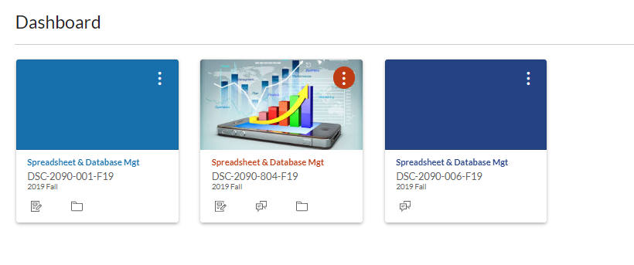
Select the Parent Shell and locate the SIS ID or Course ID. Make a note of the SIS ID.
In this example DSC-2090-804 is the Parent Shell.
STEP 1.
- You can locate the SIS ID by accessing the course from the Course Dashboard, click on Settings from the course menu, from the Course Details tab locate the SIS ID.

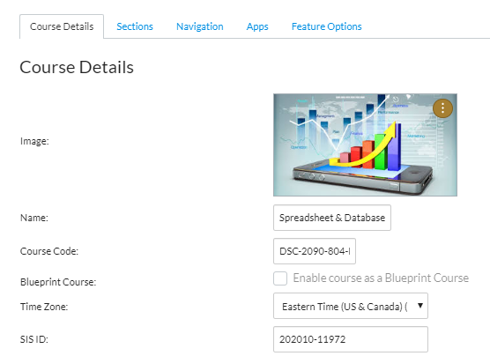

- Exit and return back to the Course Dashboard
- Click on the Child Shell (In this example it is the DSC-2090-001)

- Click on the Settings button located at the bottom of the course menu.
- Click on the Sections tab at the top of the page.
- Under the Course Sections list, click on the course name displayed. In this example it’s the
DSC-2090-001-F19. Note the student enrollment.

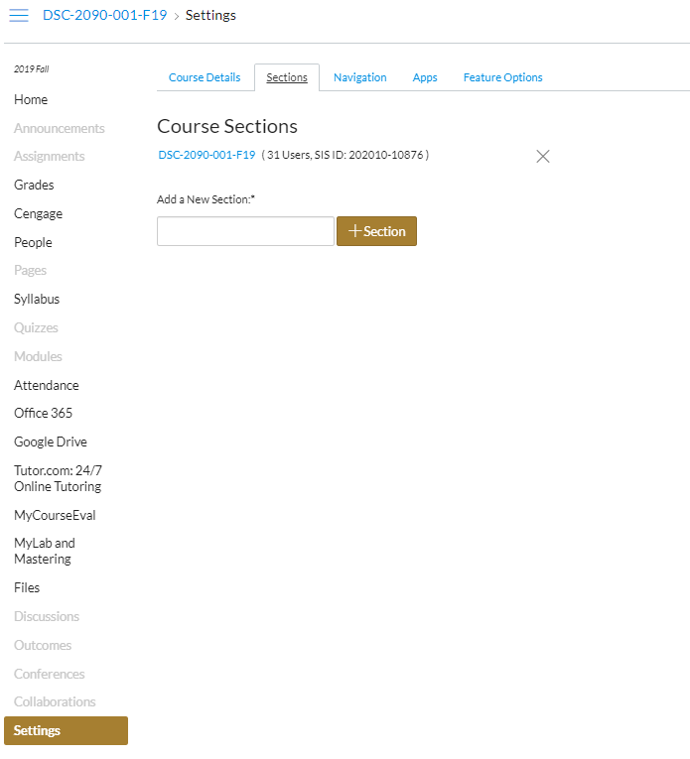

- Once the section has been selected another window opens. Locate and click on the Cross-List this Section button. (the button could be located to the right, top or bottom of the screen depending on your browser settings)
- A pop-up window appears asking for the Course ID. This is the SIS ID located from Step 1. You also have the option to Search for the Course: Not recommended. You run the chance of selecting the wrong course due to the fact that it doesn’t list the term just the course name.
- After you place the Course’s ID correctly the course will display below for selection.
- Click on the Cross-List This Section button.

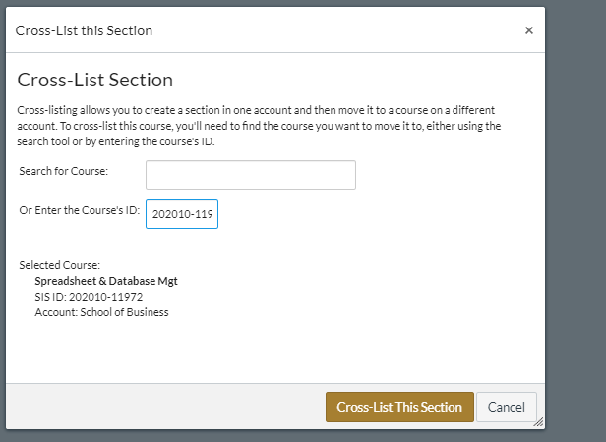

- Once completed successfully you will be immediately taken to the Parent Shell.
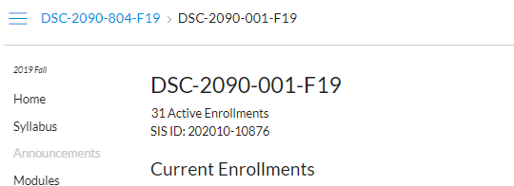

- Verify course section by clicking on the Settings button located at the bottom of the course menu.
- Click on the Sections tab, you should now see both sections listed.
- Click on the People button located on the course menu. You should now see students from both sections. Verify by looking at the Sections tab and notice both sections are now being displayed.
- Locate the Teacher Name and verify that both sections are displayed.
  - If both sections are not viewable you may need to change your privileges. You can do this by clicking on your name. Under Membership(s) both sections will be listed. If you see (let this user see all course users) click on this option and you should then be able to view both sections.
- The Child Shell will no longer display on your Course Dashboard.
- When creating Announcements, Discussions or Assignments you will have the option to display to All Sections, Either Section or any student from All Sections.
- The Gradebook should now display enrollment from both sections.
- You can filter the Gradebook to Display All Sections or Either Section by clicking on the View button, Filters-Sections. The Filter will display on the right hand side with a drop down menu.

