Note: Please verify with students that they have logged into https://uncp.webex.com before enabling this feature inside your Canvas course.
Students must also install the WebEx Teams app to participate in WebEx Teams outside of Canvas.
Click here to download Cisco Webex Teams
If students wish to join a Virtual Meeting using a mobile device they must allow the app to access the video and audio on the device.
Setup Cisco Webex in Canvas Course
- Enable Cisco Webex in Canvas: In your Canvas course, click Settings from your course menu (left side). Click on Navigation tab. The Cisco Webex is located at the bottom with the disabled apps. Drag Cisco Webex to the top within your course navigation to enable.

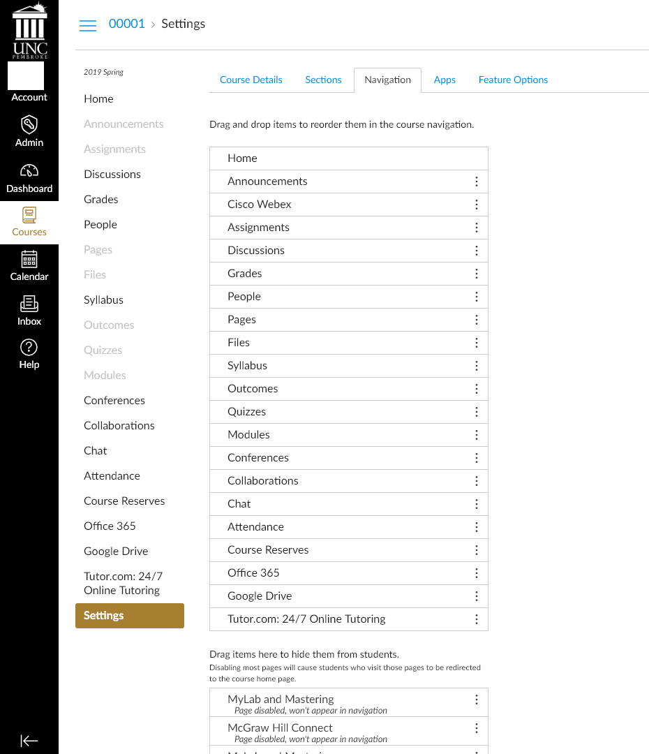

After you enable Cisco Webex from Settings it will appear on your course menu (left side).
- Setup Cisco Webex: Click on the Cisco Webex link from your course menu to complete setup.

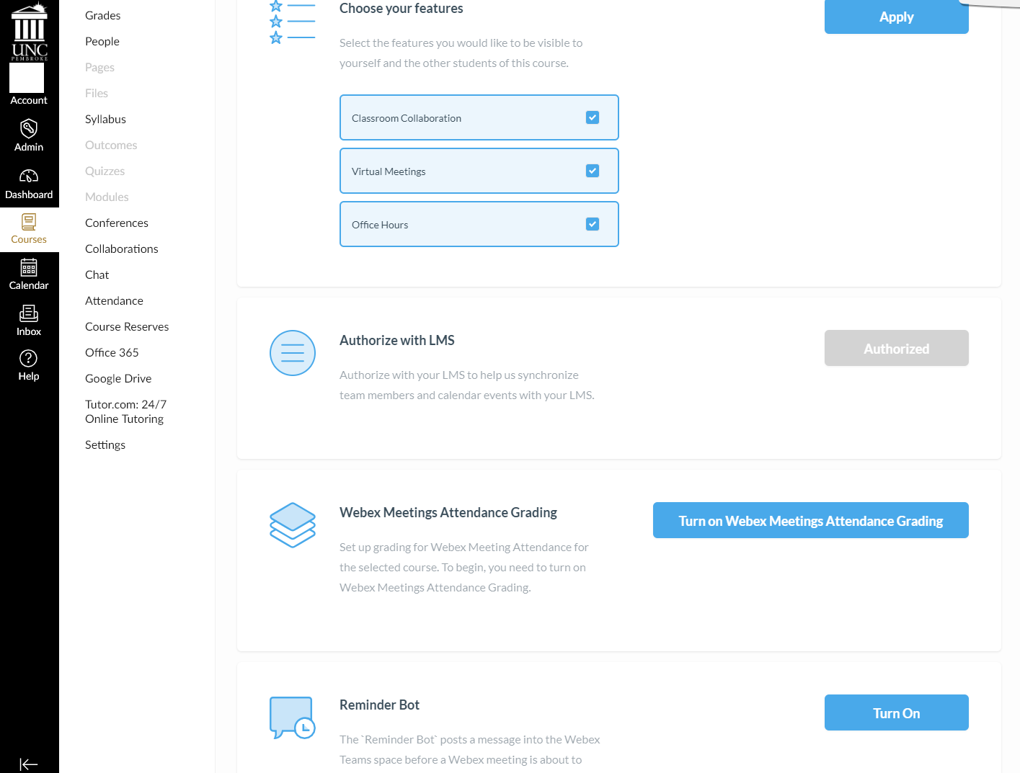
The Setup options are Classroom Collaboration, Virtual Meetings, and Office Hours. Click to choose which you would like enabled within your course. After you have made your selection choose Apply. You can make changes to your selection later if needed.
- Classroom Collaboration- Where you can create Spaces and Webex Teams from your course roster. Allows communication between faculty and students or students with other students in the course. Includes, instant messaging, calls, file uploads, people search.
- Virtual Meetings – Create meetings for class or one-on-one meeting with students.
- Office Hours – Set up time slots for office hour’s availability so that students can request meetings.
- Authorize with LMS – Click the Authorize option to allow Cisco Webex to sync with your Canvas course. (This may already be grayed out, if so skip to next option)
- Webex Meetings Attendance Grading – Turn on Webex Meetings Attendance Grading allows students to get a grade for attending the Virtual Meetings.
- Reminder Bot – Turn on to remind invitees of Virtual Meetings that have been scheduled. Reminder are displayed in the spaces window before the meeting begins.
Once you have completed the Setup click apply or save.

- Create Webex Teams or Spaces: The tabs that are available at the top depend on what was enabled during setup. Classroom Collaboration is where you will create teams and spaces. Create a team - Once you click submit it creates a General Team including all members in the course. An email is generated that notifies the member that they have been enrolled into a Webex Team. After the team has been created students can then create their own spaces for group projects. Important Note: Do not remove the General Team that is created during the setup process or remove yourself as a member; if this team is removed you will not be able to access the Classroom Collaboration tab within the course.
Create spaces allows you to create a space where members are added manually. You can add users by searching for them by email. All users within Canvas are available.
Members tab allows you to verify students that have been added and invite other members by using their email address.
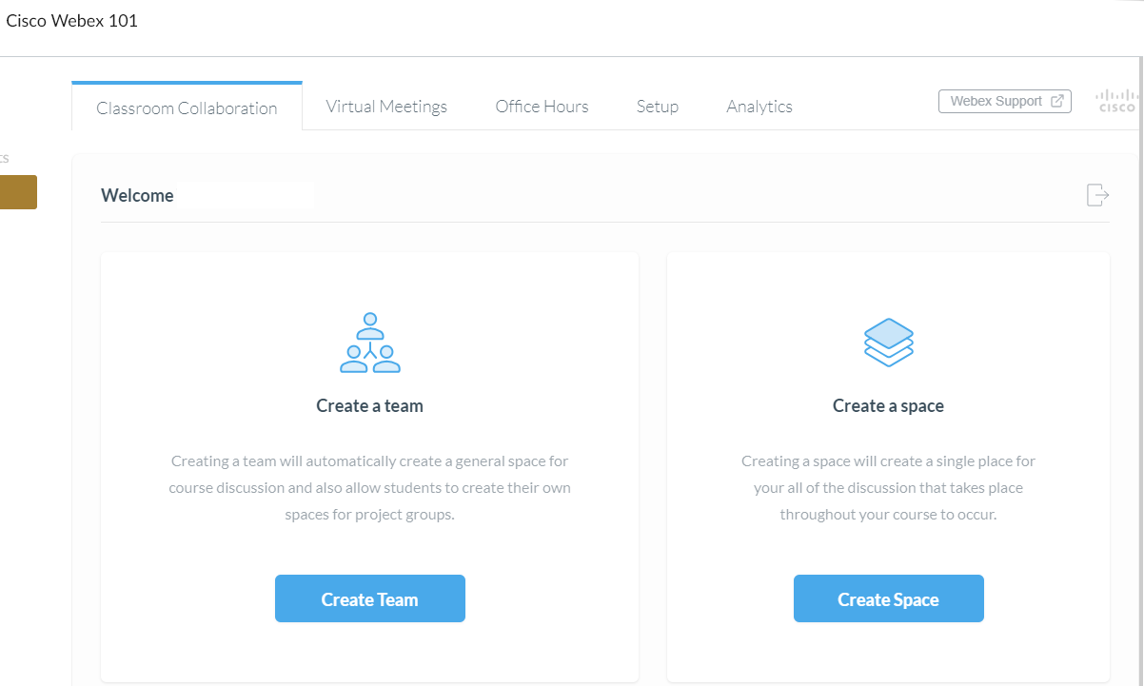

- Virtual Meetings: You can create New Meetings or view a list of upcoming or past meetings. There is a filter option that allows you to search through meetings that you have already created.
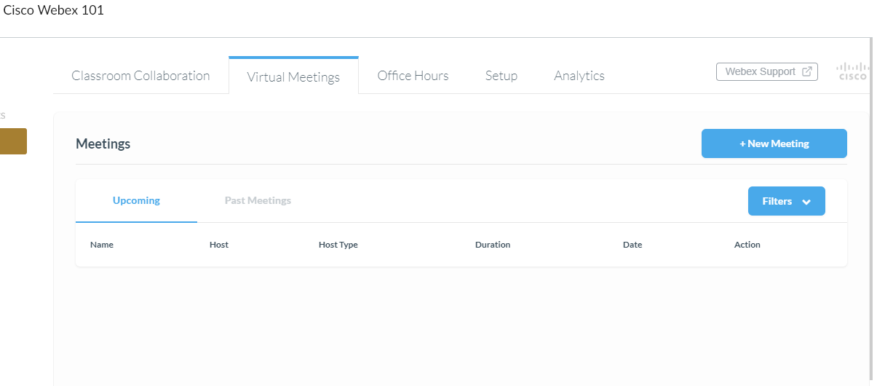
When you click + New Meeting a new window appears. You will put in the Name for the meeting, set the date and time, chose to either allow the meeting to reoccur. Click Create Meeting when finish.
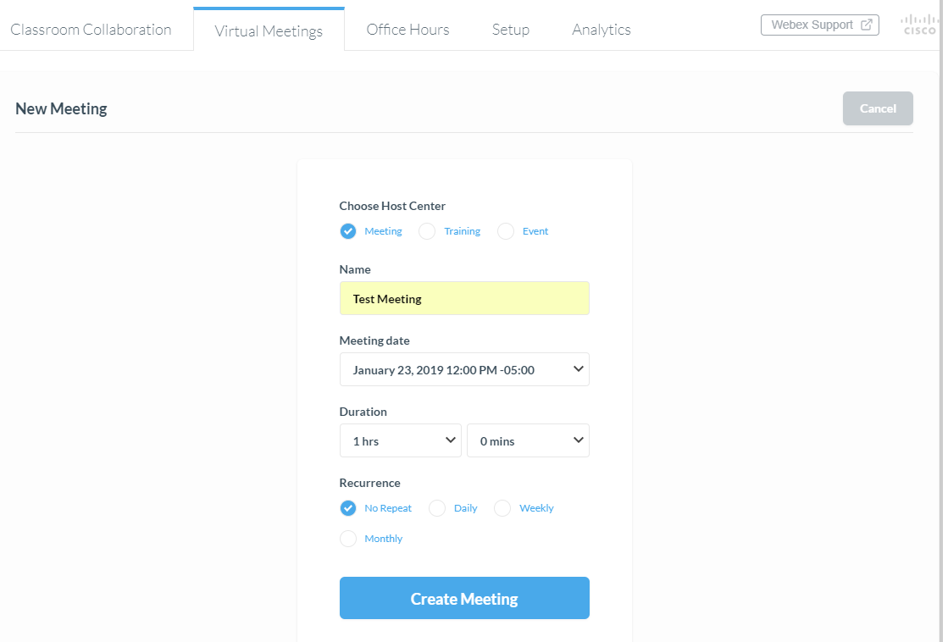
You will have 3 choices. Meeting works best for course meetings.

- Setup Office Hours: Office hours allows you to block off time to schedule meetings with students. You have the option to set the meeting duration in increments between 15 – 60 minutes. You can also block off extra time to allow a buffer between meetings. Click the time blocks to make your selection.
Faculty View
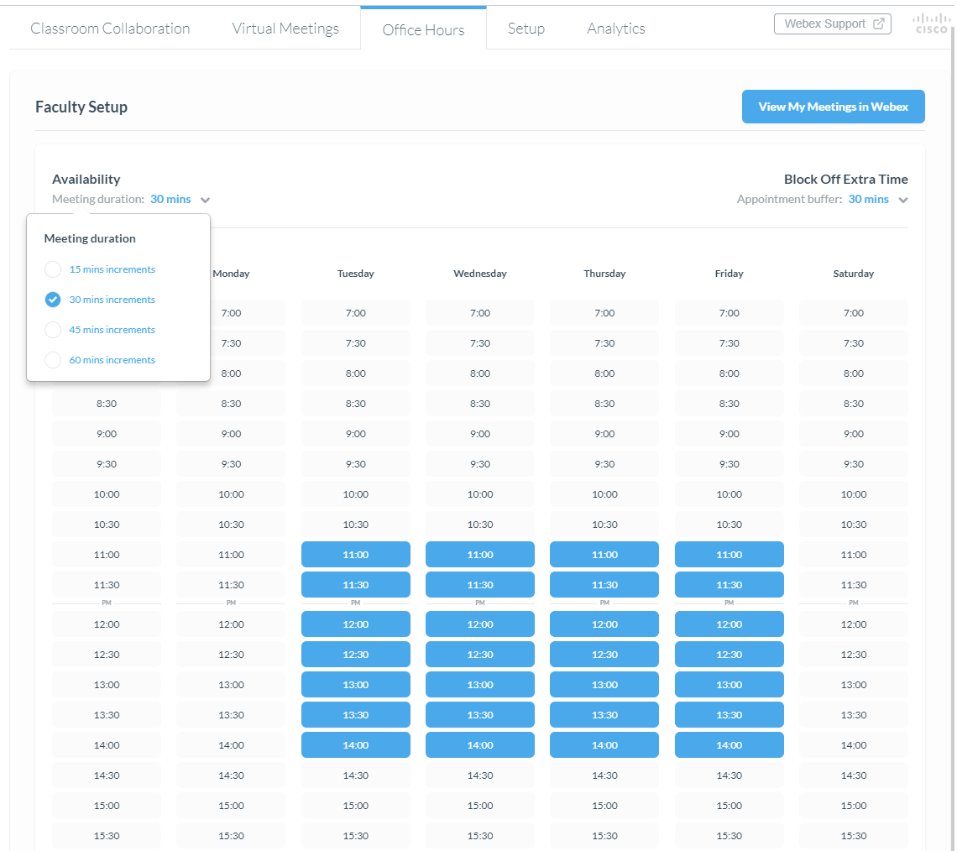
Student View
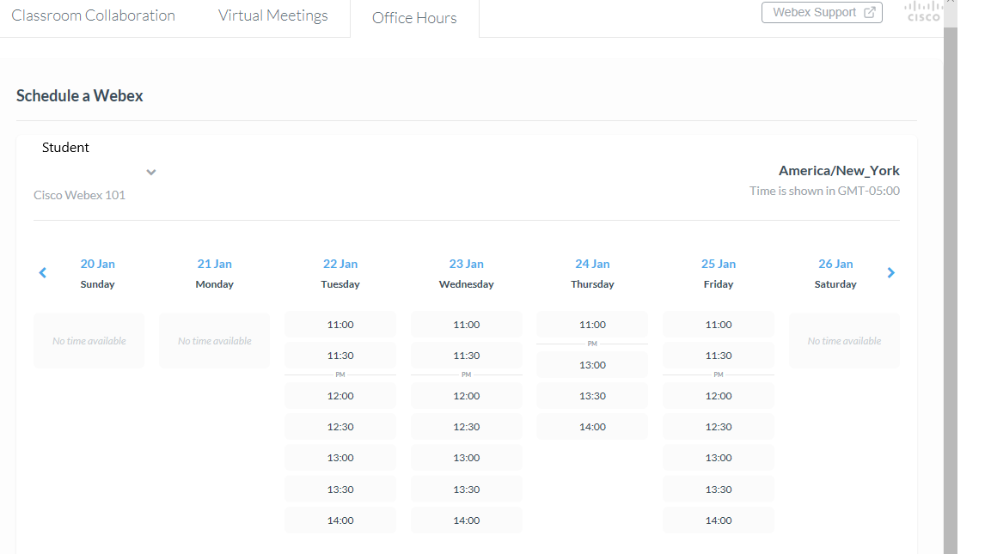
Students can view the instructor office hours by accessing their course, choose Cisco Webex, Office Hours. Student view displays available office hours posted by the instructor. Once they select a time they get the option to confirm. An email is then generated with a calendar invite for the instructor and the student. The time is then removed from all other student’s view, to prevent overlaps.

- Analytics: Displays the number of teams and spaces created, meetings scheduled, and how many office hours that have been booked.
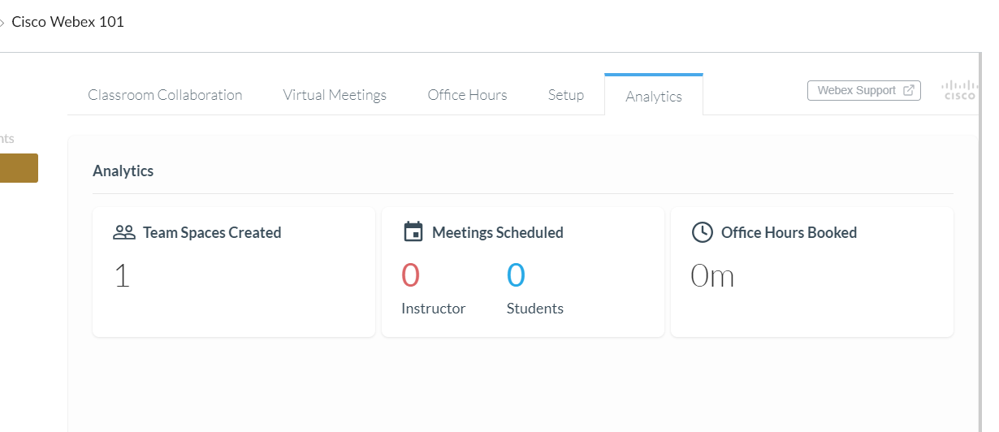

Check out our webpage on Webex to find more information on Cisco Webex Meetings and Cisco Webex Teams.
https://www.uncp.edu/resources/division-information-technology/what-do-i-need-know-about-using-webex-uncp

