The University of North Carolina at Pembroke
Academic Information Technology Committee (AITC)
Agenda - Monday, November 12, 2018 at 3:30 p.m.
Chavis University Center 208

Members of the AITC:
Aaron Vandermeer (Chair), Senator
Conner Sandefur, Senator
Larry Arnold (ARTS, 2020)
Lisa Mitchell (EDUC, 2020)
Walter Lewallen (LETT, 2019)
Jesse Rouse (NSM, 2019)
Mohammad Rahman (SBS, 2020)
Nancy Crouch, CIO
Joy Fuqua, Director of Online Learning
Terry Locklear, Instructional Designer
Debbie Bullard, Representative of the Accessibility Resource Center
Dennis Swanson, Representative of the Library
Tremain Ingram, SGA Senator

Order of Business
A. Roll Call
B. Approval of Minutes (Appendix A)
C. Adoption of Agenda
D. Reports
- AITC Chair—Aaron Vandermeer
- AVC for Technology, Resources and Chief Information Officer—Nancy Crouch
- Director of Online Learning—Joy Fuqua
E. Unfinished Business
- Quality Matters information and discussion (Appendix B)
- Course Evaluations/Scantrons (Appendix C)
F. New Business
- LMS Third Party Integration Procedure (Appendix D)
- LTI Request - Wepa (Appendix E)
- Launching Beta features in Canvas
- Classroom Instructor Machines
- Updating online program templates for consistent navigation
G. For the Good of the Order
H. DoIT Technology Report for AITC: 18.10.10 Report
I. Campus Computing Survey - Executive Summary (Appendix F)
I. Announcements
J. Adjournment
Appendix A—Minutes Draft of October 8, 2018
The University of North Carolina at Pembroke
Academic Information Technology Committee (AITC)
Agenda - Monday, October 8, 2018 at 3:30 p.m.
Chavis University Center 208

Members of the AITC Present:
Aaron Vandermeer (Chair), Senator
Larry Arnold (ARTS, 2020)
Lisa Mitchell (EDUC, 2020)
Walter Lewallen (LETT, 2019)
Jesse Rouse (NSM, 2019)
Mohammad Rahman (SBS, 2020)
Nancy Crouch, CIO
Joy Fuqua, Director of Online Learning
Terry Locklear, Instructional Designer
Dennis Swanson, Representative of the Library
Tremain Ingram, SGA Senator

Members Absent:
Conner Sandefur, Senator
Debbie Bullard, Representative of the Accessibility Resource Center

Order of Business

A. Roll Call – The meeting was called to order at 3:32PM

B. Adoption of Agenda – The Agenda was approved as disseminated

C. Review of Committee Charge
The Academic Information Technology Committee is a standing committee of the Faculty Senate. The committee represents Faculty interests in all matters relating to Information Technology and acts as the service owner for technology services and Information Technology Policy where the primary focus is on pedagogy, faculty research, and service. The committee will make recommendations to the Faculty Senate regarding the implementation, governance, or changes to these technology services. The Committee will recommend and engage in faculty centered activities to adopt key academic technologies. The Committee will also advise the CIO and the Senate on new technology initiatives and will evaluate and make recommendations concerning academic computing and information policies, standards, and procedures proposed or implemented by DoIT.

D. Election of Secretary
Jesse Rouse was elected as Secretary (9-1-0).
E. Reports
- AITC Chair—Aaron Vandermeer
  - There will be a discussion of agenda items for the year

- AVC for Technology, Resources and Chief Information Officer—Nancy Crouch
  - Student Printing
    - Spring attempt with existing multifunction devices was not successful
    - Fall, still using lab printers run by DoIT
    - Looking at kiosk printers
      - 11 locations across campus
      - Will be accessed with BraveCard or credit card
      - Students will potentially have funds loaded from fees to cover a reasonable number of prints
  - Course Evaluations - scantrons and beyond
    - The Scantron course eval system has issues. What are the alternatives? What are the costs to replace Scantrons?
    - Online SEIs may be on the horizon. The committee will look at possible mechanisms and suggest methods of increasing response rates. Current course evaluation software is licensed and used through Office of Online Learning. The site license would allow current OOL evaluation software to be used across campus. Nancy, Terry, & Joy will bring more info on online evaluation options to November meeting.
  - General DoIT service update
    - West Hall Planning
    - Possibility of tariffs impacting costs for upcoming computer refresh cycles
  - Classroom upgrades
    - Seeking classroom upgrade guidance from faculty for next round of upgrades
- Updates to furniture, possibility of a furniture upgrade cycle like computer refresh

- Director of Online Learning—Joy Fuqua
  - Focus on Access Initiative
  - Build student support
    - Create virtual learning environment
    - Connect distance students to campus
  - General Education initiative
    - Online shells to create continuity
  - Academic Partners MBA will reach 1 year next month
    - Other programs under consideration
  - Quality Matters information and discussion at the November meeting
- Dean of the Library—Dennis Swanson
  - Updates to the library’s online capabilities (Summon, addition of a new Proxy system, updated database access).
  - The process of selecting a new integrated library system (ILS) for the university.
  - New library tech updates and equipment and ongoing remodeling.
  - System-wide initiatives including: https://carolinapublicpress.org/28175/state-university-libraries-collaborate-to-carry-fewer-books/
  - The options for streaming video solutions as we look to change delivery media for DVD’s.
  - Stack map for collections

F. Unfinished Business
G. New Business
- Prioritize potential agenda topics for AY 2018-19 (Appendix A in Agenda)
  - AITC Chair will send survey of topics to committee members
- Taskstream LTI for Canvas
  - LMSIC LTI review process to be transferred to AITC
    - Process description to be sent to AITC
  - Request for Taskstream to be submitted through LTI review process for review

H. For the Good of the Order
- Faculty Training Program for Online Instruction

I. Announcements

J. Adjournment
- The meeting adjourned at 4:55

Minutes submitted by Jesse Rouse.

Return to Agenda

Appendix B—Quality Matters Survey Results
Submitted by Terry Locklear, Instructional Designer

Survey Results
There were around 50 responses to the Instructional Design Survey. Please take a look at the attached image that displays the gap analysis for each skill/competency. This chart shows the gap between competency (fluent) and importance (vital) for each skill. Basically, the results mean that the use of e-Portfolios is vital, but not many faculty members feel that they are fluent, e-Portfolios should be our top training initiative. Accessible technology ranks #2, and so forth.
The good thing about these results is that we can identify those that noted high fluency. For example, five respondents indicated that they are highly fluent in the use of e-portfolios which means that if we need help with the training, we will have at least 5 people that we can ask to co-present.

Quality Matters Update
Joy is in the process of checking the official status of our QM membership.
In the past, we’ve offered QM training that led to an actual certification, but of course, that comes with a fee. I have two QM certifications and am happy to offer sessions that discuss QM, the rubric, and or the process for getting individual courses or programs certified.

Return to Agenda

Appendix C—Course Evaluations/Scantrons

Course Evaluation Solutions – Overview for the Academic IT Committee
Prepared October 2018, Nancy Crouch, Associate Vice Chancellor for Technology Resources and CIO
DoIT seeks input from the Academic IT Committee regarding the services supporting course evaluations. Currently course evaluations are accomplished in 2 ways at UNCP. Paper evaluations are completed with Scantron forms. Online evaluations are accomplished with Course Eval (Campus Labs).
If UNCP chooses to continue to use paper course evaluations investments must be made to ensure the service meets the needs of those using it. The existing Scantron machines need to be replaced and a support model for the service must be defined to ensure it is effective for the academic departments who depend upon it.
The options for services supporting course evaluations were discussed preliminarily between DoIT, Online Learning, Auxiliary and Business Services, and Academic Affairs. Options discussed include:
- Retire all of the Scantron machines and replace all or a subset of them with new machines. Continue to license My Course Eval for online course evaluations.
- Add Canon’s Image Runner Advance service to a subset of Canon Multifunction devices on campus. Retire all Scantron machines. Continue to license My Course Eval for online course evaluations.
- Move to fully online course evaluations using My Course Eval. Eliminate the use of Scantron for tests and quizzes.
Faculty input is needed to help define the requirements for supporting course evaluations effectively and a solution that meets those requirements.
Current State
Paper Course Evaluations
UNCP has 6 Scantron machines used for scanning course evaluations. These devices are housed in College of Arts & Science, Criminal Justice, Library, Math & Computer Science and Nursing. It is assumed that they are also used for quizzes and tests, but no data is available to confirm this.
Academic departments pay for Scantron bubble sheets. The FY17-18 expenditure on the bubble sheets was $8837.21. Replacement costs for the Scantron machines is are estimated at $3700 per machine. Recurring annual costs for maintenance and licensing is estimated at $2800 per machine.
The Scantron machines are beyond end of life. The administrative support staff responsible for processing these forms report that processing the evaluations is a burdensome process that is further complicated by the condition of the Scantron machines.
UNCP Auxiliary and Business Services provides 78 Canon Multifunction Printers for faculty and staff printing needs. These machines are not currently used for course evaluation processing. However, Canon offers Image Runner Advance, as their intelligent grading system. It is a license and is installed per device. If this option were entertained for paper course evaluations specific machines would need to have the system installed. Pricing is based on the number of users, not the number of machines. Canon is willing to do a trial on a machine for testing purposes. More specific pricing would be made available after the trial.
Digital course evaluations
UNCP Academic Affairs licenses Course Eval from Campus Labs for online course evaluations. The current license agreement extends through 2020. Course Eval is administered and supported by the Office of Online Learning.
Graduate classes require students to complete 2 online evaluations: one to evaluate the course and another to evaluate the instructor. Online courses distribute online course evaluations as well. Although the online evaluations are requested, the requirement to complete is not enforced.
The following are the participation rates of the past academic calendar year for online course evaluations using the CoursEval software.
 | Fall 2017 | Spring 2018
Graduate Course Analysis | 37.1% (589 of 1589) | 37.6% (592 of 1576)
Student Evaluation of Instruction (ISI) | 22.3% (1308 of 5858) | 25.7% (926 of 3609)

Return to Agenda

Appendix D— LMS Third Party Integration Procedure

UNCP Learning Management System Third Party Integration Procedure, Version 2

Shared with the Academic IT Committee, October 2018

Process
- All requests for LTIs or third-party integrations are submitted to the Division of Information Technology (DoIT) via our Canvas Service Request in HEAT. This service request uptakes various bits of information including but not limited to, funding, availability, vendor contact info and if we have used it previously in Blackboard.
- The LMS Team in DoIT receives the request. DoIT identifies any security concerns, integrating feedback from the security team as needed. Any legal concerns (if any) are vetted first by DoIT leadership before seeking comment from legal. The Accessibility Resource Center reviews as well. A brief report and recommendation is prepared for the LMS Governance body.
- The LMS Governance body reviews the report and recommendation, deliberates as necessary and approves or rejects the request.
- Depending on funding (if needed) and the scope of the request, implementation may kick off, or a formal project may be started within DoIT.
It is DoIT’s recommendation that all LTIs go through this process regardless of how trivial. We believe a holistic image for our service owners and campus community is needed for a proper and orderly LMS.
We also believe simple LTIs from known well respected vendors should be able to receive strong recommendations and reports on which the LMS Governance body can likely act on with little deliberation.
Report
The following key points are covered in reports to the LMS Governance body for LTIs and other third party integrations.
- Role of the Product
- Nature of Vendor
- Benefits to Campus
- Areas that impact the Student Experience
- Cost/Funding
- Areas where it may overlap or duplicate existing functionality
- Legal concerns
- Security concerns
- Accessibility concerns
Process Flow, Version 2 adopted November 2017 by the LMS Implementation Committee
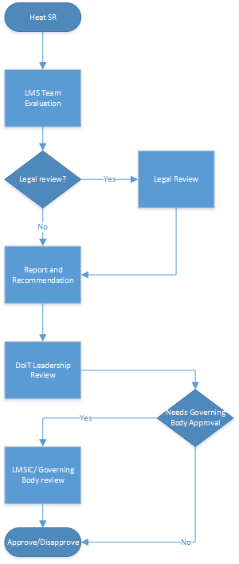
Return to Agenda

Appendix E— LTI Request - Wepa

Prepared by Wes Frazier, October 2018

Role
Wepa is a company specializing in printing solutions. They have been selected as a vendor for a larger student printing initiative. Their printer kiosks have the option for Canvas integration, allowing students to print out assignments or files from Canvas at the workstations.
Nature of Vendor
Wepa is a small company tightly focusing on campus printing and other print services. They have been operating for a decade. Headquartered in the united states and successfully partnered with many other academic institutions.
Benefits to Campus
Integrating the larger campus printing initiative with Canvas will allow students more flexibility to print documents stored in Canvas and should further increase the utility of using Canvas as a place for student collaboration.
User Experience
No user interface changes are expected to Canvas. This integration will merely allow the Wepa printing Kiosks to access files within Canvas that the student or instructor already would have access to from their computer.
Cost/Funding
No additional funding needed.
Existing Functionality
Its features are wholly unique compared to all other in use LTIs at this time.
Legal Concerns
This integration does not use the standard LTI interface and potentially could access FERPA protected data. That being said Wepa documents well what data they do collect through their interface to Canvas, how it is protected and how it is stored. (Or in Wepa’s particular case, not collected and not stored.) We do not believe there are any further FERPA issues beyond what the student printing initiative has cleared.
Security Concerns
None
Accessibility Concerns
None; as no elements of Canvas are changing the accessibility of Canvas or course content should not be impacted.
Technical Concerns
None
Recommendations
While an integration using the LTI interface is always preferable from a direct integration such as how Wepa is engineered. Given the unique nature of this integration we do not believe it could have been engineered in any other fashion. The technical piece of the integration is direct and straightforward and also potentially adds a large amount of value to our learning management system. DoIT recommends we install the LTI to facilitate interoperability with the new student printing solution in January 2019.

Return to Agenda

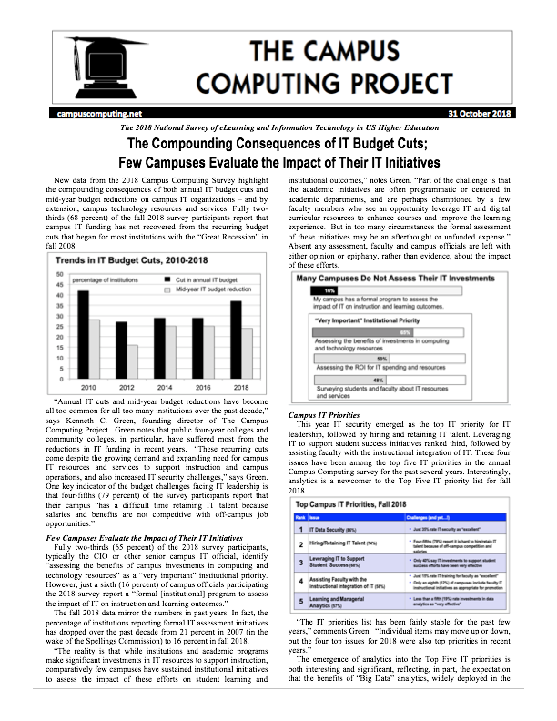
Appendix F— Campus Computing Survey - Executive Summary

