**FOURTEENTH ANNUAL**

**SOUTHEAST INDIAN STUDIES CONFERENCE**

[www.uncp.edu/ais](http://www.uncp.edu/ais)

**Thomas Assembly Room, Old Main**

**April 12-13, 2018**

**REGISTRATION - 9 CONTACT HOURS**

**Name:** ______________________________________________ **Email:** _____________________**__________________ Organization:**______________________________________________________________________________________

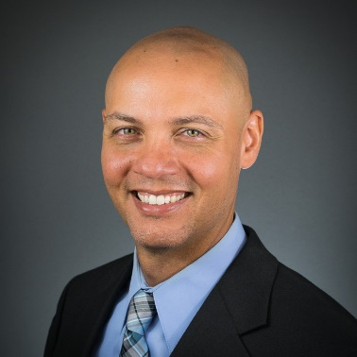

**KEYNOTE SPEAKER Dr. Ryan Emanuel** is Associate Professor and University Faculty Scholar in the Department of Forestry and Environmental Resources at NC State University.  The title of his talk is *Indigenous Peoples and the 21st Century Environment: Challenges and Opportunities for American Indians in the Southeast.* Indigenous peoples have deep cultural connections to the natural world that are far more complex than western fantasies and stereotypes.  These connections are strong, but they can be stressed by environmental planning and policies that do not fully appreciate or respect indigenous values, priorities, and cultures.  Dr. Emanuel examines some of these environmental stress points, focusing on American Indians in the southeastern United States, where tribal communities and individuals face numerous environmental challenges ranging from proposed gas pipelines to climate change.  Efforts to address these challenges are complicated by economic, policy, and other factors.  Nevertheless, tribes and individuals continue to uphold cultural beliefs and connections to place despite long odds, highlighting the creativity and resilience of indigenous peoples living in a 21st century environment.

|  |  |  |  |  |
| --- | --- | --- | --- | --- |
| Check appropriate box for  Registration Fees | | Registration | **X** for  Contact  Hours | Meals |
|  |  |  |
| **□** | Thursday and Friday | $45.00 |  | Lunch included |
| **□** | Thursday | $25.00 |  | Lunch included |
| **□** | Friday | $25.00 |  | Lunch included |
| **□** | UNCP student/faculty/staff | Free |  | Lunch **not** included |
| **□** | Community | Free |  | Lunch **not** included |
| **□** | Thursday at 5:00 pm Fuller’s BBQ Buffet | $10.99 + tax & tip ( **pay at Fuller’s**) |

**Conference Hotel: Holiday Inn Express Pembroke (910) 521-1311. Request government rate of $95 + tax per night**

**TOTAL AMOUNT ENCLOSED**: (**Make check payable to UNC Pembroke)** $____________

**VISA/MC #_______________________**

**Exp. Date_________________________**

Mail registration and payment to: Alesia J. Cummings, Department of American Indian Studies, P.O. Box 1510, Pembroke, NC 28372

***For more information, contact Alesia J. Cummings at 910-521-6266 or*** [***alesia.cummings@uncp.edu***](mailto:alesia.cummings@uncp.edu)