HOW TO GET ACCESS TO RWA (Report Web Application)

Go into BraveWeb
- Login with your user name an password
- Click on ONLINE FORMS
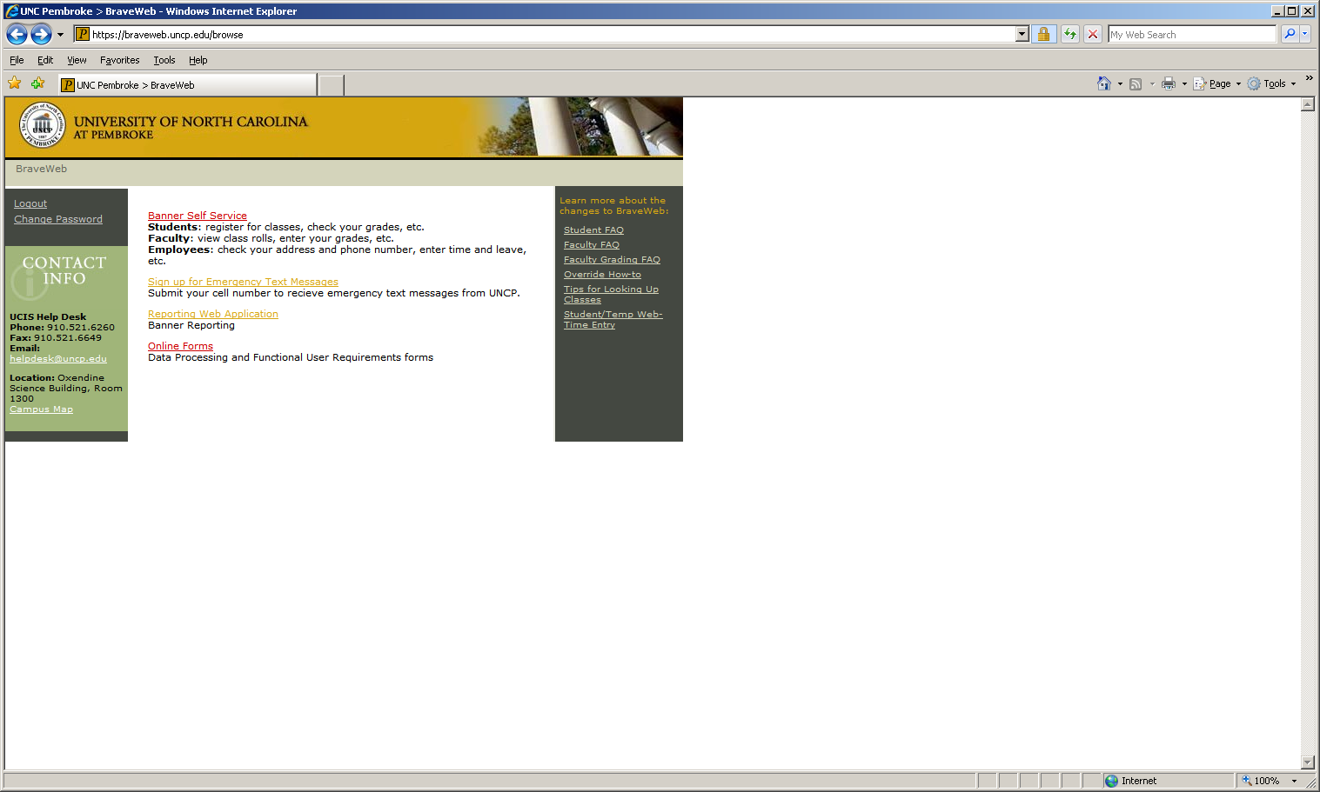
- Then ADMINSTATIVE ACCOUNT FORM
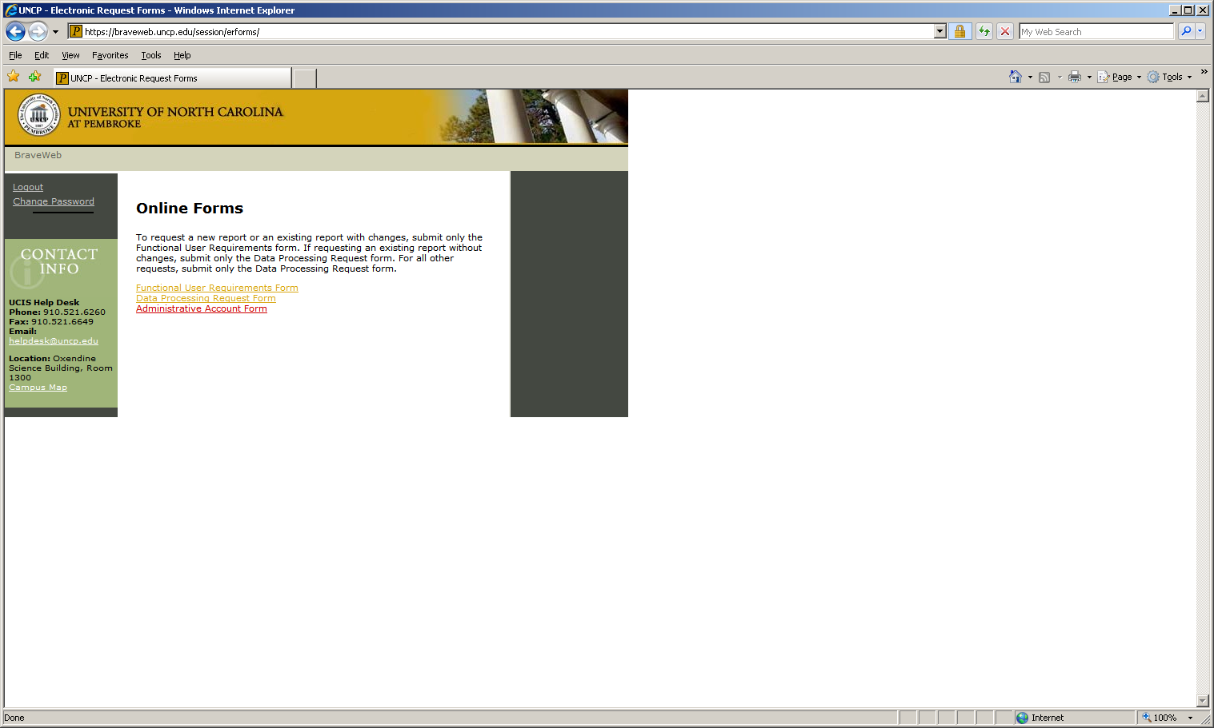
Fill the form out with all pertinent information
- Under system requested—be sure to select report web application
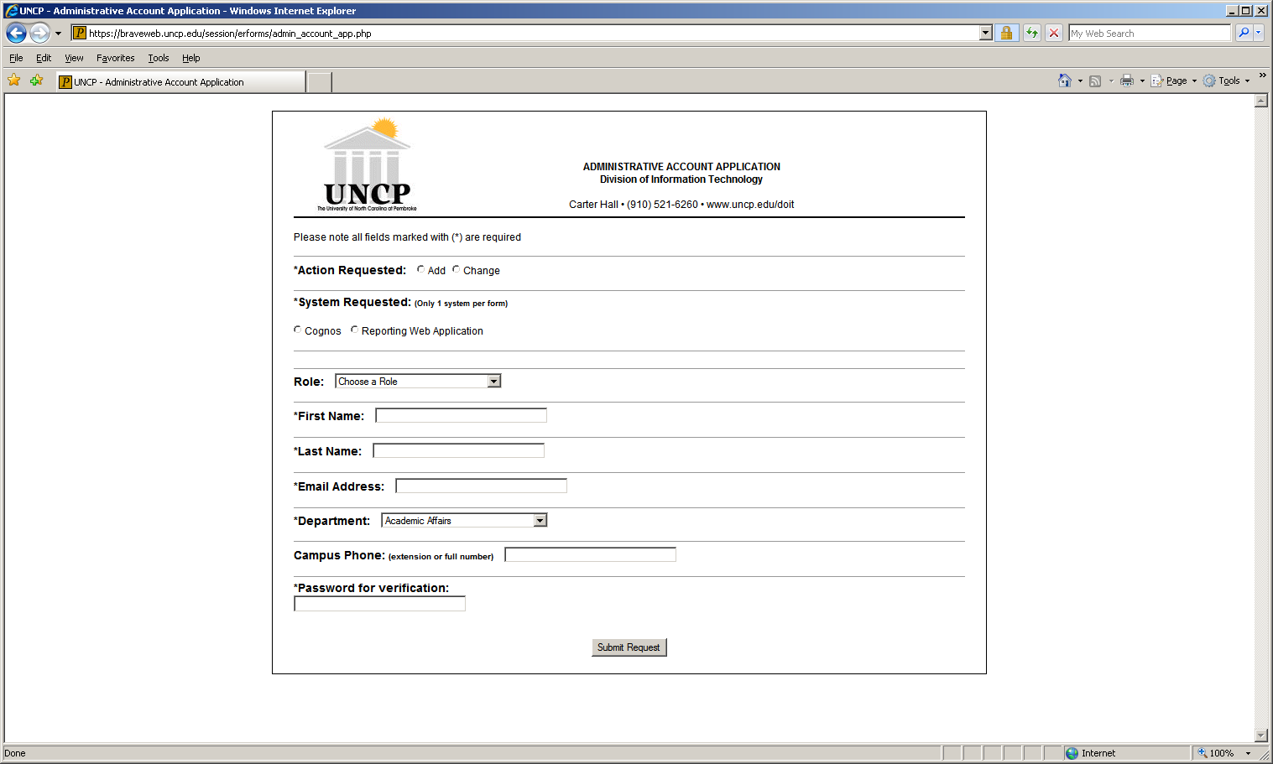

Then submit request
- The form will then be routed to the appropriate department head for approval prior to going to DoIT for set up.
- Once set up, you will then get an email confirmation that your access is granted.

Once access is granted
Go into BraveWeb
- Login with your user name and password
- Click REPORTING WEB APPLICATION
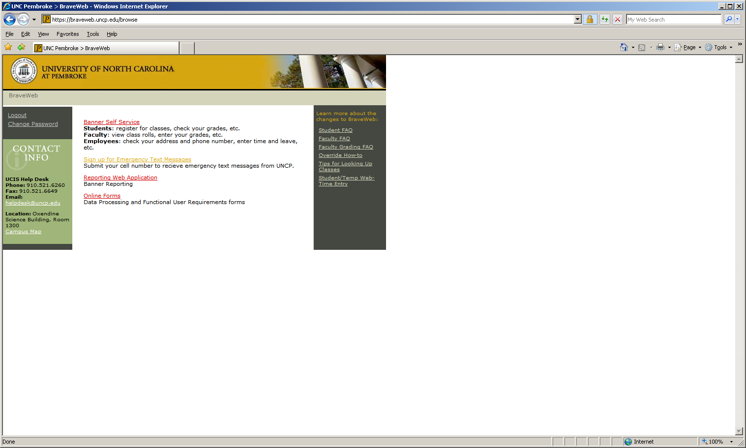
  - Congratulations you are in the REPORT WEB APPLICATION system!!


