Biochar with Worms Lab

Overview:
This activity is intended to show the students how to reduce, reuse, and recycle. It will also compare traditional agriculture with sustainable agriculture. The students will complete a project involving a soil amendment and worms. The students will recycle various leftover foods to feed to the worms. After completing the project, the students will analyze their data and record their results. The class will discuss what the results were and how the results relate to the objective.

Purpose: (Objective)
NC SCOS for Environmental Science
EEn.2.8.4 The learner will evaluate the concept of “reduce, reuse, and recycle” in terms of impact on natural resources.
OR
Bio.2.1 Analyze the interdependence of living organisms within their environments.

Instructional objectives
- The learner will design an experiment to compare regular soil with sustainably amended soil
- The learner will analyze the data collected 4-7 days after the experiment has taken place. The learner should recognize a difference in the two soils.
- The student will compare the results with the formulated hypothesis
- The learner will be able to identify the differences between traditional agriculture and sustainable agriculture. The student will also learn the importance of reduce, reuse, recycle.

Materials:
- Worms (preference: red wigglers)
- Biochar
- Gloves
- Labeling tape
- Screen divider
- Soil
- Plastic container
- Worm feed such as fruit and vegetable scraps (made by students)
- Worksheet for biochar experiment
- Blender
- Research notebook (composition notebook)

Getting Ready: (Background Information)
Background information can be found on the biochar worksheet. The teacher will also do a small lecture on biochar and the project that will take place. Some back ground information will be discussed among the students during a small debate.

Motivate! (Engage)
At the beginning of class, the students will watch a small video about biochar (http://www.youtube.com/watch?v=5ckh93qwXZk). They will then answer the following questions and record them in their interactive notebook:
- What is biochar?
- Do you recycle and reuse? If so, what do you recycle or reuse?
- What two benefits does biochar amended soil offer compared to traditional soil?
Time allotted: 5 minutes

Activity: (Explore)
Students will work in groups of 4 or more to carry out the experiment. The experiment will determine whether the sustainable soil is more beneficial than the regular planting soil. It will also show the students how recycling and reusing are important for the environment. A standard set of supplies will be provided at each station, but students may ask for more supplies if need. A scientific methods worksheet will be provided that students should begin to fill out as they complete each part of the scientific method. The students should follow the instructions on the work sheet, provided by the teacher, which will explain how to carry out the experiment. The students should also set up their laboratory notebooks at this time.
Time allotted: 30 minutes

Safety Tips:
While completing the activity be careful not to cut the worms in half when searching for them. When handling the wire fence, the students should avoid touching the cut edges of the wire because it will cut through the skin. Garden gloves should be used by all students when handling the wire. When using the blender, do not put your hand inside of it because there is a blade.

Concept Discovery: (Explanation)
The students will form groups of 4. The students will discuss how they can demonstrate the 3 R’s in their everyday lives. The students will work within their group to form a description of what sustainable agriculture would look like. The class will create a list of ways to demonstrate the 3 R’s. The class will form a consensus description of the characteristics of sustainable agriculture.
For example:

Time allotted: 30 minutes

Going Further: (Elaboration)
The students will now have a class discussion which will be led by the teacher. The teacher will start the students off with a few questions such as:
Questions
1. What do you think the results will be at the end of the experiment?
2. What was your favorite part of this experiment and why?
3. What did you learn from this experiment so far?
4. What are some things that you might do differently now that we have learned about the 3 R’s?
The students must write the questions in the interactive notebook and answer them individually. After the students have answered the questions, the teacher will have a few students come to the board and write their answers on the board. After the answers are written on the board, the class will discuss the answers. This activity will engage the students and make them think more critically about the experiment they have started.
Time allotted: 20 minutes

Closure:
The teacher will write the following questions on the board:
1. Do you agree or disagree with sustainable agriculture? Explain.
2. Will you recycle, reduce, and reuse now? How?
3. How could you change the experiment to test a different environment for worms? Explain.
4. Did you enjoy the experiment? Explain.
The students should answer yes/no or agree/disagree and provide an explanation for each question. After they have answered the questions, the students will leave the questions in a bucket provided by the teacher.
Time allotted: 3 minutes

Assessment: (Evaluation)
The students will be assessed with their lab notebook, the pre lab questions (see below) and the post lab questions (see below). The teacher will expect each student to have an idea of why the worms migrated to the side with the biochar or the side without biochar. The students should also have an understanding of how recycling and reusing products helps the environment. Lastly, they should have an understanding of the concepts of sustainable agriculture.

Name:
Date:
Class period:
Group members:
Biochar Lab Worksheet
In this experiment the student will learn about biochar, which is a soil amendment. There will be a series of steps that the students should take to figure out which soil has more nutrients. They will discover this by seeing which side of the soil the worms migrate to.

Background information about biochar: Biochar is a type of charcoal used as a soil amendment. It originated in the Amazon by the Pre- Columbian Amazonians. It was used to improve the soil in the dry seasons. They called this improved soil Terra Preta. Biochar is made with various types of biomass including chicken manure, wood chips, etc. The biochar is made in a process called pyrolysis. Pyrolysis produces biochar from biomass by heating the biomass in a low/no oxygen environment. “A research team working in French Guiana hypothesized that the Amazonian Earthworm, Pontoscolex corethrurus, was the main agent of fine powdering and incorporation of charcoal debris to the mineral soil (Emma).”

Materials

  - Worms (preference: red wigglers)
  - Biochar ( can be made or purchased)
  - Screen divider or plastic fencing
  - Soil
  - Plastic container
  - Worm feed such as fruit and vegetable scraps (made by students)
  - Worksheet for biochar experiment
  - Blender
  - Research notebook (composition notebook)
  - Gloves
  - Paper towels
  - Plastic cups
  - Labeling tape
  - Markers

Pre lab questions
- What side do you expect the worms to be on? Formulate a hypothesis.
- Why do you think the worms will be on that side?
- Why did we use worms in the soil?
- What is biochar and why is it important?

Instructions: Form groups -- at least 4 students should be in each group. The students should fill out their scientific methods worksheet as they go along with the experiment. There will be four stations provided as follows: worm food station, worm station, material station, and soil /biochar station.
One student should gather all materials needed for the experiment. Another student should gather 20 red wiggler worms. The other two students should make the worm food.

At each Station:
Worm feed station: A blender will be set up at this station. Each student should blend the food that he/she has recycled over the course of the week and place it into the small plastic container.
Worm station: A container of worms will be at this station. The student should collect 10 worms and take them back to his/her table.
Material station: This station will contain all materials such as a screen divider, labeling tape and garden gloves.
Soil and biochar station: This station will contain the regular soil and soil with biochar. The student should fill one side of the plastic container with regular soil and the other side with a mixture of soil and 10% biochar. The students should be sure to put the wire divider in between the two soils.

Procedure

- The students will leave the soil and biochar station and take their plastic container back to the station. The group should check the soil to make sure it is not too dry. To check the soil the students should place the soil in the palm of their hands and ball their hands up making a fist. The soil should stay in a ball when they open their hands.
- The soil container is to be prepared next. After they have visited each station, the students will have completed most of the set-up. The soil should already be in the large plastic container with the wire fence that divides the soils. The students should be sure to label, on the large container, as to which side has the biochar with soil and which side has the regular soil.

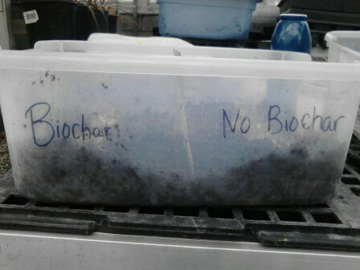

- One of the students should already have 20 worms at his/her designated work area. The group will now place 10 worms on the side with the biochar and soil and 10 worms on the side with the regular soil.
- One of the students should already have blended the worm feed, and it should be in a small container. The students will use a plastic spoon to make a trail of worm feed on each side of the fence.
This is what the container should look like when the student is finished
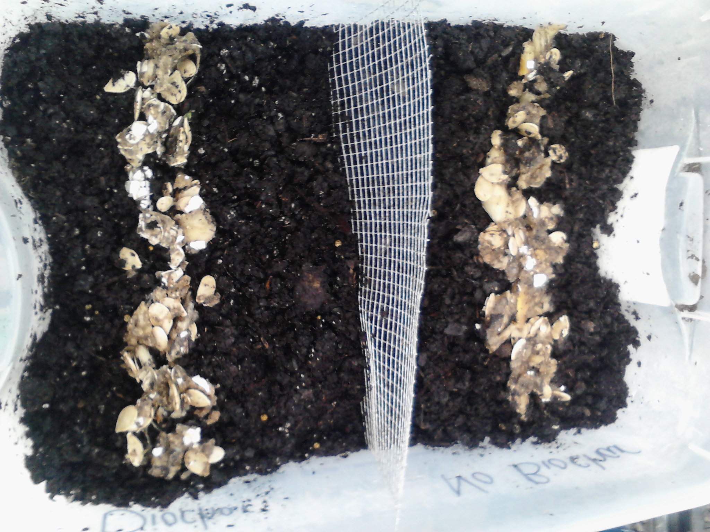

- The students should place their containers in a dark area in the classroom.
- The students should check, after 4-7 days, to see where the worms have migrated.
- When checking to see where the worms have migrated, the students should use a pair of gloves to dig for the worms. The student should do one side at a time using a paper towel on which to place the worms. The students should use one paper towel for the worms that are found in the regular soil and another paper towel for the worms found in the soil with biochar.
- The students should record and analyze their data.
Post lab questions

- Which side did the worms migrate to? Was your hypothesis correct? Explain why or why it was not correct?
- Were you surprised about your results? Why?
- Explain what you would have done differently during the experiment to have better results? Explain how you would reuse and recycle on a daily basis.
- How did you reuse and recycle? Would you like to reuse and recycle on a daily basis?
- How does this lab relate to traditional and sustainable soil? Explain in detail.

Name:
Date:
Class period:
Group members:

Scientific Methods Worksheet
Name of experiment:
My hypothesis (what is you estimated guess as to what will happen in the experiment?)



Do the experiment (write your steps you took to do the experiment)

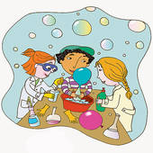

Draw your experiment ( draw a small picture of the experiment)


Make observations (record your results)

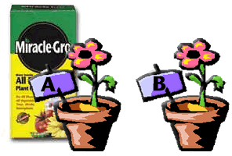

Conclusion (what did you conclude from this experiment?)
