Ordering Transcripts Through National Clearing House

When and why is it important to request a transcript for college purposes?
- Answer: Completing college applications for undergraduate, graduate admission, and transcript credit review.
Step 1:
Use a computer to visit https://tsorder.studentclearinghouse.org/school/select
Step 2:
Select school institution you’d like to request your transcript from, click continue and then select order transcripts.
- Example:
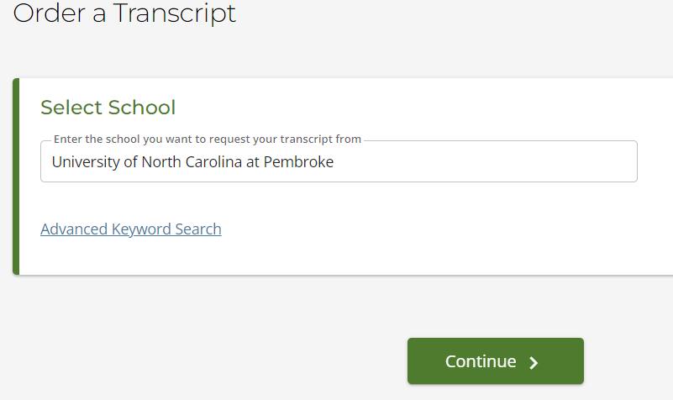
Step 3:
Enter personal and student identification and then click continue.
- Example:
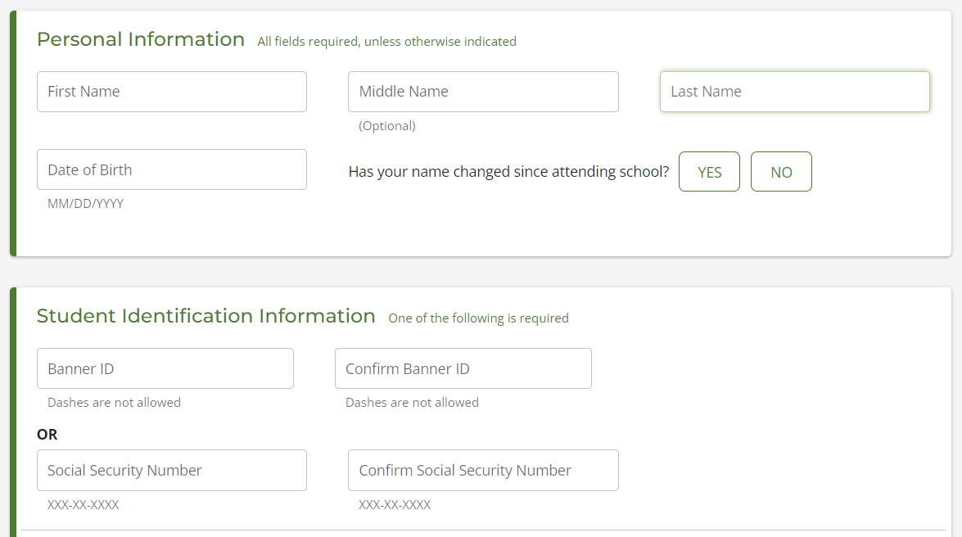

Step 4:
Enter contact information and click continue (be sure to use personal email).
- Example:
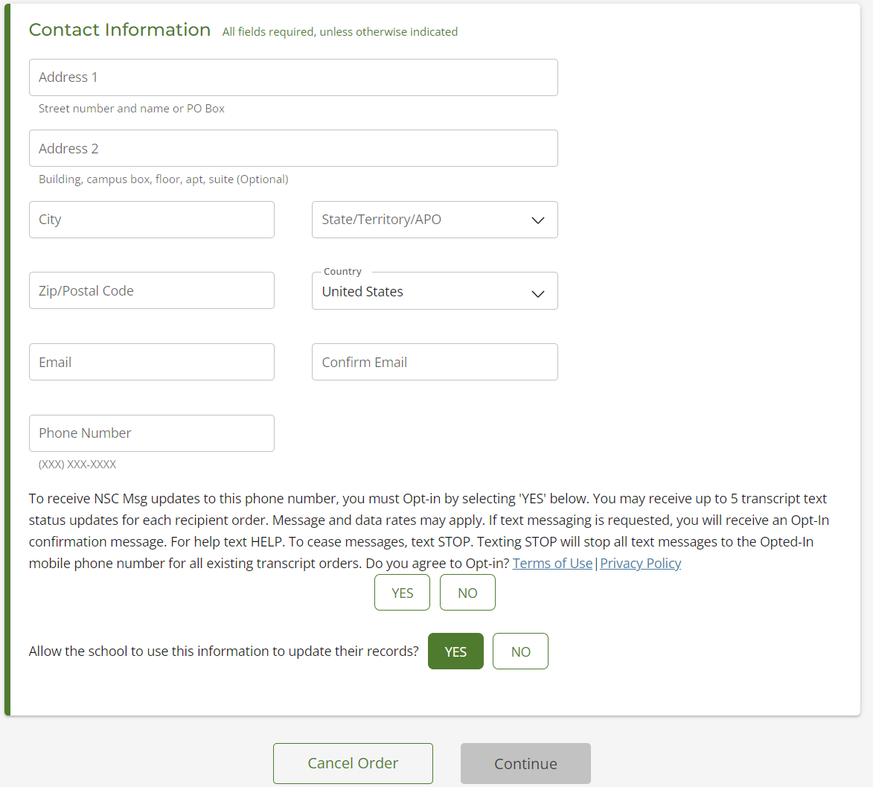
Step 5:
Select transcript and delivery details and click continue.
- Example:
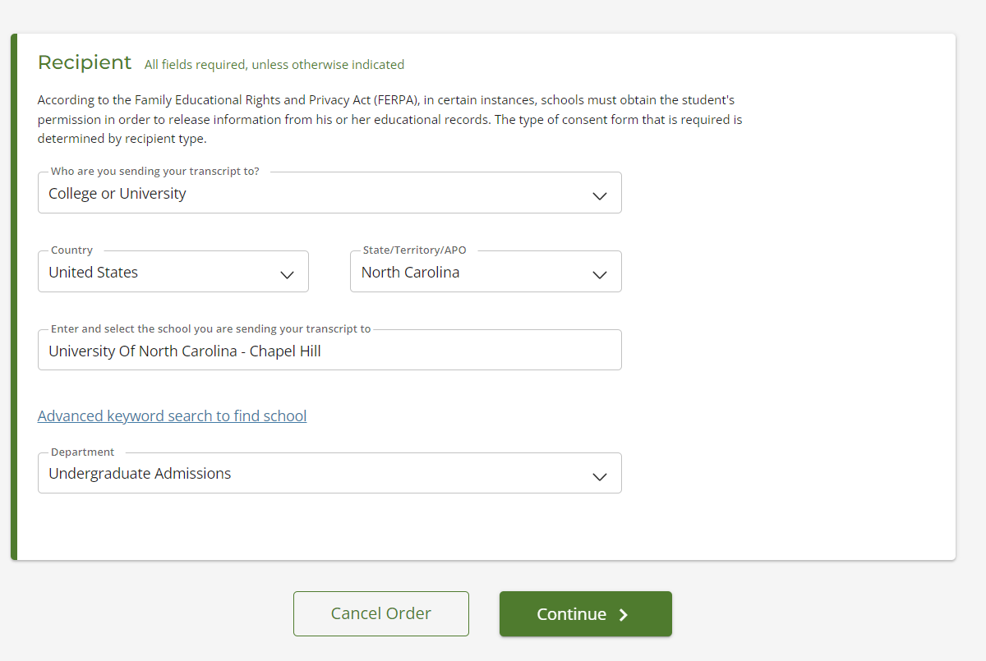
- transcripts can be sent to colleges or universities, education organizations, scholarships, or professional licensing.
- Please note: if transcripts are requested for admissions application, make sure that you select the undergraduate admissions. If they are requested for transcript review, select undergraduate admissions or registrar office as the department.
Step 6:
Enter processing details, delivery information, upload any documentation if needed, and click continue.
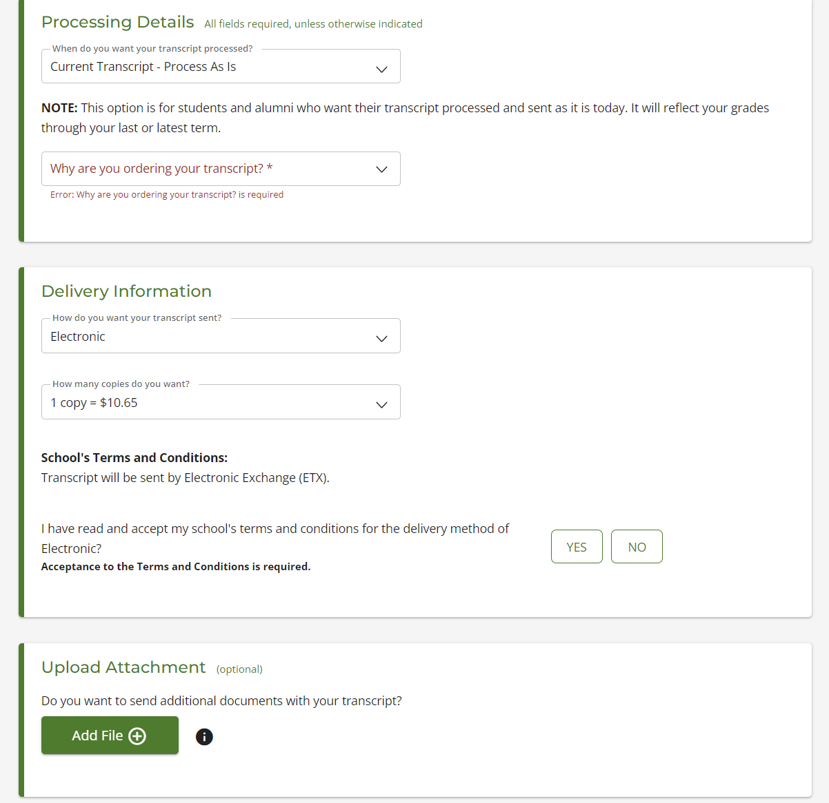

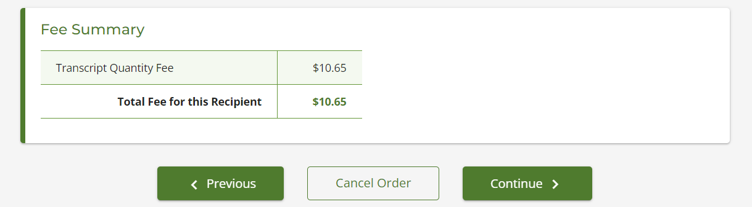
Step 7:
Confirm order and checkout. You will be able to electronically sign a consent form on the website and print it if needed.
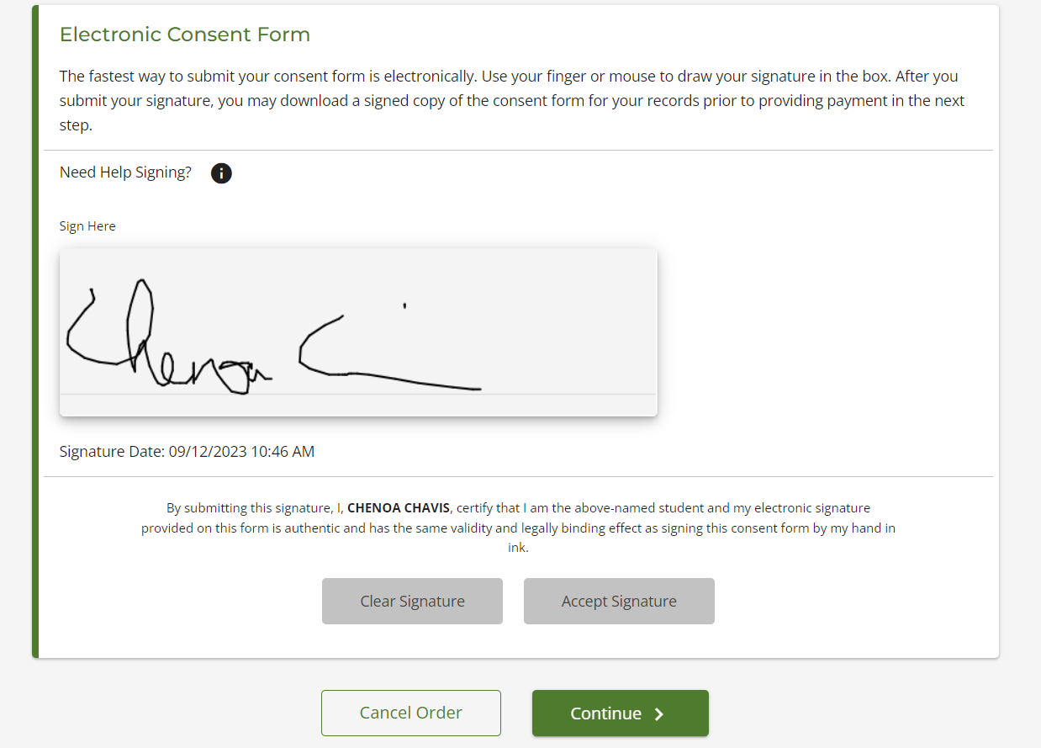
Step 8:
Payment details and submit order.
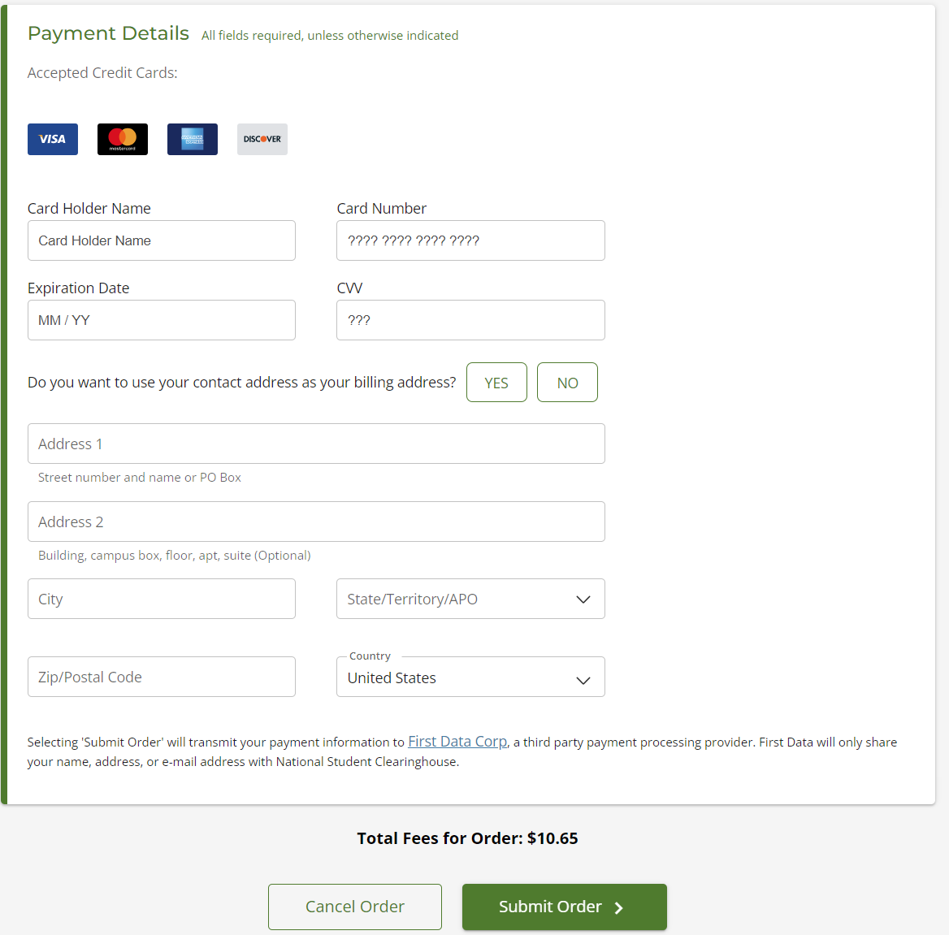
- You will be sent a confirmation code on requesting the transcript to be sent to desired destination and you will receive confirmation when recipient has retrieved the transcript.

